

CHAPTER 1 – EXECUTIVE MAYOR’S FOREWORD AND EXECUTIVE SUMMARY 7
COMPONENT A: EXECUTIVE MAYOR’S FOREWORD 7
COMPONENT B: EXECUTIVE SUMMARY 11
1.1. MUNICIPAL MANAGER’S OVERVIEW 11
1.2. MUNICIPAL FUNCTIONS, POPULATION AND ENVIRONMENTAL OVERVIEW 14
1.3. SERVICE DELIVERY OVERVIEW 28
1.4. FINANCIAL HEALTH OVERVIEW 30
1.5. ORGANISATIONAL DEVELOPMENT OVERVIEW 32
1.6. AUDITOR GENERAL REPORT 33
1.7. STATUTORY ANNUAL REPORT PROCESS 34
CHAPTER 2 - GOVERNANCE 35
COMPONENT A: POLITICAL AND ADMINISTRATIVE GOVERNANCE 35
2.1. POLITICAL GOVERNANCE: 36
2.2. ADMINISTRATIVE GOVERNANCE 39
COMPONENT B: INTERGOVERNMENTAL RELATIONS 39
2.3. INTERGOVERNMENTAL RELATIONS STRUCTURES: 39
COMPONENT C: PUBLIC ACCOUNTABILITY AND PARTICIPATION 41
2.4. PUBLIC MEETINGS 41
2.5. IDP PARTICIPATION AND ALIGNMENT 42
COMPONENT D: CORPORATE GOVERNANCE 43
2.6. RISK MANAGEMENT 44
2.7. ANTI-FRAUD AND CORRUPTION 44
2.8. SUPPLY CHAIN MANAGEMENT 44
2.9. WEBSITES 45
2.10. BY-LAWS 46
CHAPTER 3 - SERVICE DELIVERY PERForMANCE 48
COMPONENT A 49
3.1. WATER PROVISION 49
3.2. WASTE WATER (SANITATION) 49
3.3. ELECTRICITY 49
3.4. WASTE MANAGEMENT 49
3.5. HOUSING 49
3.6. SOME FREE BASIC SERVICES AND INDIGENT SUPPORT 50
COMPONENT B: ROAD TRANSPORT 51
3.7. ROADS 51
3.8. TRANSPORT (INCLUDING VEHICLE LICENSING AND PUBLIC BUS OPERATION) 51
3.9. WASTE WATER (STORMWATER DRAINAGE) 51
COMPONENT C: PLANNING AND DEVELOPMENT 52
3.10. INTRODUCTION TO PLANNING 52
COMPONENT D: ENVIRONMENTAL PROTECTION 54
3.11. POLLUTION CONTROL 54
3.12. BIO-DIVERVISTY, LANDSCAPE (INCLUDING OPEN SPACES) AND OTHER (E.G. COASTAL PROTECTION) 54
3.13. LOCAL ECONOMIC DEVELOPMENT (INCLUDING TOURISM AND MARKET PLACES) 54
COMPONENT E: COMMUNITY SERVICES 59
3.14. LIBRARIES; ARCHIEVES; MUSEUMS; GALLERIES; COMMUNITY FACILITIES; OTHER (THEATERS, ZOOS, ETC) 59
3.15. CEMETERIES AND CREMATORIUMS 60
3.16. CHILD CARE; AGED CARE; SOCIAL PROGRAMMES 60
COMPONENT F: HEALTH 64
3.17. CLINICS 65
3.18. AMBULANCE SERVICES 68
3.19. HEALTH INSPECTION, FOOD AND ABATTOIR LICENSING AND INSPECTION 68
COMPONENT G: SECURITY AND SAFETY 70
3.20. POLICE 70
3.21. FIRE 74
3.20. OTHER (DISASTER MANAGEMENT, ANIMAL LICENCING AND CONTROL, CONTROL OF PUBLIC NUISANCES AND OTHER) 74
COMPONENT H: SPORT AND RECREATION 78
3.21. SPORTS & RECREATION UNIT 78
COMPONENT I: CORPORATE POLICY OFFICES AND OTHER SERVICES 87
3.22. EXECUTIVE AND COUNCIL 87
3.23. FINANCIAL SERVICES 88
3.24. HUMAN RESOURCE SERVICES 90
3.25. INFORMATION AND COMMUNICATION TECHNOLOGY (ICT) SERVICES 92
3.26. PROPERTY; LEGAL; RISK MANAGEMENT AND PROCUREMENT SERVICES 94
COMPONENT J: MISCELLANEOUS 96
COMPONENT K: ORGANISATIONAL PERFOMANCE SCORECARD 96
CHAPTER 4 98
(PERFORMANCE REPORT PART II) 98
COMPONENT A: INTRODUCTION TO THE MUNICIPAL PERSONNEL 98
4.1. EMPLOYEE TOTALS, TURNOVER AND VACANCIES 98
COMPONENT B: MANAGING THE MUNICIPAL WORKFORCE 100
4.2. POLICIES 100
4.3. INJURIES, SICKNESS AND SUSPENSIONS 101
4.4. PERFORMANCE REWARDS 103
COMPONENT C: CAPACITATING THE MUNICIPAL WORKFORCE 104
4.5. SKILLS DEVELOPMENT AND TRAINING 105
COMPONENT D: MANAGING THE WORKFORCE EXPENDITURE 108
CHAPTER 5 109
COMPONENT A: STATEMENTS OF FINANCIAL PERFORMANCE 109
5.1. STATEMENTS OF FINANCIAL PERFORMANCE 110
5.2. GRANTS 114
5.3. ASSET MANAGEMENT 116
5.4. FINANCIAL RATIOS BASED ON KEY PERFORMANCE INDICATORS 118
COMPONENT B: SPENDING AGAINST CAPITAL BUDGET 127
5.5. CAPITAL EXPENDITURE 127
5.6. SOURCES OF FINANCE 128
5.7. CAPITAL SPENDING ON 5 LARGEST PROJECTS 130
5.8. BASIC SERVICE AND INFRASTRUCTURE BACKLOGS – OVERVIEW 131
COMPONENT C: CASH FLOW MANAGEMENT AND INVESTMENTS 132
5.9. CASH FLOW 133
5.10. BORROWING AND INVESTMENTS 134
5.11. PUBLIC PRIVATE PARTNERSHIPS 137
COMPONENT D: OTHER FINANCIAL MATTERS 137
5.12. SUPPLY CHAIN MANAGEMENT 137
5.13. GRAP COMPLIANCE 138
CHAPTER 6 – AUDITOR GENERAL AUDIT FINDINGS 140
COMPONENT A: AUDITOR-GENERAL OPINION OF FINANCIAL STATEMENTS Year -1 140
6.1. AUDITOR GENERAL REPORTS Year -1 (Previous year) 140
COMPONENT B: AUDITOR-GENERAL OPINION YEAR 0 (CURRENT YEAR) 149
6.2. AUDITOR GENERAL REPORT YEAR 0 149
GLOSSARY 150
APPENDICES 152
APPENDIX A – COUNCILLORS; COMMITTEE ALLOCATION AND COUNCIL ATTENDANCE 152
APPENDIX B – COMMITTEES AND COMMITTEE PURPOSES 154
APPENDIX C –THIRD TIER ADMINISTRATIVE STRUCTURE 155
APPENDIX D – FUNCTIONS OF MUNICIPALITY / ENTITY 157
APPENDIX E – WARD REPORTING 158
APPENDIX F – WARD INFORMATION 158
APPENDIX G – RECOMMENDATIONS OF THE MUNICIPAL AUDIT COMMITTEE YEAR 2017/18 159
APPENDIX H - LONG TERM CONTRACTS 161
APPENDIX I – MUNICIPAL ENTITY/ SERVICE PROVIDER PERFORMANCE SCHEDULE 165
APPENDIX J – DISCLOSURES OF FINANCIAL INTERESTS 166
APPENDIX K: REVENUE COLLECTION PERFORMANCE BY VOTE AND BY SOURCE 168
APPENDIX K (i): REVENUE COLLECTION PERFORMANCE BY VOTE 168
APPENDIX K (ii): REVENUE COLLECTION PERFORMANCE BY SOURCE 169
APPENDIX L: CONDITIONAL GRANTS RECEIVED: EXCLUDING MIG 170
APPENDIX M: CAPITAL EXPENDITURE – NEW & UPGRADE/RENEWAL PROGRAMMES 171
APPENDIX M (i): CAPITAL EXPENDITURE - NEW ASSETS PROGRAMME 171
APPENDIX M (ii): CAPITAL EXPENDITURE – UPGRADE/RENEWAL PROGRAMME 173
APPENDIX N – CAPITAL PROGRAMME BY PROJECT YEAR 0 174
APPENDIX O – CAPITAL PROGRAMME BY PROJECT BY WARD YEAR 0 174
APPENDIX P – SERVICE CONNECTION BACKLOGS AT SCHOOLS AND CLINICS 174
APPENDIX Q – SERVICE BACKLOGS EXPERIENCED BY THE COMMUNITY WHERE ANOTHER SPHERE OF GOVERNMENT IS RESPONSIBLE FOR SERVICE PROVISION 174
APPENDIX R – DECLARATION OF LOANS AND GRANTS MADE BY THE MUNICIPALITY 174
APPENDIX S – NATIONAL AND PROVINCIAL OUTCOMES FOR LOCAL GOVERNMENT 174
VOLUME II: ANNUAL FINANCIAL STATEMENTS 175

CHAPTER 1 – EXECUTIVE MAYOR’S FOREWORD AND EXECUTIVE SUMMARY

COMPONENT A: EXECUTIVE MAYOR’S FOREWORD

EXECUTIVE MAYOR’S FOREWORD

VISION

Sedibeng District Municipality envisages building towards a developmental Metropolitan River City of Choice

MISSION

To promote and sustain integrated service delivery that enhances and supports the municipality to achieve growth and development for its community.

The District Municipality is strategically focused:

- To promote efficient and effective integrated services that addresses the socio-economic and environmental development imperatives of the region.
- To implement prudent and cost effective financial management and sustainability;
- To ensure good governance and sound management practices; and
- To ensure effective service delivery

KEY POLICY DEVELOPMENTS

Sedibeng District Municipality’s is committed to address the current social challenges – high unemployment rate, inequality, poverty and drug abuse; and economic impasse – low investment levels and declining economy within the district. The aim is to promote agriculture, tourism and logistics, protect and expand the manufacturing industry in line with the Premier’s Gauteng City Region (GCR) vision 2055, the Gauteng Spatial Development Framework and the Gauteng Transformation Modernisation and Reindustrialisation (TMR) Strategy. To date the following key strategy interventions have taken place; in line with Southern Corridor Development Approach:
- 2016 – 2021 Integrated Development Plan (IDP) – 5 Year Plan ( reviewable each and every year)
- Southern Corridor Implementation Plan–whereby 43 projects were rigorously assessed for investment and implementation readiness, resulting into 13 projects across the region.
- The district is at its final stage of developing the 3rd Generation of Sedibeng Growth and Development Strategy 2030
Sedibeng District Municipality still remains the “hydrotropolis” focusing on and developing economies around water and “agrotropolis” – focusing on and developing economies around agriculture. It is critical to note that in order to strive and thrive in our policy direction and implementation, the five (5) pillars of Local Government Back to Basics will serve as anchor in our citizen/stakeholders and government interface approach.
KEY SERVICE DELIVERY IMPROVEMENT

I am happy to share the number of service delivery successes and improvements with the people of Sedibeng region, namely:
- During the outbreak of Listeriosis, the district primary health units showed its resilience, focused and showed the mettle in monitoring, reporting, managing incidents and engaging diverse stakeholders mostly affected. This is evidenced by an audit achievement of 88% by the National Department of Health for compliance to national standards and norms.
- SANTAM partnership is bearing fruits – more than 33 old age homes and children’s homes have been installed with fire hazards and rescue equipment, and a donation of firefighting equipments to the three fire station in the region
- We have directly spent twenty three million rand (R23 million) in empowering SMMEs, of which 37% of municipal direct procurement came from township business;
- Amicable resolution of the disputes between Morning Star Taxi Association, Meyerton Taxi Association and Gauteng Small Buses Operations Company.
- Number of informal traders benefited from BenBen Technologies CSI project with a donation of 50 eco-trolley, to provide mobile, multi-use and supporting infrastructure to improve informal entrepreneurship
- The International Day against Drug Abuse and Illicit Trafficking was commemorated in our region with an increase of subsidised beds at Jamela Rehabilitation Centre to address increased demand for substance abuse in-patient treatment services
- The commencement of the implementation of Sedibeng District Municipality Agri-Parks Master Plan

PUBLIC PARTICIPATION
Local governance as a cornerstone rests on both representative and participatory democracy. Since the inception of the Service Delivery War Room by the provincial government, Sedibeng District Municipality has strengthened its community engagement. This done to increase public awareness on service delivery and accountability to the communities. The following instruments are used to achieve the above mandatory responsibility:
- Ntirhisano Community outreach Programme
- Section 80 Oversight Visits
- Sector-focused forums such as Community Safety Forums, Agriculture Forum et cetera.
- A newly launched Fraud and Corruption hotline ( 0860 061 022)

FUTURE ACTIONS

In order to execute our mandatory responsibility of good governance, financial viability and continuous enhanced services delivery, the municipality will engage on the following issues:
- Continuous supportive role to local municipalities, particularly Emfuleni and Lesedi Local Municipalities
- Application for housing accreditation in terms of the National Housing Code;
- Relentless pursue for reassignment of powers and functions to the Municipality; as per section 84 of the Municipal Structures Act.
- Explore various potential avenues in order to improve the financial viability of the municipality;
- Speedy and closer focus into agriculture infrastructure and creative sector projects; and
- The development of the Multi-Purpose Government Precinct

AGREEMENTS / PARTNERSHIPS

“Local government is everyone’s business” said the late Minister, Mr Sicelo Shiceka. It still remains true today. And the regulatory framework encourages the local government to use innovative, sustainable and ethical approaches to build capacity and serve our citizens. The following agreements/partnerships have been entered into to achieve the service delivery obligation, namely:
- National Youth Development Agency – to provide skills and empowerment programmes for youth across the region for the next 10 years in all our Youth Advisory Centres;
- Agreement with Gauteng Provincial Government, Department of Sports, Recreation, Arts and Culture to fund Boipatong Memorial Centre for the next 3 years – purposed for heritage and youth development;
- Public-Private Partnership with S-Trading (Pty) Ltd towards the implementation of the “Multi-purpose Government Precinct” flagship project.
- Agreement with Department of Rural Development and Land Reform regarding Sedibeng Agri-Parks Master Plan implementation
- Contract Bus Service Intergovernmental Authorisation Agreement with GPG, Department of Roads and Transport;

CONCLUSION

The year 2017/18 came and ended with many influential events in South Africa and the globe. We have drawn immense inspiration and selfless service from Mama Winnie and may her soul rest in peace. May her celebrated life continue to remind us that we are in public service to empower and help our fellow citizens liberate their talents, passions and dreams and never to instil fear, doubt and hopelessness. I warmly extend gratitude to our government, non-governmental and private sector and every citizen of our region for their support and collaboration during the year. Moreover, I applaud our municipal officials in responding to the needs of our people and their selfless service. As we move forward with new resolutions into the new financial year, we must all remember that the cornerstone of democracy is our right to vote and elect public representatives. I encourage everyone to be ready and exercise their rights during the upcoming National and provincial elections in 2019.

Yours Sincerely,
________________________

Cllr Busisiwe Modisakeng, Executive Mayor

COMPONENT B: EXECUTIVE SUMMARY

MUNICIPAL MANAGER’S OVERVIEW

BACKGROUND:

It is my greatest pleasure to report and give highlights of how the municipality is performing in relation to its expected mandate, adopted plans and rolling out implementation of programmes and projects that were well justified in the budget endorsed by Council. This report comes at the time when Sedibeng District Municipality had made tremendous improvement on Operational Systems for 2017/18 financial year.

OUR ALIGMENT WITH COUNCIL PRIORITIES:

The administrative team worked together with the political pillar in developing the 2017/18 Integrated Development Plan (IDP). The Integrated Development Plan (IDP) is a “super-plan” for our district that lays down an overall framework for development. It aims to co-ordinate the work of District Municipality, Local Municipalities and other Spheres of Government in a coherent plan to improve the quality of the lives of the people of Sedibeng District Municipality.

IDP reflects Council’s vision for the long term development of the Municipality with special attention on critical developmental issues and internal transformation needs. It is a five-year strategic tool used to address and measure the level of service delivery in the District.

While we are still deliberating on best possible ways to address the current set up with existing practices of Powers and Functions which have financially handicapped this District Municipality, we continue to implement the Austerity Measures as approved by the council and re- examine some of its policies and practices as resources come under extreme pressure.

With the newly appointed Management of Sedibeng District Municipality, we are committed to improving the Auditor General Audit reports from an unqualified audit opinion to an even better Audit outcome in this Financial Year.

Sedibeng District Municipality has so much developmental potential yet it is under-developed and heavily dependent on grants. However, we are committed to turnaround the situation by putting the Municipality in a state that it will be able to attract investors through other Local Economic Development Initiatives.

SERVICE DELIVERY & BUDGET IMPLEMENTATION PLAN (SDBIP) 2017/18:

The Sedibeng District Municipality has successfully integrated its Integrated Development Planning with the Performance Management System. This has made it possible for the municipality to monitor, measure and report against all set deliverables in its IDP. SDM is fully compliant with Section 38 of the Local Government: Municipal Systems Act, 32 of 2000, which states that:

All municipalities must establish performance management system that is:
- Commensurate with its resources;
- Best suited to its circumstances; and
- In line with the priorities, objectives. Indicators and targets contained in our integrated development plan.

The establishment, development, monitoring and general management of performance at a municipal level is governed by stipulations in Chapter 6 of the Local Government: Municipal Systems Act, No. 32 of 2000.

The electronic IDP-SDBIP alignment makes it possible for all Clusters in SDM to progress report and collates evidence against the set Deliverables. These reports are consolidated on quarterly, mid-year and annual basis, and measured against the set ‘SMART’ targets. The Performance Management system has an inherent monitoring tool in form of dashboards, thus on continuous basis showcase areas of performance and under-performance. This tool gives progress status against the set Deliverables in all Clusters and affords early detection and intervention in areas of need.

OUR SERVICE DELIVERY:

In the context of this Financial Year with regard to service delivery, as a District we have developed the 12 Months Plan which outlines the various projects. These projects includes:
- Sedibeng/Vereeniging Government Precinct,
- Sedibeng/ Vereeniging Fresh Produce Market,
- Sedibeng Regional Sewer Scheme,
- Freight & logistic hub,
- Township Economic Revitalisation,
- Tourism,
- Agriculture,
- Vereeniging Intermodal Facility (Taxido),
- Vereeniging Airport

These projects will also unlock investment; create economic and long term sustainable job opportunities in our district.

Our Financial cluster is currently conducting monthly reporting on two parallel platforms to ensure MFMA section 71 reports are MSCOA compliant. The municipality initiated the financial system upgrade in Q3 which will further improve automated financial reporting and MSCOA compliance.

The municipality successfully compiled and approved their 17/18 MTREF on MSCOA, and will initiate the drafting of the 18/19 MTREF on MSCOA in Q3 with the guidance and support provided by National and Provincial Treasury. The municipality had also begun transacting fully on the National Treasury MSCOA as from 01 July 2017.

BACK TO BASICS:

The Back to Basics (B2B) Programme was launched at Presidential Local Government Summit on 14 September 2014. The programme is aimed at strengthening the local sphere of government, improve service delivery and promote economic growth and development at the local level.

The Gauteng CoGTA and Provincial Treasury revealed number of challenges facing the Municipalities. The challenges are mainly service delivery, governance and finance. In addressing the challenges, the support packages based on 8 Back to Basics pillars have being identified for implementation. Those pillars are:

- Putting People First,
- Delivery Basic Service and Infrastructure,
- Good Governance and Accountability,
- Sound Financial Management,
- Building Institutional and Administrative Capabilities,
- Spatial Planning and IDPs,
- Local Economic Development,
- Building Resilience for Climate Change
Circular No 47 of the Department of Cooperative Governance requires all the Municipalities to furnish the Minister of COGTA with information on monthly basis to assist him in his analysis of the state of Local Governance in our country, and afford COGTA the opportunity to make an informed assessment to support and intervene where needed in Municipalities.

As a District Municipality we are fully complying with the Circular by constantly submitting Back to Basics monthly reports.

PROCESS TOWARDS SINGLE WINDOW AUTHORITY:

The Municipal Demarcation Board announced officially on 07 August 2013, that through the demarcation process, that proposal DEM- 4059-3 was endorsed and that the formation of a Metro that comprised of an amalgamation of the Sedibeng District, the Emfuleni Local and the Midvaal Local Municipalities would be undertaken. In respect of the above, processes began to unfold towards the establishment of a Vaal Metro in 2016.Following the announcement of the MDB, the MEC for COGTA in Gauteng issued a 14(5) Notice on 31 March 2014.

For the period 2016-2021, the Sedibeng District Municipality will consider measures and processes that lead us to becoming a Metro during the next local government elections.

These processes include but not limited to:

- Setting up of transitional processes towards the metro.
- Compliance with Section 14 of the Municipal Structures Act 117 of 1998 in relation to assets and liabilities as well as staffing matters.
- Engagements with Municipal Demarcation Board
- Interaction with the Local Municipalities and the Independent Electoral Commission towards the realization of the single authority.

REVIEW OF POWERS AND FUNCTIONS:

One of the key engagements that will need to be continuously undertaken even during the 2018/19 financial year would be the review of Powers and Functions. As a District Municipality we are still continuing in having further discussions with both the MEC for Gauteng Provincial COGTA and Gauteng Provincial Treasury, seeking their support in pursuing the review of Powers and Functions.

The reviewed Powers and Functions will enable us to claim and acquire improved equitable shares that will put us in a position to provide improved quality services to our communities. Through this provision, the Municipality will be able to make environment conducive for economic opportunities which will attract investment and ultimate reduction of high levels of inequality, poverty and unemployment in the District.

……………………………………………………
Mr. S. Khanyile
Municipal Manager

MUNICIPAL FUNCTIONS, POPULATION AND ENVIRONMENTAL OVERVIEW

    - INTRODUCTION AND BACKGROUND

Sedibeng District Municipality (SDM) is regarded as a category C. The municipality covers the entire southern part of Gauteng Province and consists of three local municipalities: Emfuleni, Midvaal and Lesedi. Towns within these municipalities include Vereeniging, Vanderbijlpark, Meyerton and Heidelberg. Townships include Evaton, Sebokeng, Boipatong, Bophelong, Sharpeville and Ratanda.

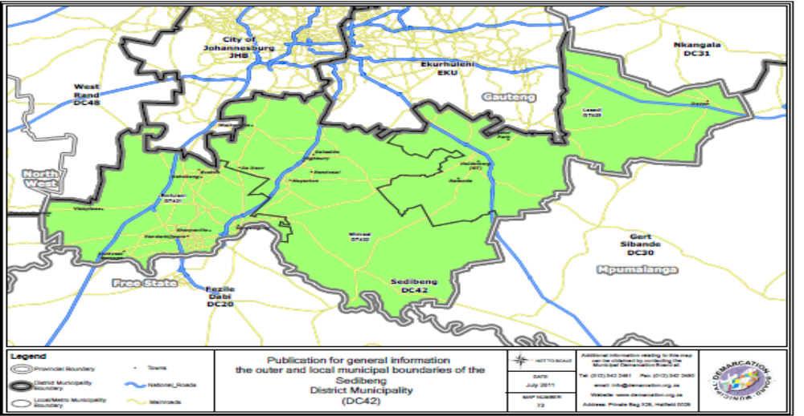
Source: Municipal Demarcation Board 2011

The district is surrounded by the following municipalities;

• City of Johannesburg to the North;
• Ekurhuleni (East Rand) to the North-East;
• Delmas Local Municipality to the East;
• Metsimaholo Local Municipality to the North of Free State
• Merafong City of North West

The eastern areas of the district are mainly agricultural or rural. The main urban areas are Vereeniging and Vanderbijlpark, as well as the Evaton / Sebokeng residential complex, are concentrated in the western part of the district, in Emfuleni. Smaller urban concentrations are found in Meyerton, in Midvaal, and in Heidelberg / Ratanda in Lesedi.

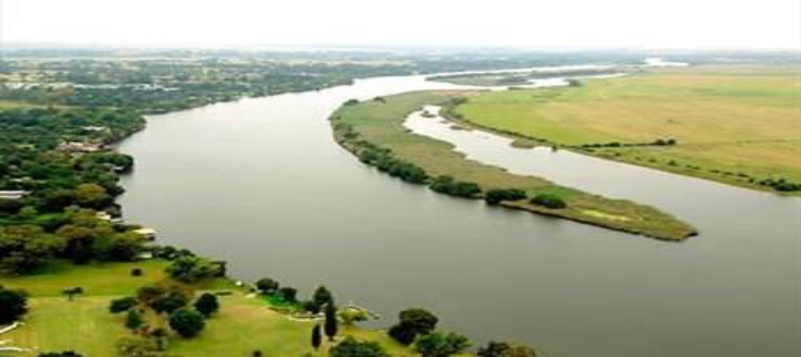

The Vaal River on the southern border of Sedibeng constitutes one of the most important sources of water in South Africa. Water from the river meets the residential, industrial and agricultural needs for much of Gauteng. The River is also a key supplier of other tributaries located in Mpumalanga, the Free State, North West and the Northern Cape. Construction of the Vaal Dam was completed in 1938 but its capacity was later extended during the 1950s.

The tourism town of Vaal Marina is located on the banks of the dam in the Midvaal Local Municipality. Development of irrigation farming, tourism and agro-processing industries are of central importance to Sedibeng, especially in the Midvaal and Lesedi municipal areas.

Health:

Health services within the District are provided by both Public and Private sector. There are three (3) public hospitals in Sedibeng District Municipality, namely Kopanong and Sebokeng Hospitals that are located in Emfuleni Local Municipality and Heidelberg Hospital which is within the Lesedi Local Municipality.

In addition to these public hospitals there are five private hospitals of which four of the hospitals are within Emfuleni and one is located in Lesedi. Based on this scenario it is evident that hospitals services are clustered in Emfuleni Local Municipality.

Primary Health Care (PHC) and Emergency Medical Services (EMS) are areas of provincial competency in terms of the Constitution and the Health ACT 61 of 2003; whilst EMS was transferred back to Province in 2012; processes are unfolding to provincialized Primary Health services.

The Primary Health Care facilities (clinics) are clustered more in urban and service centres, while the rural areas are served through the mobile units. Emfuleni sub District has twenty (20) clinics, four (4) Community Health Centres (CHC) and 4 mobile units. In Midvaal there are 5 clinics and 4 mobile units. In Lesedi there are 8 clinics and 3 mobile units.

The table below illustrates the number of health facilities in the District per sub District and the type of service rendered by the facility:

Municipality | Ward Based PHC outreach Teams | Mobiles | Satellites | Clinics | Community Day  Centres | Community Health  Centres | Hospitals | Specialized Health Centres
Emfuleni | 55 | 4 | 0 | 20 | 1 | 4 | 2 | 1
Lesedi | 14 | 3 | 0 | 8 | 0 | 0 | 1 | 0
Midvaal | 5 | 4 | 0 | 5 | 1 | 0 | 0 | 0
Sedibeng | 74 | 11 | 0 | 33 | 2 | 4 | 3 | 1

There are four (4) Maternity Obstetric Units (MOU’s) and all these are located at Emfuleni Sub District, and therefore there is a backlog of MOU’s in Lesedi and Midvaal. In light of this both Lesedi and Midvaal lack fully fledged Community Health Centres. The establishment of Ward Based PHC Outreach Teams has increased the accessibility of health services to our communities.

In recent years, the world has committed to ending the AIDS pandemic by 2030. While this world dream remains the mountain to climb; there are signs in many countries that this feat is achievable. South Africa is amongst the first countries in the world with the largest HIV and AIDS programme. This has drastically and amazingly reduced AIDS-related deaths. In the last two years, the number of people on antiretroviral drugs has increased by almost a third.

Figure 1: Statistics of Estimates of HIV+People in 2005 and 2016

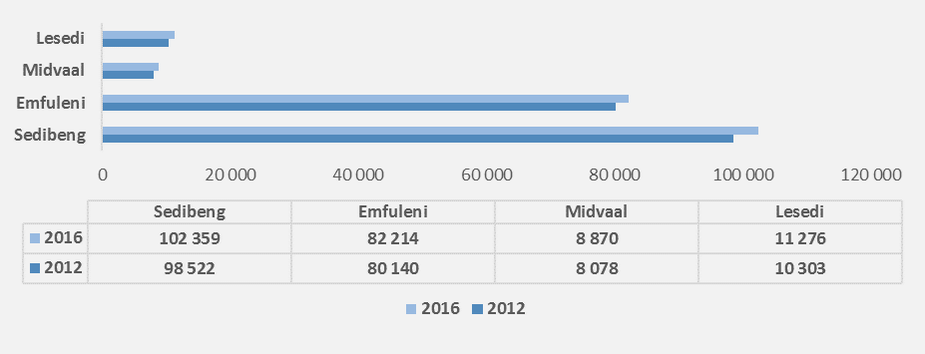

The figure above shows the estimated growth in number of people with Human Immunodeficiency Virus (HIV) in the Sedibeng region as well as the share of estimated number of HIV+ people in Sedibeng municipalities. It is not surprising that Emfuleni accounts for the largest share of HIV+ people in Sedibeng, given that Emfuleni has the highest number of population of all the two municipalities. In terms of growth in the estimated number of HIV+ people, the municipalities that account for the lowest share of Sedibeng population (Midvaal and Lesedi), seem to have experienced a relatively high growth in the number of people that are estimated to be HIV+.

Housing

The Constitution of the Republic of South Africa, supported by other pieces of legislation, places the responsibility on government to ensure that basic services are provided to the entire population within the available resources. There is statistically significant improvement in the provision of these basic services such as housing, drinkable water and sanitation. However it is of critical importance that all monitor access and quality of these services, so that the goals and targets outlined in policy documents such as the National Development Plan 2030 can be reached.

The Sedibeng District Municipality comprised of 300 000 households. This equates to an average annual growth rate of 2.34% in the number of households from 2003 to 2016. With an average annual growth rate of 1.62% in the total population, the average household size in the Sedibeng District Municipality is by implication decreasing. This is confirmed by the data where the average household size in 2003 decreased from approximately 3.4 individuals per household to 3.1 persons per household in 2016.
The growth in the number of African headed households was on average 2.83% per annum between 2003 and 2016, which translates in the number of households increasing by 60 600 in the period. Although the Coloured population group is not the biggest in size, it was however the fastest growing population group between 2003 and 2016 at 3.16%. The average annual growth rate in the number of households for all the other population groups has increased with 2.33%.

Settlement Type | Household | Population
Towns | 220 545
Subtotal | 220 545 | 916 484
Rural
Farm | 4711
Commercials | 2569
Parks and Recreation | 120
Collective Living quarters | 4906
Industrials | 1139

Education:

In South Africa during Apartheid, education systematically reinforced inequality. Education was enshrined in the constitution as a basic human right post-1994 as a critical element of transformation. Improving access to educational opportunities for the historically disadvantaged was considered key. There were marginal improvements in educational attainment between 2012 & 2016.

Table 2: Provincial, District and Local education figures from 2001 to 2016
Gauteng
 | No Schooling (%) | Growth  rate |  | Degree (%) | Growth  rate | Post Grad.  Degree (%) | Growth  rate
2001 | 5.15 |  |  | 2.22 |  | 1.17
2006 | 3.71 | -18.92 |  | 3.11 | 57.81 | 1.75 | 68.24
2011 | 2.23 | -30.83 |  | 4.21 | 55.73 | 2.11 | 38.82
2015 | 2.03 | 0.71 |  | 4.44 | 16.28 | 2.22 | 16.45
2016 | 2.02 | 1.72 |  | 4.86 | 11.84 | 2.24 | 2.79
Status quo | Slight increase in percentage of people without formal schooling |  |  | Increase in percentage of people with a degree |  | Slight increase in percentage of people with a postgraduate degree
Annual growth  from 1996-2016 |  | -2.13 |  |  | 10.98 |  | 8.98
Sedibeng DM
 | No Schooling (%) | Growth  rate |  | Degree (%) | Growth  rate | Post Grad. Degree (%) | Growth  rate
2001 | 5.96 |  |  | 1.13 |  | 0.44
2006 | 4.25 | -24.85 |  | 1.66 | 55.37 | 0.74 | 77.15
2011 | 2.63 | -32.28 |  | 2.46 | 62.05 | 1.08 | 59.78
2015 | 2.37 | -4.53 |  | 2.67 | 14.61 | 1.22 | 20.08
2016 | 2.39 | 0.80 |  | 3.00 | 12.53 | 1.27 | 4.01
Status  Quo | Increase in percentage of people without formal schooling |  |  | Increase in percentage of people with a degree |  | Increase in percentage of people with a postgraduate degree
Annual growth  from 1996-2016 |  | -2.55 |  |  | 11.24 |  | 12.68
Emfuleni LM
 | No Schooling (%) | Growth  rate |  | Degree (%) | Growth  rate | Post Grad. Degree (%) | Growth  rate
2001 | 5.47 |  |  | 1.08 |  | 0.42
2006 | 3.78 | -28.70 |  | 1.57 | 50.50 | 0.70 | 73.88
2011 | 2.30 | -35.39 |  | 2.34 | 58.39 | 1.04 | 57.70
2015 | 2.13 | -3.65 |  | 2.59 | 15.16 | 1.18 | 17.99
2016 | 2.13 | 1.10 |  | 2.90 | 12.89 | 1.22 | 4.00
Status  Quo | Increase in growth rate of people without formal schooling |  |  | Increase in percentage of people with a degree |  | Increase in percentage of people with a postgraduate degree
Annual growth  from 1996-2016 |  | -2.76 |  |  | 10.50 |  | 11.82
Midvaal LM
 | No Schooling (%) | Growth  rate |  | Degree (%) | Growth  rate | Post Grad. Degree (%) | Growth  rate
2001 | 7.11 |  |  | 1.75 |  | 0.74
2006 | 5.08 | -15.38 |  | 2.52 | 70.18 | 1.11 | 77.86
2011 | 3.14 | -25.32 |  | 3.83 | 83.65 | 1.52 | 65.49
2015 | 2.68 | -3.75 |  | 3.69 | 8.98 | 1.55 | 14.91
2016 | 2.63 | 0.56 |  | 3.99 | 10.73 | 1.55 | 2.29
Status  Quo | Increase in growth rate of people without formal schooling |  |  | Increase in percentage of people with a degree |  | Increase in growth rate of people with a postgraduate degree is decreasing
Annual growth  from 1996-2016 |  | -1.94 |  |  | 13.87 |  | 12.30
Lesedi LM
 | No Schooling (%) | Growth  rate |  | Degree (%) | Growth  rate | Post Grad. Degree (%) | Growth  rate
2001 | 9.37 |  |  | 0.99 |  | 0.36
2006 | 7.39 | -21.15 |  | 1.58 | 80.02 | 0.67 | 111.24
2011 | 4.59 | -37.93 |  | 2.04 | 59.13 | 0.91 | 69.01
2015 | 3.73 | -18.73 |  | 2.17 | 20.15 | 1.18 | 45.75
2016 | 3.63 | -2.69 |  | 2.38 | 12.62 | 1.22 | 6.25
Status  quo | Decrease in percentage of people without formal schooling |  |  | Increase in percentage of people with a degree |  | Slight increase in percentage of people with a postgraduate degree
Annual growth  from 1996-2016 |  | -1.87 |  |  | 14.39 |  | 22.60
Source: IHS Global Insight (2016)
Economic Performance of the Region

The economic performance of South Africa has been negatively affected by subdued growth in advanced and major emerging economies in 2015. The South African economy is estimated to have grown by 1.2 percent in that year, compared with 1.5 in 2014. The Gauteng province’s economy is estimated to have grown by 1.2percent also in 2015. This largely disappointing growth was mainly due to low commodity prices, weak capital flows and slow global trade.

Sedibeng unemployment rate is at 45.0%, and has been increasing ever since 2006. It is however believed that with mega projects lined up to stimulate the economy growth, more employable people will have opportunities to participate in the world of work.

It is clear from the table below that unemployment in the region continues to spiral out of control. Amongst others, contributing factors are the same as every municipality; where external and global circumstances have influence in the local economy.

Table 3: Key labour market indicators of 2006 and 2015
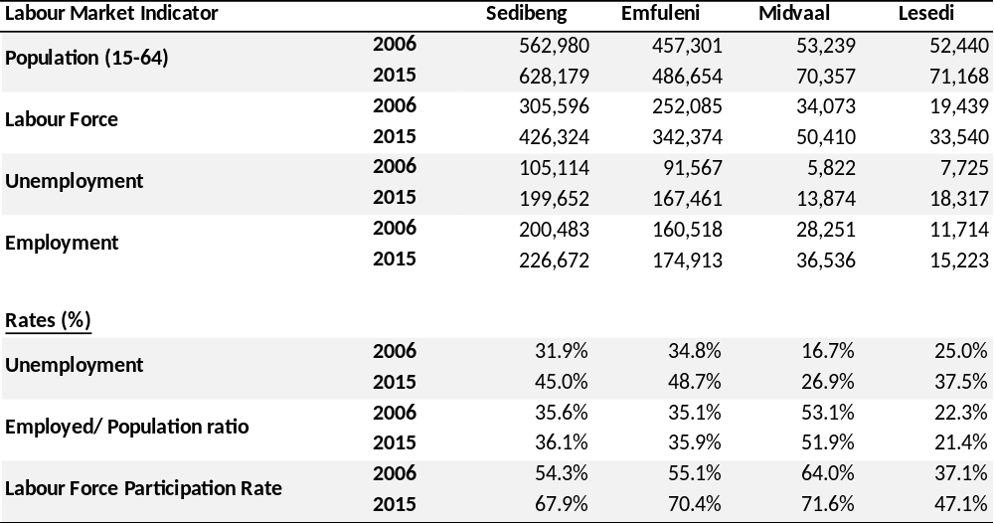
Source: IHS Global Insight (2016)
Table above also shows the labor market indicators in the Sedibeng region, for 2006 and 2015. Overall, the working-age population has increased across all Sedibeng locals. Significant increases were recorded in Emfuleni (not surprising since Emfuleni accounts for the largest share of district population) with an increase of 29 353 people, followed by Lesedi (18 728) and Midvaal (17 118).
The labour force also increased across all the municipalities. What is of a concern is the magnitude of the increase in the number of unemployed people versus the number of employed people. The larger increase in the number of unemployed people compared to the employed indicates that the region’s economy was not able to create enough jobs to absorb the majority of those entering the labour market, resulting in a relatively higher number of unemployed people. In Lesedi, only 21.4 per cent of the population was employed in 2015, whilst only 35.9 per cent in Emfuleni and 36.1 per cent in Sedibeng as a whole. High unemployment poses a challenge in the district as it has a direct impact on the district’s socio-economic development.
Development Indicators
The section analyses the following as measures of the level of development in the district: Human Development Index, the Gini coefficient, which is the measure of inequality, number of people below the food poverty line, the percentage of people living in poverty.
Human Development Index:

The Human Development Index (HDI) is a composite, relative index that attempts to quantify the extent of human development of a community. It is based on measures of life expectancy, literacy and income. It is thus seen as a measure of people’s ability to live a long and healthy life, to communicate, to participate in the life of the community and to have sufficient resources to obtain a decent living. The HDI can assume a maximum level of 1, indicating a high level of human development, and a minimum value of 0, indicating no human development.
Figure 2: Poverty and HDI in 2016
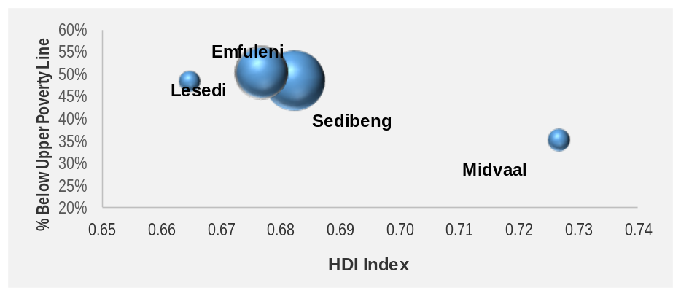
Source: IHS Markit, 2017
Note: The bubble size shows the Per Capita Income

Figure shows the link between poverty and the HDI for the Sedibeng district and its local municipalities. Although there is a negative relationship between the two indicators, Midvaal has the highest level of development and the smallest share of the population living below the upper poverty line.

Figure 3: HDI and Per Capita Income in 2016
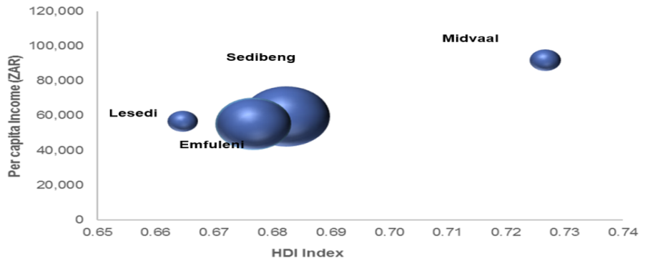
Source: IHS Markit, 2017, Note
Note: The size of the bubble indicates GDP-R of the regions.
The Figure above shows the link between the HDI and the per capita income for Sedibeng and its regions. It indicates that high levels of development are associated with high per capita income. Midvaal had the highest HDI at 0.71 as well as the highest per capita income at R89 thousand in 2015, while Emfuleni had the lowest per capita income at R47 thousand and the HDI level of 0.66. Lesedi’s income per capita was at R49 thousand and an HDI level of 0.65 for the same period.

Figure 4: Gini Coefficient in 2012 & 2016
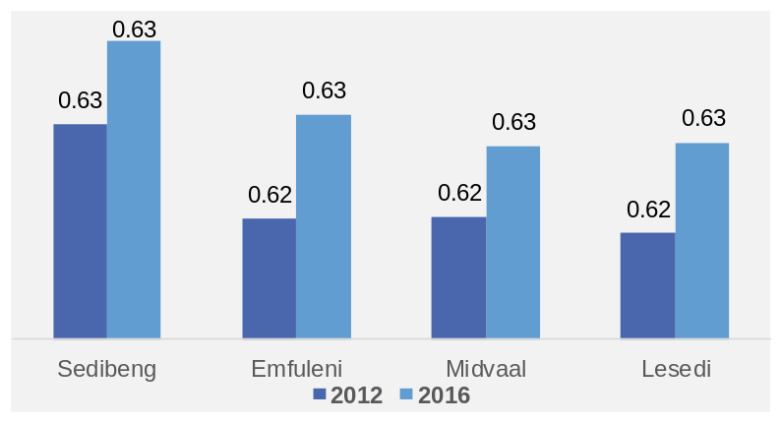
Source: IHS Markit, 2017

Figure indicates the level of income inequality as measured by the Gini coefficient for Sedibeng and its locals. The figure shows there have not been any significant changes in the Gini coefficient in the Sedibeng region. In fact, it is worrying that over the past 10 years; only little progress has been made in reducing income inequality levels in the region. It is hoped that Gauteng’s specific initiatives to reduce the levels of inequality, including the township economic revitalization and infrastructure investment, will accelerate the pace of reducing income inequality.

    - MUNICIPAL FUNCTIONS:

Section 155 of Constitution of the Republic of South Africa, Act 108 of 1996 establishes Sedibeng District Municipality, as a category C municipality and must provide the following powers and functions, as dictated by Section 84 (1) of the Municipal Structures Act, 117 of 1998:

- Integrated development planning for the district municipality as a whole, including a framework for integrated development plans of all municipalities in the area of the district municipality.
- Potable water supply systems.
- Bulk supply of electricity, which includes for the purposes of such supply, the transmission, distribution and, where applicable, the generation of electricity.
- Domestic waste-water and sewage disposal systems.
- Solid waste disposal sites, in so far as it relates to –

- The determination of a waste disposal strategy;
- The regulation of waste disposal; and
- The establishment, operation and control of waste disposal sites, bulk waste transfer facilities and waste disposal facilities for more than one local municipality in the district.
- Municipal roads which form an integral part of a road transport system for the area of the district municipality as a whole.
- Regulation of passenger transport services.
- Municipal airports serving the area of the district municipality as a whole.
- Municipal health services.
- Firefighting services serving the area of the district municipality as a whole, which includes-

- Planning, co-ordination and regulation of fire services;
- Specialised firefighting services such as mountain, veld and chemical fire services;
- Co-ordination of the standardisation of infrastructure, vehicles, equipment and procedures;
- Training of fire officers

- The establishment conduct and control of fresh produce markets and abattoirs serving the area of a major proportion of the municipalities in the district
- The establishment conduct and control of cemeteries and crematoria serving the area of a major proportion of municipalities in the district
- Promotion of local tourism for the area of the district municipality.
- Municipal public works relating to any of the above functions or any other functions assigned to the district municipality.
- The receipt, allocation and, if applicable, the distribution of grants made to the district municipality.
- The imposition and collection of taxes, levies and duties as related to the above functions or as may be assigned to the district municipality in terms.

However, the following functions were adjusted by the MEC for Local Government to be performed by the Local Municipalities:
- Bulk supply of electricity, which includes for the purposes of such supply, the transmission, distribution and where applicable, the generation of electricity.
- Domestic waste-water and sewage disposal systems.
- Solid waste disposal sites, in so far as it relates to-
(i) The determination of a waste disposal strategy;
(ii) The regulation of waste disposal; and
(iii)The establishment, operation and control of waste disposal sites, bulk waste transfer facilities and waste disposal facilities for more than one local municipality in the district.
- Municipal roads which form an integral part of a road transport system for the area of the district Municipality as a whole.
- Firefighting services serving the area of the district municipality as a whole, which includes-
(i) Planning, co-ordination and regulation of fire services
(ii) Specialised firefighting services such as mountain, veld and chemical fire services;
(iii)Co-ordination of the standardisation of infrastructure, vehicles, equipment and procedures;
(iv)Training of fire officers.

The establishment, conduct and control of cemeteries and crematoria serving the area of a major proportion of municipalities in the district.
- Municipal public works relating to any of the above functions or any other functions assigned to the district municipality.
- The imposition and collection of taxes, levies and duties as related to the above functions or as may be assigned to the district municipality in terms of national legislation.

    - SEDIBENG POPULATION PROFILE

The total population of the District is 959 955. Lesedi has a population of 111 558, Midvaal 107 430 and Emfuleni 740 967. Source: (Stats SA, 2011). The population density of the District as a whole is 198 people per km². It is clear from the stats that 8 out of every 10 people in Sedibeng live in Emfuleni and the vast majority (more than 700 000 people) live in the black township areas (especially Sebokeng and Evaton). In terms of IHS Global Insight, 2016, the population structure of the Sedibeng region (including its local municipalities) has change notably between 2005 and 2015.

Figure 5: Population Pyramid

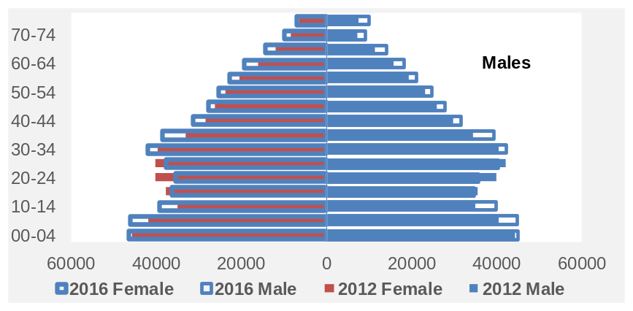

The Figure above shows the population pyramid of the Sedibeng region by gender for 2012 and 2016. The region has a population bulge between 15 and 64 years of age, which is part of the working age population. However, it has another bulge from 0 to 9 years old, indicating that supporting children is a significant factor for the average working-age person in the region. The region’s population grew at an average of 1.4 per cent between 2012 and 2016. In the two review years, there were more males than females in the district municipality

For the district overall, female population has declined quite notable across all age cohorts (except 15-19, 20-24, and 25-29 age cohorts) between 2005 and 2016, whilst the same male population age cohorts have increased during the same period. Comparing local municipalities, Emfuleni was the only municipalities with declines in population, particularly for 15-19 and 20-24 age cohorts. In Midvaal and Lesedi, population increased between 2005 and 2016, for all age cohorts. Overall, the Sedibeng region has a youth population bulge and comprises of those between15 and 64 years of age which are part of the working age population.

Below are summary of the status quo of the population situation in Gauteng and the Sedibeng region between 1996 and 2016.

Table 4: Provincial, District and Local population figures
Year | Gauteng |  | Sedibeng |  | Emfuleni |  | Midvaal |  | Lesedi
Year | Population | Population growth rate | Population | Population growth rate | Population | Population growth rate | Population | Population growth rate | Population | Population growth rate
1996 | 8 139 176 |  | 746 676 |  | 623 136 |  | 57 359 |  | 66 181
1997 | 8 351 962 | 2.61 | 752 447 | 0.77 | 627 613 | 0.72 | 58 487 | 1.97 | 66 347 | 0.25
1998 | 8 566 079 | 2.56 | 758 588 | 0.82 | 632 022 | 0.70 | 59 827 | 2.29 | 66 739 | 0.59
1999 | 8 771 354 | 2.40 | 764 209 | 0.74 | 635 589 | 0.56 | 61 340 | 2.53 | 67 280 | 0.81
2000 | 8 975 132 | 2.32 | 769 883 | 0.74 | 638 835 | 0.51 | 63 031 | 2.76 | 68 017 | 1.10
2001 | 9 189 869 | 2.39 | 776 441 | 0.85 | 642 448 | 0.57 | 64 962 | 3.06 | 69 031 | 1.49
2002 | 9 408 139 | 2.38 | 783 517 | 0.91 | 646 149 | 0.58 | 67 068 | 3.24 | 70 300 | 1.84
2003 | 9 626 243 | 2.32 | 790 753 | 0.92 | 649 676 | 0.55 | 69 277 | 3.29 | 71 799 | 2.13
2004 | 9 857 202 | 2.40 | 799 066 | 1.05 | 653 780 | 0.63 | 71 677 | 3.46 | 73 610 | 2.52
2005 | 10 101 566 | 2.48 | 808 499 | 1.18 | 658 516 | 0.72 | 74 239 | 3.58 | 75 744 | 2.90
2006 | 10 348 748 | 2.45 | 818 410 | 1.23 | 663 306 | 0.73 | 76 910 | 3.60 | 78 193 | 3.23
2007 | 10 628 223 | 2.70 | 832 076 | 1.67 | 670 692 | 1.11 | 79 900 | 3.89 | 81 485 | 4.21
2008 | 10 903 317 | 2.59 | 845 966 | 1.67 | 677 909 | 1.08 | 82 915 | 3.77 | 85 141 | 4.49
2009 | 11 214 648 | 2.86 | 861 891 | 1.88 | 686 747 | 1.30 | 86 092 | 3.83 | 89 052 | 4.59
2010 | 11 555 339 | 3.04 | 878 112 | 1.88 | 695 879 | 1.33 | 89 419 | 3.86 | 92 813 | 4.22
2011 | 11 907 709 | 3.05 | 893 603 | 1.76 | 704 382 | 1.22 | 92 839 | 3.82 | 96 382 | 3.84
2012 | 12 250 534 | 2.88 | 908 025 | 1.61 | 712 064 | 1.09 | 96 185 | 3.60 | 99 775 | 3.52
2013 | 12 574 211 | 2.64 | 921 802 | 1.52 | 719 504 | 1.04 | 99 311 | 3.25 | 102 987 | 3.22
2014 | 12 874 997 | 2.39 | 934 707 | 1.40 | 726 516 | 0.97 | 102 201 | 2.91 | 105 990 | 2.92
2015 | 13 151 268 | 2.15 | 946 817 | 1.30 | 733 176 | 0.92 | 104 858 | 2.60 | 108 783 | 2.64
2016 | 13 427 665 | 2.10 | 959 955 | 1.39 | 740 967 | 1.06 | 107 430 | 2.45 | 111 558 | 2.55
Status quo | Increase in population to over 13 million people in the last two years. | Annual growth rate from 1996-2016: 3.25% | Population also increasing significantly during past 6 years. | Annual growth rate from 1996-2016: 1.43% | Population increased with 14 451 people in the last 3 years. | Annual growth rate from 1996-2016: 0.95% | Population increase with over 30 000 people in the last 10 years. | Annual growth rate from 1996-2016: 4.36% | Population also continuously increasing. | Annual growth rate from 1996-2016: 3.43%
Source: IHS Global Insight (2016)

Figure 6: Total population of the Sedibeng District and its locals
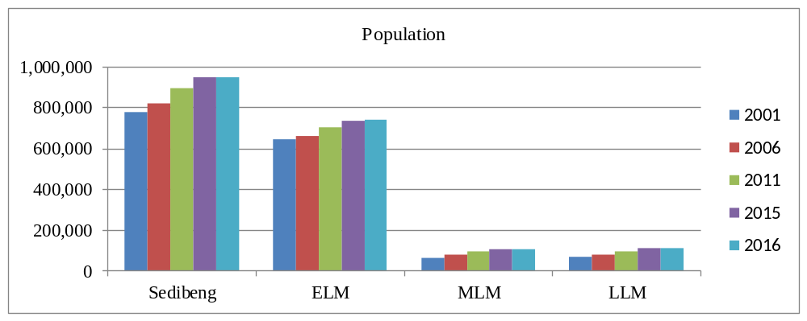
Source: IHS Global Insight (2016)
Figures 6 above evidently shows that all of the region’s population have increased year on year. Emfuleni Local Municipality boasts the largest population and is thus the largest contributor to Sedibeng’s population. Midvaal Local Municipality has experienced the largest annual growth rate, at over 4%. Therefore, policies should aim at addressing rapid population growth together with determining how limited resources could be efficiently distributed in the region.
Figure 7: Population Shares in 2012 & 2016

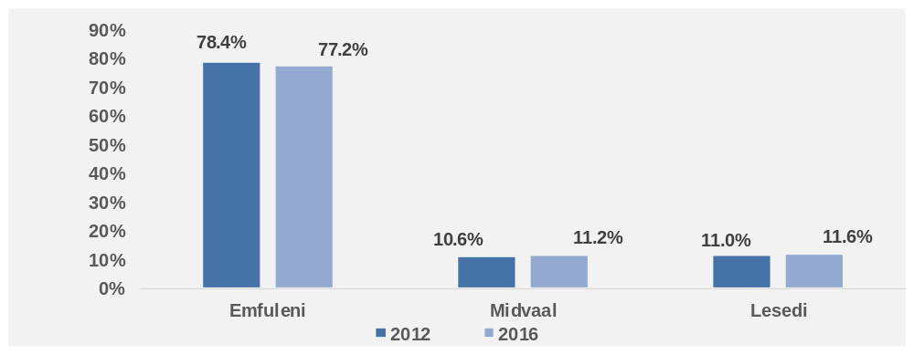
Source: IHS Markit, 2017

Figure 7 above shows the local municipalities’ share of the total regional population for 2012 and 2016. Although the share of population has declined between 2005 and 2015, Emfuleni accounted for the highest proportion of Sedibeng population, at over 70 % in 2015. In Midvaal and Lesedi, the share of population rose by over 1.5% between 2005 and 2015.

The population density of Emfuleni is the highest in the District at 565 people per km², with Midvaal’s population density at only 41 people per km² and Lesedi with 95.5 people per km². Approximately 78.7% of the District population resides in Emfuleni, with Lesedi having only 10.9% and Midvaal 10.4% of the population of the District.
Internal Migration:

Migration is, in many ways a response to structural disequilibrium between and within sectors of the economy; and much pressure for migration is created by deepening and widening inequality in income and opportunities within the country.

Historical patterns of migration into Sedibeng District, in the main, came from Free State; as the District was used as the first stop into Gauteng. Major migration into the District comes primarily from farm dwellers and poor people from rural areas, who migrate primarily because of economic prospects of urban areas. This is done in an endeavor to seek better opportunities, especially jobs, better wages, improved amenities, housing as well as security of tenure. The current trends of migration show that the majority of people coming to this District are young people who come due to the following opportunities.

- To further their studies at institutions of higher learning i.e. North West University Vaal Campus, Vaal University of Technology, and Sedibeng College as well as other independent or private institutions.
- Employment opportunities in the areas of Emfuleni, Midvaal and Lesedi, especially in the manufacturing sector.

The influx of students into Sedibeng District Municipality has had a positive impact in the regional and provincial economy. The national trends indicate that after successful completion or even drop out of their studies, students hardly return to their respective homes but seek jobs in that area. The large number of migration in Sedibeng are moving into local townships, especially in Emfuleni and other areas of Midvaal because they offer the promise for access to housing and services as well as easier ties with the areas of their origin.

    - ENVIRONMENTAL OVERVIEW

Environmental quality has been an ongoing concern in the Sedibeng Region for a number of years. The Growth and Development Strategy through the pillar of “Reviving Our Environment” gives the region the means to comprehensively address this issue and ensures that its citizens live in an environment that supports a positive quality of life for them, their children and future generations. Sedibeng has identified awareness as a key intervention to assist communities to understand issues around the environment.

Water Pollution:

Sedibeng is faced with serious water pollution challenges in its river systems and water bodies, notably the Kliprivier and Blesbokspruit which are polluted from runoffs from industrial areas, townships and waste water treatment works. The Kliprivier is one of the most polluted rivers in the Sedibeng District. This is as a result of mining and industrial activities in the upper catchments, outside the borders of the Sedibeng. Sedibeng’s surface and ground water quality is influenced by activities within and beyond the boundaries of Sedibeng. External pressures, emanating from mining and industrial activities on the West Rand (Roodepoort and Randfontein) and East Rand (Germiston, Boksburg, Brakpan and Springs), are major contributing factors to the current state of surface and ground water quality in Sedibeng.

The largest internal pressures are limited to the industrialized and urban areas in Emfuleni, including Meyerton, Vanderbijlpark and Vereeniging. Rural areas in Midvaal and Lesedi, where agricultural activities dominate, have a lesser, but nonetheless important influence on the surface and ground water quality. Heidelberg and Devon, which are the main urban areas of Lesedi, also contribute to surface and groundwater deterioration through urban associated pollution.

Waste:

Sedibeng’s history with regards to waste management is not that different to the South African situation in general. The issue of waste as with most locals, provincial and national departments has many facets including economical, physical and social. Waste management has traditionally taken place on an ad-hoc basis to meet the current needs, with very little foresight into the future needs of an ever increasing population.

Identification of landfill sites has generally taken the form of unplanned site location with little or no thought of design to reduce potential impacts to the environment, neighbouring communities, etc. With the development of the minimum requirements by the Department of Water Affairs and Forestry (DWAF) for waste disposal by landfill, the identification of landfill sites now take a much more pro-active approach in reducing further negative consequences related to activities such as planning and design.

Local authorities in Sedibeng have indicated that they have neither sufficient funding nor adequate trained staff to effectively plan and execute their waste management functions in a sustainable manner. Communities have also not been involved in the identification of the landfills, which has resulted in community resistance and/or limited support. The level of services varies from area to area, and in particular the previously disadvantaged areas have been left without proper waste management services.

The Sedibeng District’s Integrated Waste Management Plan was approved by the Province for inclusion in the IDP as per the Waste Act, in November 2014; and the implementation thereof will assist in achieving the National Waste Management Strategy’s goals which are as follows;

▪ Promote waste minimization, reuse, recycle and recovery
▪ Ensure the effective and efficient waste services
▪ Grow the contribution of the waste sector to the green economy
▪ Ensure that people are aware of the impact of waste on their health, well-being and environment
▪ Achieve waste management planning
▪ Ensure sound budgeting and financial management of waste services
▪ Provide measures to remediate contaminated land; and
▪ Establish effective compliance with the enforced Waste Act

Air Quality:

Air quality is affected by the climate, the landscape, natural and economic activities that take place in an area. There are different sources of Air pollution: emissions from industrial processes, domestic fuel burning, vehicle exhaust emissions and waste facilities. Sedibeng District Municipality is regarded as one of the most polluted municipality because of the level of industrialization in the areas within the Emfuleni Local Municipality and Midvaal Local Municipality.

Emfuleni Local Municipality and Midvaal Local Municipality have been declared as part of the first national priority area in Vaal Air-shed Priority Area; because of the elevated level of pollution within the area. Lesedi local Municipality is also included in the second declared priority areas i.e. the Highveld Priority Area which includes areas in Mpumalanga and Ekurhuleni. Particulate matter has been identified as a pollutant of concern within the region and the major contributors for particulate matter (PM10) is both industrial sources and domestic sources especially in winter.

In an attempt to improve the quality of air in the region, Sedibeng is participating fully in both priority area Air-shed implementation forum that seeks to ensure the implementation of projects that are identified in the priority area plans (Vaal Triangle Air-shed Priority Area and Highveld Priority Area Air Quality Management Plan).

The plans have been adopted by Sedibeng District Municipality as the region’s Air Quality Management plan in order to inform the management of air quality within the region. The objectives of the priority area plans are the same as the district objectives that of achieving clean air for the residents of the region.

Sedibeng District Municipality has, as of the 1st April 2010 been delegated the function of an Atmospheric Emission licensing authority, in terms of the Air Quality Act 39 of 2004.The licensing authority functions involves the licensing of listed industrial activities. The licensing of industrial activities is identified as an important function of the municipality towards regulating emissions and ensuring atmospheric emission control.

The municipality is currently having a number of challenges with regard to availability of both human and financial resources to efficiently execute the function of air quality management. The lack of/or insufficiency of these minimum resources results in the district not being able to implement programmes that are directed at reducing air pollution within the region.

Despite the number of challenges to date, the municipality has managed to issue a number of licenses to industries in the region. The licensing of industries has been identified as a critical mechanism of ensuring that industries are regulated and emissions improved. The focus is rather not on issuing licenses only, but together with the local municipalities and with the support from province compliance monitoring exercises are conducted in the region.

The Sedibeng District Municipality has two Ambient Air Quality Monitoring Stations which are operational, form where the raw data collated from both stations is forwarded to SAQIS for verification. They are:

• Meyerton Ambient Air Quality Monitoring Station
• Vanderbijlpark Ambient Air Quality Monitoring Station

.

SERVICE DELIVERY OVERVIEW

Constitutional provisions do not give Sedibeng as a District Municipality, powers to provide basic services. Although the District supports and coordinates the provision of such in Local Municipalities; there are direct services mandated by legislation, which the Municipality provides. These include the following as outlined below:

- Air quality Management

This service is being incrementally expanded. Air Quality monitoring stations operated by SDM are functional. Data is also obtained from other monitoring stations that are run by National Government. The District issues licenses to industries and as soon as tariffs are set for these licenses, the income generated is used for improved monitoring of air quality.

- Driver Licensing Testing Centres (DLTC’s)

The service is functional. Ageing infrastructure has hampered operations and services from being delivered at an optimal level. Allegations of fraud and corruption remain a major challenge at all DLTC’s. During the year under review a joint operations unit has been established between the GDRT and SDM to coordinate antifraud and corruption measures and to deal with violations. Misconduct cases have been dealt with by province and the municipality.

- Motor Vehicle Registration and Licensing

The service is functional and several new and innovative ideas have been proposed and implemented to improve services to the public. Plans are well underway to extend these services in Township areas.

- Public Halls (Vereeniging City Hall)

Although not generating revenues as expected, the Vereeniging City Hall remains the most used public hall in the District and is fully utilised by the public for a variety of events and functions. The comparative low rates charged for the hiring of the City Hall (and adjoining Banqueting Hall) make it accessible to the public, but also inhibits capital investment in the development thereof. There is a move to relook at the Civic Theatre Strategy to stimulate revenue.

- Theatres (Mphatlalatsane and Vereeniging Civic Theatres)

Even though Mphatlalatsane Theatre was meant to be a multi-purpose facility for the Sebokeng Community; however, that facility has deteriorated rapidly. The Vereeniging Civic Theatre is functional but also under-utilized by the arts community; and also underperforming in relation to its income potential.

- Aerodromes

The Vereeniging and Heidelberg Aerodromes are functional. For the period under review, the Vereeniging Aerodrome has continued to improve its services and supply of fuel, general maintenance and usage that stabilised. The municipality is in the process of calling for expression of interest; to implement the Airport Strategy.

The Heidelberg aerodrome is primarily operated by the local flying club and a pilot training school is also based at the facility. An Agency agreement has been entered into between Sedibeng and Lesedi Local Municipality. A former landing strip in Vanderbijlpark has been deregistered as it ran alongside a residential community and was therefore unsuitable for use; moreover there were developments earmarked for the area.

- Disaster Relief

The service is fully functional. However, the district only has capacity to provide very limited and small scale, emergency relief for incidents of natural disaster and mishaps. Disaster Relief is intended for short-term interventions, however, due to a lack of relevant transfer of incidents to relevant authorities, the District was being burdened with having to provide long-term solutions (e.g. emergency drinkable water in Midvaal). In the event of a large scale disaster, the District is fully dependent on the support of Provincial and National programmes.

- Heritage Centres (Vaal Teknorama, Sharpeville Monument)

The former Transport Museum in Lesedi has been decommissioned and the facility returned to the Lesedi Local Municipality. The Vaal Teknorama is fully functional and still attracts a steady flow of visitors (especially schools). The facility is deteriorating rapidly due to a lack of maintenance as a result of financial constraint. The Sharpeville Heritage precinct is functional. The ‘handover’ of the Boipatong Memorial Site to our portfolio has been delayed, and this has revealed procedural weaknesses in the ‘handover’ process of facilities from provincial to Local Government.

- Taxi ranks

The non-usage of the Bophelong Intermodal hub remains a pressing challenge for the Municipality. The SDM does maintenance and cleaning of Taxi ranks across the District; but most are not owned by the SDM, and the overlap on infrastructure maintenance and cleansing has led to many of the taxi ranks being inadequately maintained. Progress of the redevelopment of the Vereeniging Taxido Junction has picked up recently and needs to be speeded up by the Provincial Government.

Core Support Functions:

- Support to Local Municipalities

The Sedibeng District continues to support the local municipalities, wherever possible, and is willing to avail, in the midst of the district financial inadequacy, only human Capital. The shrinking Capital Budget of the District has seen diminishing support in capital projects.

- Facilitating Role between spheres of government

The Sedibeng District facilitated a number of projects that were implemented in communities. These include the NDPG (Neighborhood Development Partnership Grant) projects, Alien Vegetation Project, Lotto Sports, Facilities Development Project and Fabrication Lab Project.

- Facilitating Development

This remains one of the key areas that the District plays and essential role in. Both in the areas of economic and social developments, the District has stimulated investment and facilitated development, including development interventions such as Savanah City, the R82 road, the R59 corridor, The Zone of Opportunity, Barrage infill development are all examples of ‘services’ that the District delivered and that communities indirectly benefited from.

- Performance Management System and Overview of Performance:

The municipality has a Performance Management Unit which is responsible for coordinating the Performance Management of the municipality. With the staff challenges the municipality is managing to ensure that on quarterly basis, performance is reported, evaluated and is verified by internal audit unit. This also plays a key role in ensuring that the performance of the senior management is evaluated.

The municipality is still planning to ensure that performance management is cascaded down to the lower levels employees. The review of the Performance Management Policy is pending and is being prioritized in order to enable the cascading of the Performance Management System of the municipality.

FINANCIAL HEALTH OVERVIEW
For the financial year ending 30 June 2018, the municipality’s total liabilities (R190 million) exceeded the municipality’s total assets (R189 million); and the municipality has moved from a positive (surplus) position in the prior year to a deficit net worth position (R643,403). This places the municipality in an unattractive standing on the open investment market.
The municipality further declares an operating deficit of R32 million where the total revenue of R358 million was insufficient to meet the operational expenditure of R 390 million for the financial year ending 30 June 2018. This is primarily attributed to the municipality’s limited ability to grow and raise revenue from rendering of municipal functions as assigned, as well as from the disproportionate staff structure, which is the primary operating cost of the municipality.

Financial Overview: Year 0
 |  |  | R' 000
Details | Original budget | Adjustment Budget | Actual
Income:
Grants | 268 290 | 271 717 | 269 415
Taxes, Levies and tariffs | 3 620 | 4 286 | 4 105
Other | 92 277 | 90 659 | 84 573
Sub Total | 364 187 | 366 662 | 358 094
Less: Expenditure | 385 423 | 388 559 | 447 444
Net Total* | (21 236) | (21 896) | (89 351)
* Note: surplus/(deficit) |  |  | T 1.4.2

Operating Ratios
Detail | %
Employee Cost | 75%
Repairs & Maintenance | 2%
Finance Charges & Impairment | 16%
 | T 1.4.3

COMMENT ON OPERATING RATIOS:

The Municipality’s employee cost is much higher than the expected percentage and therefore resulted in the reduction in repairs and maintenance cost and general expenses in order to compensate for the employee cost, while the impairment cost is the main driver towards a higher than expected level; with a contribution towards bad debts for the Emfuleni Local Municipality arrear account.

Total Capital Expenditure: Year -2 to Year 0
 |  |  | R'000
Detail | 2015/16 | 2016/17 | 2017/18
Original Budget | 13 616 | 20 820 | 6 000
Adjustment Budget | 9 951 | 9 471 | 5 350
Actual | 9 033 | 5 300 | 3 126
 |  | T 1.4.4

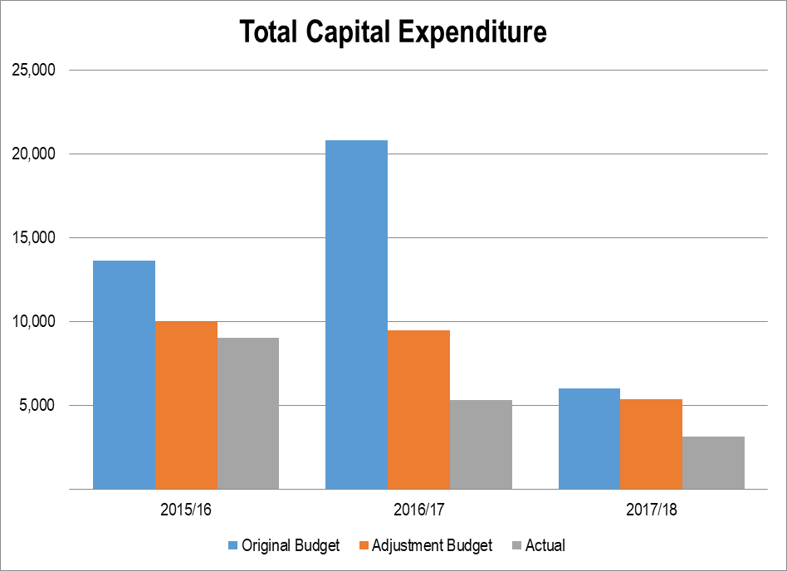

COMMENT ON CAPITAL EXPENDITURE:

Based on the current powers and functions, the District Municipality is not capital intensive. The lower than expected capital spending is due to the SOLAR system upgrade which is finalized in the 2018/19 financial year

ORGANISATIONAL DEVELOPMENT OVERVIEW

The Human Capital of Sedibeng District Municipality comprises of 662 appointed employees, Elected Councillors and appointed community members serving on ad-hoc committees. Section 67 of the Municipal Systems Act requires municipalities to develop and adopt appropriate systems and procedures to ensure fair; efficient; effective; and transparent personnel administration in accordance with the Employment Equity Act 1998. In an effort to mainstream systems, processes and procedures, the municipality employed the following:
- All Section 57 Managers except the position of the Chief Financial Officer.
- Based on the changing circumstances and the world of work emerging trends, some new policies were developed while existing ones were reviewed and all were tabled at various council forums for noting and approval.
- Based on gathered individual Personal Development Plans, in line with individual job description; a Workplace Skills plan was reviewed; as attached in the report.
- The municipality introduced the electronic clocking system and is implementing effective electronic leave management system. In the coming financial year, the systems will effectively feed to finance to ensure correct leave credits and that employees are accounted for.
- Employees Assistance Programme; through employees’ roadshows and workshops, empowered employees on socio-economic programmes as well as work-related enhancement programmes.
- The appointment of an Occupational Health and Safety Officer in the past few years has assisted and stabilised workplace related injuries and accident. For the period under review, there were no fatalities emanating from work-related accidents.
- Participation by employees on Employee Equity Programme has ensured that all recruitment and selection processes were done fairly, presenting all employees with an opportunity to be part of the broader team of Sedibeng.
- The Local Labour Forum is fully functional and issues are resolved at that level; hence for the period under review there has never been a protest by employees. There is a harmonious working relation between management, employees and unions; and this has ensured effective service delivery and improved staff morale.
- In line with the TASK systems, the municipality is in the process of finalizing Job descriptions and Evaluation.
- However, financial constraints invariably delay human development for career-pathing, individual development and talent searching and succession plans.

AUDITOR GENERAL REPORT

AUDITOR GENERAL REPORT: YEAR 0 (CURRENT YEAR)
The municipality has receive an unqualified audit opinion on the financial statements with emphasis of matters. The main concern is the municipality's current financial status (Liquidity). Note that the full audit report is contained in chapter 6 of the Annual Report

STATUTORY ANNUAL REPORT PROCESS

No. | Activity | Timeframe
1 | Consideration of next financial year’s Budget and IDP process plan. Except for the legislative content, the process plan should confirm in-year reporting formats to ensure that reporting and monitoring feeds seamlessly into the Annual Report process at the end of the Budget/IDP implementation period | July
2 | Implementation and monitoring of approved Budget and IDP commences (In-year financial reporting). | July
3 | Finalise the 4th quarter Report for previous financial year | July
4 | Submit draft year 0 Annual Report to Internal Audit and Auditor-General | July
5 | Municipal entities submit draft annual reports to MM | July
6 | Audit/Performance committee considers draft Annual Report of municipality and entities (where relevant) | August
8 | Mayor tables the unaudited Annual Report | August
9 | Municipality submits draft Annual Report including consolidated annual financial statements and performance report to Auditor General | August
10 | Annual Performance Report as submitted to Auditor General to be provided as input to the IDP Analysis Phase | August
11 | Auditor General audits Annual Report including consolidated Annual Financial Statements and Performance data | September - October
12 | Municipalities receive and start to address the Auditor General’s comments | November
13 | Mayor tables Annual Report and audited Financial Statements to Council complete with the Auditor- General’s Report | November
14 | Audited Annual Report is made public and representation is invited | November
15 | Oversight Committee assesses Annual Report | November
16 | Council adopts Oversight report | December
17 | Oversight report is made public | December
18 | Oversight report is submitted to relevant provincial councils | December
19 | Commencement of draft Budget/ IDP finalisation for next financial year. Annual Report and Oversight Reports to be used as input | January
T 1.7.1

CHAPTER 2 - GOVERNANCE

COMPONENT A: POLITICAL AND ADMINISTRATIVE GOVERNANCE

The relationships of all structures of government are regulated by, firstly in the Constitution of the Republic of South Africa (1996) and secondly by primary legislation governing local government, namely:

• The Local Government: Municipal Structures Act, 1998.
• The Local Government: Municipal Systems Act, 2000
• The Local Government: Municipal Finance Management Act, 2003
• The Local Government Electoral Act, 27 of 2000
• The Local Government: Municipal Demarcation Act, 27 of 1998
• The Local Government: Municipal Property Rates Act, 6 of 2000

On the 3rd of August 2016, South Africa conducted Local Government Elections. Emanating from this process, there were changes in the municipality; where new Councillors were ushered in Council. Subsequently Sedibeng Council was established on the 18th of August 2016 led by African National Congress; with new political parties constituting Sedibeng Council.

In addition to the Democratic Alliance, the following parties also became members of Sedibeng Council, namely, Economic Freedom Fighters (EFF), Freedom Front +, Plus and African Independent Congress (AIC); while Pan Africanist Congress (PAC) were notably absent as they did not receive sufficient votes. Sedibeng Council consists of 49 Councillors arranged as follows:

▪ Twenty (20) Proportional representatives, 29 seconded Councillors (23 seconded from Emfuleni Local Municipality, 3
Midvaal Local Municipality, 03 Lesedi Local Municipality)

Table: Political Parties representation in Sedibeng

Political Parties | Number of Representatives
ANC | 26 Councillors
DA | 15 Councillors
EFF | 5 Councillors
AIC | 1Councillor
VFP | 1 Councillor
Freedom Front + | 1 Councillor

Refer to Appendix A for a full list of Councillors (including committee allocations and attendance at council meetings). Committees of Council established according to Local Government Structures Act of 1998, Section 33 are as follows:

• Elections Committee
• Ethics Committee
• Rules Committee
• Gender Committee
• Municipal Public Accounts Committee
• Petitions Management Committee

Effective corporate governance is a central focus that distinguishes Sedibeng District Municipality from other municipalities. The District Municipality has established important committees to encourage compliance with all legislation and to enhance ethical consideration by all its employees and Councillors. The Risk Management Committee identifies all risks and oversees processes in managing and mitigation.

All Supply Chain Management Bid Committees operational, i.e. Bid Specification Committee, Bid Evaluation Committee and Bid Adjudication Committee. An Audit Committee is also established and hosts quarterly meetings and special meetings, should the need arise. These committees of Council deal with all audits of the municipality, performance issues, risk management, and provide advice and report to Sedibeng District Council.

The municipality ensures constant communication with its stakeholders by continuously uploading information on its website. Such information is related to compliance, financial, performance and general information; and some matters on service delivery in the region.

POLITICAL GOVERNANCE:

The Sedibeng District Municipality has an effective governance structure, both political and administrative. The Municipality is led by the Executive Mayor, with the support of the efficient members of the Mayoral Committee (MAYCO), and Councillors. Hereunder is a narrative relating to political structures of the municipality.

Political Structures and Functions:

Political Head | Functions
Executive Mayor:  Cllr. Busisiwe Joyce Modisakeng | - Presides as the Chair in the Mayoral Committee Meetings.  - Recommends to the municipal council strategies, programmes and services to address priority needs through the IDP, and the estimates of revenue and expenditure, taking into account any applicable national and provincial development plans
Speaker of Council:  Cllr. Melina Gomba | - Chairs Council meetings, and advice on major legislative compliance issues  - Coordinates public participation in line with legislation
Chief Whip of Council:  Cllr. Assistance Mshudulu | - Oversee that roles and responsibilities of Councillors are implemented, thus provide full political councillors support.  - Oversee that political mandate and policies are implemented by Councillors  - Chairing of Caucus and Whippery meetings
MEMBERS OF MAYORAL COMMITTEE
Name | Portfolio Committee
Councillor S. Maphalla | - Administration
Councillor P.B. Tsotetsi | - Finance
Councillor Y. Mahomed | - Sport, Recreation, Arts, Culture and Heritage
Councillor Z. Raikane | - Health and Social Development
Councillor M. Kgomoeasera | - Human Settlement
Councillor G.Hlongwane | - Planning and Local Economic Development
Councillor L. Gamede | - Environment
Councilor J.Dlangamandla | - Transport and Infrastructure

Sedibeng District Municipality has established all committees and subcommittees to enhance governance structures. Such committees operate with clearly defined roles and responsibilities. For instance, the Section 79 and 80 Committees are set up to deal with oversight roles, and to provide an advisory role to Council. Council convenes on monthly basis without fail.

The Municipality’s Audit Committee contract term has expired and it is in the process of appointing new Audit Committee. The Audit Committee is accountable to Council; and it provides opinions and recommendations on financial processes and performance; and provides comments to the Oversight Committee on the Annual Report.

The Sedibeng District Municipality also established Section 79/Oversight Committees. Some of these committees include Councillors. The following committees were established:

Municipal Public Accounts Committee (MPAC)

This committee exercises oversight responsibilities over the executive obligations of Council. It also assists Council to hold the Executive to account, and ensures economic, efficient and effective use of municipal resources. By doing so the Committee helps to enhance the public awareness on financial and performance issues of Council.

Gender Committee

The committee oversees and reviews the alignment, efficiency and effectiveness of gender policy, mainstreaming and implementation. It also oversees and ensures that civic education and awareness programmes, gender analysis and impact assessments are activated within the municipality and across the district.

Petitions Management Committee

The committee meets at intervals, not exceeding six months to report to Council all the petitions received, referred and resolved and a summary of the responses to the petitioners/community.

Ethics Committee and Rules committee

Sedibeng resolved to consolidate Ethics and Rules committee to form one committee called the Rules and Ethics Committee. This committee exists to create a clear road map on the implementation of rules within the Sedibeng District Municipality. To enforce compliance in all sittings and official gatherings of council. It also puts into place systems that enhance the development of members of council, in terms of conducting fruitful gatherings within the Council. Lastly the committee enforces discipline among its employees during council sittings and public gatherings.

Elections Committee

Sedibeng District Municipality interacts with the local independent electoral commission pertaining to election matters; the committee operates within the confines of the Electoral Act.

Remunerations Committee

The Remuneration Committee is established and functional. It is chaired by the Executive Mayor, and constitutes other members of the Mayoral Council and members opposition parties. Corporate Services provides a secretarial service to the committee i.e. responsible for meeting registers, minutes and all other logistics. The committee deals with all remuneration matters of the municipality, including the performance bonuses for the Section 57 employees.

Audit/Performance and Risk Committee

The Audit/Performance and Risk Committee was functional in the year under review. A total number of four ordinary meetings were held, with two special meetings included. The committee approved the Annual Audit Plan and reviewed its charter. The sub-committee on risk management was established and performed all tasks as expected, i.e. ensuring that organizational risks, both strategic and operational, are identified, captured in the registers, communicated and mitigated, accordingly.

As per legislative compliance and directed by the Internal Audit Plan, various reports were tabled before the committee for noting and approval, These reports included all finance reports, performance, risk management, internal audit reports and review of controls. The committee ascertained that internal controls were implemented as per the Annual Audit Plan.

Section 80 (MSA 32 of 2000) Committees

All 8 Section 80 Committees have been established, chaired by relevant members of Mayoral Council, and fully operational. The Municipality has appointed a highly competent and capable administrative leadership led by the Municipal Manager. The administrative wing of governance consists of the Municipal Manager, five Executive Directors, and four Directors (representing the office of the Municipal Manager, Executive Mayor, Speaker and Chief Whip). These members constitute a Management Committee (MANCO) which sits on a fortnightly basis to address both strategic and operational issues.

The municipality has an active inter-governmental relations functions, which is shared across the entire organization. There are constant engagements with all intra-, inter- and external stakeholders, thus to ascertain that information sharing, challenges and updates are communicated on continuous basis. External stakeholders include all spheres of government, and established entities like the office of the Auditor General.

Effective corporate governance is a central focus that distinguishes Sedibeng District Municipality from other municipalities. The District Municipality has established important committees to encourage compliance with all legislation and to enhance ethical consideration by all its employees and Councillors.

Political Decision-making:

The political-decisions are processed by TROIKA plus One (Political Management Team); which is composed of the Executive Mayor, the Speaker, the Chief Whip and the Municipal Manager.

ADMINISTRATIVE GOVERNANCE

The administrative arm of the Municipality is headed by the Municipal Manager; as the Accounting Officer. The Accounting Officer is executing statutory functions assisted by the six Manager reporting directly to him. The Municipality; for some time now, has roped in the Managers from Political Offices to be part of the Management Committee, extending the committee to 10 strong Management Committee (MANCO), namely:

Name and Surname | Position
Mr. S. Khanyile | Municipal Manager
Ms K. Wiese | Acting Chief Financial Officer
Mr. M. Makhutle | Executive Director: Corporate Services
Ms. J. Nxumalo | Executive Director: Community Services
Mr. Z.J. Majola | Executive Director: Strategic Planning and Economic Development
Ms. N. Baleni | Executive Director: Transport, Infrastructure and Environment
Mr. A. Mokonane | Director: Office of the Executive Mayor
Mr. M. Mpontshane | Director: Office of the Speaker of Council
Mr. J. Tsoho | Director: Office of the Chief Whip of Council
Ms. S. Mpeta | Director: Office of the Municipal Manager

COMPONENT B: INTERGOVERNMENTAL RELATIONS

The Sedibeng District Municipality established functional structures to undertake its objectives on Inter-Governmental Relations (IGR).The IGR Unit, located in the office of the Municipal Manager, was capacitated with staff in order to fulfil its objective of close interaction with all spheres of government, thus playing a demanding coordination role.

The ‘unqualified audit’ status of the Sedibeng District Municipality has encouraged constant engagement with other municipalities, entities and government departments on learning, networking and benchmarking. The unit still sits actively in all district, provincial and national forums

INTERGOVERNMENTAL RELATIONS STRUCTURES:

National Inter-Governmental Structures

The Sedibeng District Municipality actively participates in various key forums at a national level. The key forums include the South African Local Government Association (SALGA) and the National Anti - Fraud & Corruption IGR Forum. In SALGA, the Directorate of Community Safety represents Sedibeng District Municipality at the Civilian Secretariat for Police Working Group and Plenary Forums.

These platforms are responsible for policy development and reviews related to the Community Policing Forums, Community Safety Forums, Green Paper on Policing, Rural Safety, etc.

Participation at this level enables the Sedibeng District Municipality to expand and further build its strategic networks, impacting positively in terms of acquisition of best models for the benefit communities within Sedibeng. Information attained from these forums assist the municipality during its policy and procedure processes undertaken on an annual basis.

Provincial Inter-Governmental Structure

Sedibeng District Municipality also participates in various structures at provincial level, namely the Gauteng Inter-governmental Safety Coordinating Committee, MEC/Mayoral Committee Forum, Gauteng Speaker Forum, Premier’s Coordinating Forum, and SALGA Working Groups & Functional Areas. SDM is fully represented by the relevant clusters and members of the Political Management Team. Their participation and continuous feedback keep the municipality informed of current issues related to amendments in legislation and new developments in municipal management and strategies

The Municipality has set up these Forums and Committees to advise on direct operationalization of policies, systems, projects and programmes as mentioned above. They advocate integration, coordination and synergy in the region, thus curbing duplications and possible waste of time and public resources.

District Inter-Governmental Structures

Sedibeng District Municipality, in consultation with all local municipalities in its municipal area, has set up relevant IGR forums. These have been established to advance cooperation and consultation towards coordinated development and advancement of the region. These structures meet monthly, quarterly and bi–annually. Sedibeng District Municipality and three local municipalities, are fully represented in these Forums. Some of these are aligned to both national and provincial structures for direct implementation of plans as designated at higher levels.

The Municipality has set up these Forums and Committees to advise on and direct operationalisation of policies, systems, projects and programmes as discussed. Various forums like the CFOs Forum, Safety Management Forum, Municipal Environmental Health Forum, Transport and Roads Forum, IDP Task Team Forum, IDP Steering Committee, IDP District wide Lekgotla, and many more were established. These structures advance district-wide delivery of desired services towards realization of the growth and development strategy.

The following Forums were established and are currently operational:

- Joint Mayors Forum;
- Sedibeng Speakers Forum;
- Sedibeng Chief Whips Forum;
- Joint Municipal Managers Forum;
- Chief Financial Officers Forum;
- Community Safety Forum;
- Municipal Environmental Health Forum;
- Transport and Roads Forum;
- Legal IGR Forum;
- Disaster Management Forum;
- IDP Task Team Meetings ;
- IDP Steering Committee;
- IDP District-wide Lekgotla; and many more.

Relationships with Municipal Entities

Sedibeng District Municipality established and registered an entity; a state owned company called Vaal River City Tourism Promotion Company. The objective of the Vaal River City Tourism Promotion Company (SOC) is to promote and develop the Sedibeng Region as the destination of choice for domestic and international tourists. This, is envisaged that it will be done through various coordinated marketing initiatives such as promoting Vaal River City brand and encouraging the hosting of unique integrated events. This structure is meant to advance district-wide delivery of desired services towards realization of the Growth and Development Strategy (GDS).

COMPONENT C: PUBLIC ACCOUNTABILITY AND PARTICIPATION

The Sedibeng District Municipality rolled out various public engagements such as programmes, projects and activities in the form of summits and stakeholder participation to ensure public accountability and participation in governance issues. These engagements were very successful and adequately attended and became fruitful as they assured that expected outcomes were reasonably achieved.

PUBLIC MEETINGS

Communication, Participation and Forums

The Sedibeng District Municipality held public engagements, including meetings, events and consultations led by both political and administration principals. These occasions were organised according to Sedibeng District Municipality outcomes as aligned to legislative requirements and annual plans.

Although stakeholders were reached as planned, the critical focus was mainly on the organised ones; that encouraged local municipalities to pay attention to general communities’ issues. Sedibeng District Municipality’s Communication Department played a major role to reach all stakeholders, physically and through electronic media, including website information.

WARD COMMITTEES

The Sedibeng District Municipality has no Ward Committees. However, through the Office of Speaker and in collaboration with local municipalities, it provides oversight, capacity building and support to all Ward Committees.

PUBLIC MEETINGS

- Public comments were integrated into the IDP. Clusters had to respond in writing and in terms of the community needs and clusters individual area of responsibilities.
- IDP Business Breakfast Public Participation took place on the 30 April 2017
- The Executive Mayor reflects on community needs and municipal future plans and the intentions to address these challenges facing our communities.

COMMENT ON THE EFFECTIVENESS OF THE PUBLIC MEETINGS HELD

Sedibeng District Municipality led a critical process of complete alignment between its process plan and those of local municipalities in the region. Sedibeng District Municipality officials and leadership attended public participation sessions organised by these local municipalities for synergy in engagement with various communities. Sedibeng District Municipality communication with its communities did yield positive results and outcomes. The public used there platforms for engagements and to voice their concerns, as well as appreciations of significant areas of growth and development. They acknowledged that lack of public protests in the area signifies a positive progress by SDM in delivery of basic services as discussed and monitored in the year under review.

IDP PARTICIPATION AND ALIGNMENT

Does the municipality have impact, outcome, input, output indicators? | Yes
Does the IDP have priorities, objectives, KPIs, development strategies? | Yes
Does the IDP have multi-year targets? | Yes
Are the above aligned and can they calculate into a score? | Yes
Does the budget align directly to the KPIs in the strategic plan? | Yes
Do the IDP KPIs align to the Section 57 Managers? | Yes
Do the IDP KPIs lead to functional area KPIs as per the SDBIP? | Yes
Do the IDP KPIs align with the provincial KPIs on the 12 Outcomes | Yes
Were the indicators communicated to the public? | Yes
Were the four quarter aligned reports submitted within stipulated time frames? | Yes

Nature and purpose of  the meeting | Date of  the events | Number of  Participating  Councillors | Number of  Participating  municipal  Administrators | Number of  Community  members  attending | Issues  Addressed  Yes/No | Dates and manner of feedback given to community
IDP stakeholders engagements | 01/02/2017 | 10 Councillors | 9 Administrators | 80 stakeholders delegates | Yes | Presentation of Municipality’s future development plans to stakeholders for their input in contribution s to the plans
IDP Mayoral Business Breakfast  meeting | 04/05/2017 | 10 Councillors | 14 Administrators | 55 stakeholders delegates | Yes | Presentation of Municipality’s future development plans to Business stakeholders for their input in contribution s to the plans
IDP stakeholders engagements | 22/11/2017 | 10 Councillors | 14 Administrators | 90 stakeholders delegates | Yes | Feedback session on the outcome of the previous stakeholders engagement, looking at both human and financial resources and their implications and responses to written comments in the IDP by the Cluster
IDP Representative forum | 14/03/2018 | 9 Councillors | 10 Administrators | 4 Local Municipalities | Yes | Technical advice and support to Politicians on intended future plans, looking at resources and the budget at all municipalities’ disposal

The Sedibeng District Municipality and its local municipalities prepared an Integrated Process Plan (IPP) within the adopted IDP Framework. The IPP outlined all events and activities involved leading to the drafting and completion of the annual IDP review processes.

The IDP, Performance Management Systems (PMS) and budget are all components of one overall development planning and management system of SDM. Since the integrated development planning is an inter-governmental system of planning which requires involvement of all three spheres of government, the SDM engaged all government departments and other stakeholders like Stats SA and Provincial Treasury (State of Economic Review and Outlook-SERO) to compile its final IDP document, which was successfully approved by Council on 4 June 2018.

COMPONENT D: CORPORATE GOVERNANCE

Sedibeng District Municipality has a strong governance system. All political and administrative structures are set in terms of relevant legislations and aligned in operation to the revised King Report. Municipal Council embraces various circulars from Cooperative Governance and Traditional Affairs (COGTA) and Treasury Departments, thus noted to improve processes on governance.

SDM through its IGR structures, liaise with all stakeholders at Local, Provincial and National levels. Section 79 and 80 Committees are established to assist political leadership, the Executive Mayor and the Members of the Mayoral Committee with oversight on the total efficiency and effectiveness of the municipal systems. MPAC provides the overall oversight report of the municipality.

Audit Committee is also a critical institution set up as a Committee of Council. SDM has an outsourced Internal Audit Function working close with the Audit Committee and technically coordinated and supported by the Assistant Manager: Internal Audit. The Risk Management Unit, manages and deals decisively with issues of Fraud and Corruption. The Local Labour Forum advocates for harmonious workplace relationship between employer and employees. The following were achieved during the period under review:

- IGR Framework is implemented and the coordination is functional and effective.
- All MEC/MMC meetings are attended and reports brought back to the Mayoral Committee.
- Fraud and Corruption issues are addressed as and when they are reported.
- Capacity-building programmes are continuously undertaken by SDM.
- Code of Conduct for Councillors and Officials are distributed to all
- Engaged in capacity building programmes for officials to meet minimum competency requirements
- Adhered to all legislative compliance requirements
- All Committees of Council are fully functional
- Oversight Committees which are Audit and MPAC are all functional.
- Conducted internal financial procedures training
- Institutionalized internal Financial Controls
- Political Management Team is fully functional

RISK MANAGEMENT

Note: MFMA section 62 (i) (c) requires a municipality to have and maintain an effective, efficient and transparent system of risk management. The Risk Management Unit provides a comprehensive support service to ensure systematic, uniform and effective Enterprise Risk Management (ERM). The Risk Management Unit plays a vital communication link between operational level management, senior and executive management, risk management committee and other relevant stakeholders. The Risk Management Unit is the custodian of the ERM strategy and framework, the coordinator of the risk management processes throughout the institution and the institutional advisor on all risk management matters. Top 5 Strategic Risks of Sedibeng District Municipality are:

- Stagnant and declining economy within the District region;
- Inability to continue operations in the event of disaster;
- Uncertain financial sustainability of the District;
- Compromised quality of life for Sedibeng Citizens; and
- Fraud and Corruption

ANTI-FRAUD AND CORRUPTION

Sedibeng District Municipality (SDM) subscribes to the principles of good corporate governance, which requires conducting business in an honest and transparent manner. Consequently SDM is committed to fighting fraudulent behaviour at all levels within the organisation. The Municipal Manager bears the ultimate responsibility for fraud and corruption risk management within the Municipality. This includes the coordination of fraud risk assessment, overseeing the investigation of suspected fraud corruption and facilitation of the reported employees or other parties.

Sedibeng District Municipality, has no standalone unit for anti-fraud and corruption, however the Risk Management unit is responsible for coordination of fraud risk assessment, overseeing the investigation of suspected fraud corruption and facilitation of the reported employees or other parties. Anti-fraud and Corruption Strategy is being developed. Furthermore, an anti-fraud and corruption hotline has been established (0860 061 022).

SUPPLY CHAIN MANAGEMENT

Note: MFMA section 110-119; SCM Regulations 2005; and relevant MFMA circulars set out required processes and guidance manuals to help ensure that SCM arrangements provide appropriate goods and services, offer best value for money and minimize the opportunities for fraud and corruption. The Supply Chain Management Unit resides within the Finance Cluster. The Local Government: Municipal Finance Management Act (Act 56 of 2003) requires the municipality to have and implement a Supply Chain Management Policy (SCM Policy) which gives effect to the provisions of Part 1 of Chapter 11 of the Act that deals with 'Supply Chain Management'.

In addition, the Preferential Procurement Policy Framework Act (Act 5 of 2000) requires an organ of state to determine its Preferential Procurement Policy and to implement it within the framework prescribed. The following bid committees were established and are fully functional:

• Bid Specification Committee;
• Bid Evaluation Committee; and
• Bid Adjudication Committee.

All municipal procurement is conducted against the annual procurement plan that has been approved by the Accounting Officer. Demand management performance has been monitored and reported on a monthly basis to the senior management team for oversight and control purposes.

National Treasury have developed a centralized supplier database (CSD) to optimise the efficiency of service delivery. The CSD is interfaced to South African Revenue Service (SARS) to enable tax clearance status verification of suppliers throughout the Procure-to-Pay process and the Companies and Intellectual Property Commission (CIPC) for vetting of business registration and business ownership.

All municipalities were required to migrate onto the CSD by 01 July 2016. The SCM unit at the municipality is registered onto the CSD and the SCM Demand Unit has begun incorporating information from CSD onto the existing Venus database, on an as and when required basis.

The Venus system has the database of suppliers and is updated on a daily basis. It gives effect to all the SCM and legislative requirements. The department receives new applications on a daily basis which show the interest of suppliers in the local economy, while existing suppliers are required to update their vendor information as and when required The Acquisition Unit has also begun running parallel processes for the sourcing of quotations between R1, 000 up to R30, 000 on both, the Venus database and the CSD in order to not disadvantage any existing suppliers on the municipal database set.

The Executive Mayor provided general political guidance over fiscal and financial affairs of the municipality. She also monitored and oversaw the exercising of responsibilities assigned to the Accounting Officer and the Chief Financial Officer. Municipal policy and national legislation prescribe that Councillors are not permitted to serve as members in any bid committee or participate in the supply chain management processes.

The municipality has established a Contracts Management Committee which meets on a quarterly basis to monitor progress on implementation of all available contracts within the municipality. The Committee is coordinated by Corporate Services, and resides in the Directorate: Legal Services.

WEBSITES

Section 75 of the MFMA requires that the municipality publishes in the website business activities. This will assist the community to assess how the municipality is doing in terms of programmes and projects, inclusive of the financial spending. Therefore it is required of the municipality clusters and department to furnish the webmaster, on monthly basis, the information to be uploaded in the website.

Since the beginning of the year under review, Corporate Services Cluster has been tasked with the responsibility of overseeing the operations of Internal Communication; where the website unit resides. This Unit is responsible for the design, layout and uploading of all relevant documentation related to the District functions and compliance onto the website. The unit is on the verge of finalizing the revamped Council website; which will still provide easy access to the communities and stakeholders.

MUNICIPAL WEBSITE: CONTENT AND CURRENCY OF MATERIAL
Documents published on the Municipality's / Entity's Website | Yes/No | Date of Publication
Current annual and adjustments budgets and all budget-related documents | Yes
All current budget-related policies | Yes | 01/06/2017
The previous annual report (Year -1) | Yes | 25/01/2018
The annual report (Year 0) published/to be published | Yes | To be published
All current performance agreements required in terms of section 57(1)(b) of the Municipal Systems Act (Year 0) and resulting scorecards | Yes | 03/09/2017
All service delivery agreements (Year 0) | Yes | 2013/2014
All long-term borrowing contracts (Year 0) | N/A | N/A
All supply chain management contracts above a prescribed value (give value) for Year 0 | Yes | 06/08/2017
An information statement containing a list of assets over a prescribed value that have been disposed of in terms of section 14 (2) or (4) during Year 1 | Yes | 23/02/2017
Contracts agreed in Year 0 to which subsection (1) of section 33 apply, subject to subsection (3) of that section |  | 14/03/2017
Public-private partnership agreements referred to in section 120 made in Year 0 | None | None
All quarterly reports tabled in the council in terms of section 52 (d) during Year 0 | Yes

The SDM website performed much better in the year under review as far as the MFMA requirements are concerned. Great strides have been made in the collection of the material that needed to be uploaded to the website to comply with the MFMA requirements. At the end of the financial year the SDM website was 100% compliant. A new page on the website was designed under the “Key Documents” section which addressed the MFMA compliance issues directly; for which it pointed to all the relevant content. The district has established an Anti-Fraud and Corruption hotline. 0860 061 022; which is linked to the Office of the Municipal Manager. The Public can access information on www.sedibeng.gov. Twenty four hours (24hours) a day by viewing some information on respective pages. Some other information is available as downloads i.e. PDFs (Readable with Acrobat Reader).

BY-LAWS

For the year under review, no new By-Laws were developed, but there were Municipal Tariffs reviewed by the municipality.

By-laws Introduced during Year 0
Newly Developed | Revised | Public Participation Conducted Prior to Adoption of By-Laws (Yes/No) | Dates of Public Participation | By-Laws Gazetted* (Yes/No) | Date of Publication
 | Municipal Tariffs | Yes | During IDP process | Yes | 18-Jul-18
*Note: See MSA section 13. |  |  |  | T 2.9.1

PUBLIC SATISFACTION ON MUNICIPAL SERVICES

SDM has no constituency; as such did not conduct public satisfaction levels surveys; however the municipality relies on the public participation fora. These public participation engagements have given the municipality the nod from members of the public during discussions.

CHAPTER 3 - SERVICE DELIVERY PERForMANCE

This Chapter provides information and gives account on all services that were provided by the municipality during the year under review. However, it is noted that basic services such as the provision of water (3.1); waste water (sanitation) (3.2); electricity (3.3.) waste management (3.4); housing services (3.5); and some free basic services (3.6) are provided at local municipality level. The district plays a facilitating and coordinating role in direct liaison with local municipalities.

In this chapter, we focus closely at what the municipality set out to achieve at the begging of the financial year; and the achievements thereof. All anticipated projects and programmes are enshrined in the GDS II, the IDP and SDBIP; and all are also outlined in the 5+2 Pillars of the GDS II and the IDP. The pillars are:

- Re-invent our Economy
- Renew our Communities
- Re-integrate our Region
- Revive our Environment
- Release Human Potential
- Good Governance
- Deepening Democracy

The Transformation, Modernization and Reindustrialization (TMR) Programme pursued by the Gauteng Province 5th Administration; which brought a sign of urgency and renewed hope is included in the objectives of the municipality as a guiding principle. The municipality achieved most of its objectives in the year under review. The municipality’s powers and functions doesn’t allow it to offer basic services; as such the municipality renders very few services directly to residents. These include:
- Licensing
- Emergency Medical Services
- Facilities e.g. Theatre, Hall

Further information on the above mentioned services is comprehensively captured under the same titles here under. Over and above these services the municipality plays a coordinating and facilitation role. Section 41 of the Municipal Systems Act 32 of 2000 dictates that:

- A municipality must prepare for each financial year a performance report reflecting:
- The performance of the municipality and of each external service provider during that financial year;
- A comparison of the performances referred to in paragraph (a) with targets set for and performances in the previous financial year; and(c) measures taken to improve performance.
- An annual performance report must form part of the municipality's annual report in terms of Chapter 12 of the Municipal Finance Management Act.

It is against this legislative background the municipality presents the Annual Performance Report (APR). This Annual Performance Report forms part of the consolidated Annual Report of the Municipality.

While local municipalities provide the following basic services; Sedibeng District Municipality only plays a coordinating and facilitating role in housing and transport. They are water, sanitation, electricity, waste management, some free basic services and indigent services.

COMPONENT A

WATER PROVISION

The provision of water is the primary function of local municipalities.

WASTE WATER (SANITATION)

This services is a primary function of local municipality.

ELECTRICITY

Some functions are provided by local municipalities while a certain portion is provided by ESKOM.

WASTE MANAGEMENT

Local Municipalities’ primary function is to provide waste management.

HOUSING

The human settlements development function in Sedibeng Region is administered by Gauteng Department of Human Settlements (GDHS) and is characterized by different challenges like slow delivery of houses, water logged stands, invasion of houses, delay in allocation to beneficiaries, etc.

Sedibeng District Municipality (SDM) role is only to coordinate and monitor human settlements programs through established IGR Human Settlements coordinating forum. The Forum is made up of GDHS, the three local Municipalities and the District.

The Forum discusses issues such as provision of houses, title deeds, engineering services, land use applications and etc. Sedibeng District Municipality received funding from the Gauteng Provincial Treasury (GPT) to register and transfer Title Deeds to beneficiaries. SDM subsequently appointed conveyancers to assist with this process which is currently underway.

However, the table below shows that over 6.5% of the people living in Gauteng lives in informal dwellings. From 2010 the province has not made any significant progress in decreasing the number of people living in informal dwellings. The region of Sedibeng sees a lower percentage of people living in informal dwellings when compared to that of Gauteng. When comparing the three local municipalities, Emfuleni Local Municipality is seen to be the municipality with the least amount of people living in informal dwellings whereas Midvaal Local Municipality has the largest amount of people living in informal dwellings. When looking at the annual growth rates over a 20-year period, Emfuleni Local Municipality is the only municipality that has managed to keep reducing the percentage of people living in informal dwellings, therefore this region has made some progression in providing formal housing.

Figure: Percentage of population residing in informal dwellings
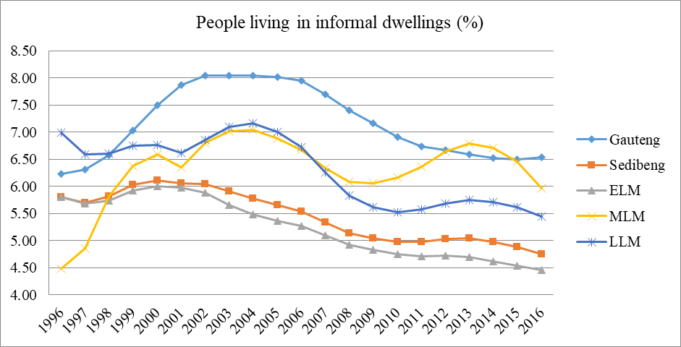Source: IHS Global Insight (2016)
The table below indicate financial performance with regards to employees that are working within the Human Settlement Directorate for the year under review.

Financial Performance Year 0: Housing Services
R'000
Details | Year -1 | Year 0
Details | Actual | Original Budget | Adjustment  Budget | Actual | Variance to Budget
Total Operational Revenue | 612
Expenditure:
Employees | 1 569 | 1 985 | 1 392 | 1 380 | -44%
Repairs and Maintenance
Other | 629 | 28 | 11 | 11 | -154%
Total Operational Expenditure | 2 198 | 2 013 | 1 403 | 1 391 | -45%
Net Operational Expenditure | 1 586 | 2 013 | 1 403 | 1 391 | -45%
 |  |  |  |  | T 3.5.5

SOME FREE BASIC SERVICES AND INDIGENT SUPPORT

• These are local municipalities’ competence

COMPONENT B: ROAD TRANSPORT

ROADS

The provision of roads planning and infrastructure resides within local municipalities in the district. The Sedibeng district municipality is however developing the rural roads asset management system for the local municipalities. This digital system will help municipality to better manage the road infrastructure and develop preventative maintenance plans.

TRANSPORT (INCLUDING VEHICLE LICENSING AND PUBLIC BUS OPERATION)

Transport

The Sedibeng District Municipality is currently not providing the bus services. The Public bus services in the district is provided by the Gauteng Provincial Government through the Department of Roads and Transport.

The Sedibeng District Municipality is currently developing the Sedibeng District Integrated Plan (DITP) inclusive of the associated local municipalities ITP’s consisting of Emfuleni, Lesedi and Midvaal Local municipalities. The plan will include but not limited to:

1. Commuter Rail Information
2. Rail Infrastructure
3. Road based public transport information
4. Transport needs assessment

Motor Vehicle Licensing and Registration

Sedibeng District, on an agency basis and on behalf of Provincial Department of Roads and Transport; runs a successful vehicle licensing and operations. This is attested by the increasing number of clients utilising the services.

However, there are incidents of misconducts by employees. These are handled jointly by province and Sedibeng District Municipality. The Service Level Agreement between province and the municipality is in the process of review. In addition, the municipality is looking at reviewing the Strategy; which will be in line with the province and the municipality’s strategies, goals and objectives.

The risks regarding cash at licensing centres still remain a concern but the municipality is engaging relevant banks to reinforce cash management; which should reduce theft and potential and current robberies at these centres.

WASTE WATER (STORMWATER DRAINAGE)
This function is not applicable to Sedibeng District Municipality.
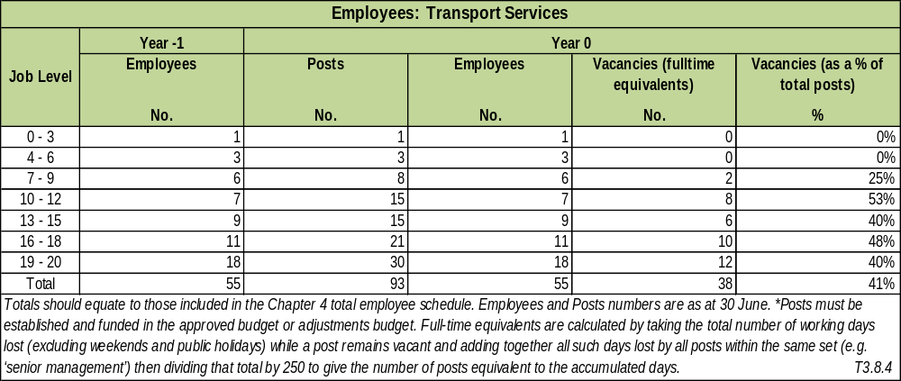

Financial Performance Year 0: Transport Services
R'000
Details | Year -1 | Year 0
Details | Actual | Original Budget | Adjustment  Budget | Actual | Variance to Budget
Total Operational Revenue | 64 802 | 63 158 | 71 033 | 63 158 | 0%
Expenditure:
Employees | 62 495 | 56 916 | 56 325 | 56 328 | -1%
Repairs and Maintenance |  |  |  |  | #DIV/0!
Other | 27 306 | 6 623 | 7 543 | 7 607 | 13%
Total Operational Expenditure | 89 801 | 63 538 | 63 868 | 63 935 | 1%
Net Operational Expenditure | 24 999 | 380 | (7 165) | 777 | 51%
Net expenditure to be consistent with summary T 5.1.2 in Chapter 5. Variances are calculated by dividing the difference between the Actual and Original Budget by the Actual. |  |  |  |  | T 3.8.5

COMPONENT C: PLANNING AND DEVELOPMENT

INTRODUCTION TO PLANNING

Sedibeng District Municipality (SDM) is responsible for the Spatial Planning of the district and Local Municipalities are responsible for deciding on Land Use matters in terms of Spatial Planning and Land Use Management Act (SPLUMA, 2013). Therefore all statutory applications are submitted and decided by Local Municipalities, the district can only comment when requested to do so. SDM therefore uses Land Use Management Systems (LUMS) as a tool to manage spatial planning and land use in the region. LUMS consists of the Spatial Planning and Geographic Information Systems (GIS).

SPATIAL PLANNING

Spatial Development Framework (SDF)

The SDF is reviewed annually in line with the Integrated Development Plan (IDP) in accordance with the Municipal Systems Act Chapter 5 section 26 (e).

Regional Spatial Development Framework (RSDF)

SDM in partnership with Fezile Dabi District Municipality, Gauteng Office of the Premier and Department of Rural Development and Land Reform have embarked on a process to establish and develop a Regional Spatial Development Framework (RSDF) for the areas around the Vaal River and Vaal Dam. The delineation of this RSDF includes sections of the North West and Mpumalanga Provinces respectively.

The North West Province has already sent a letter of support towards the process. According to SPLUMA, the Minister should promulgate the area as a “Region” prior to studies being conducted and developing the RSDF. A letter of request will be sent to the Minister once support has been gained from all affected parties.

The Vaal Regional Spatial Development Framework (VRSDF) project has currently stalled due to the changes of the Spatial Planning and Land Use Management (SPLUM) function being moved from DRDLR to the Monitoring and Evaluation Department. This shift has caused confusion on which Minister should promulgate and declare the area as a region in line with the act.

Sedibeng District Rural Development Plan (SDRDP)

SDM in partnership with the Department of Rural Development and Land Reform (DRDLR) have developed a SDRDP. This seeks to find solutions to rural areas in terms of economic development, social capital, human settlements and provision of social and engineering services.

Strategic Game Changer Projects

SDM together with the Office of the Premier has identified key projects that will change the socio-economic impasse in the region. These are projects which will impact on the broader Gauteng City Region (GCR) in terms of the Gauteng 2055 vision. These projects will be used as a marketing tool for the region and an Implementation Plan has been developed.

SDM has sourced external funding for Government Precinct for feasibility studies as well as upgrading of Fresh Produce Market.

Geographic Information Systems (GIS)

An integrated GIS system has been developed for the district and local municipalities. The system includes a central server which is located at the district offices and a viewer which is accessed by all municipalities.

Lesedi Local Municipality (LLM) is the only LM that is not connected to the central server. This is due to the fact that the municipality is not on the centralized I.T network of the SDM. This poses a challenge in terms of data transfer and storage.

Financial Performance Year 0: Planning Services
R'000
Details | Year -1 | Year 0
Details | Actual | Original Budget | Adjustment  Budget | Actual | Variance to Budget
Total Operational Revenue | 3 427 |  | 3 000 | 715 | 100%
Expenditure:
Employees | 14 475 | 13 980 | 14 050 | 13 919 | 0%
Repairs and Maintenance
Other | 5 550 | 7 693 | 10 835 | 8 936 | 14%
Total Operational Expenditure | 20 026 | 21 673 | 24 885 | 22 855 | 5%
Net Operational Expenditure | 16 598 | 21 673 | 21 885 | 22 141 | 2%
Net expenditure to be consistent with summary T 5.1.2 in Chapter 5. Variances are calculated by dividing the difference between the Actual and Original Budget by the Actual. |  |  |  |  | T 3.10.5

In conclusion, the Spatial Development Framework (SDF) chapter was drafted and incorporated in the Integrated Development Plan (IDP) 2018-2019 as Chapter 5 of the document. Integrated GIS portal developed. The cost of licensing and system maintenance is borne by the Gauteng Provincial Government until 2019.

COMPONENT D: ENVIRONMENTAL PROTECTION

POLLUTION CONTROL

The function of Pollution control is rendered by Local Municipalities on behalf of the District Municipality. A Service Level Agreement signed between the Local Municipalities and the District stipulating services such as pollution control, surveillance of premises, management of illegal dumping, sanitation, noise pollution, odours, dust, water and air pollution is still in force.

BIO-DIVERVISTY, LANDSCAPE (INCLUDING OPEN SPACES) AND OTHER (E.G. COASTAL PROTECTION)

Sedibeng District Municipality is involved in several projects related to the removal of alien vegetation. The project involves eradication of invasive plants and treatment of those removed.

LOCAL ECONOMIC DEVELOPMENT (INCLUDING TOURISM AND MARKET PLACES)

The Sedibeng District Municipality has developed incentive framework with incentive package which was aimed at providing enabling environment for growth and development of the Emfuleni, Lesedi, and Midvaal economies.
Its main purpose is to eliminate the discrepancies between these economies in terms of provided incentives and formulate a uniform approach to promotion of investment and economic growth in these areas. Manufacturing sector remains a dominant sector of our regional economy, however, it is experiencing a decline due to macro factors and it is for this reason that Sedibeng District Municipality has begun to diversify and grow other sectors. The Services Sector, the Financial Sector, the Tourism Sector and the Agricultural Sectors are all on the rise.
The Partnership programme between Gauteng Provincial Department of Economic and Vaal University of Technology (VUT) to support SMME’s incubation and drive innovation through digital manufacturing with the establishment of a Fabrication Laboratory has now been extended to the schools in the Townships in Emfuleni area.
AGRICULTURE
Through DGARD programmes we have had immense support of local farmers and processes towards establishment of a Mega Agripark. A business plan for Farmer Production Support Unit within the Mega-Agripark is completed. The Feasibility study for Milling Plant is completed. SDM has sourced external funding for Milling Plant project.
On the initiative of creating access to markets on agro-processing opportunities for Co-operative’s, small & medium farmers and SMME’s, Department of Rural Development & Land Reform in partnership with Sedibeng DM organised a session for local farmers to access its procurement opportunities. The small scale to medium scale farmers in the district continues to receive mechanisation support through the assistance of the province to the district from the period when farmers received tractor services and implements.
More than 250 households were identified and supplied with food gardening supplies i.e. Starter packs of production inputs and garden tools
Expanded Public works Programme (EPWP)
Expanded Public Works programme has contributed to the reduction in unemployment. 147 EPWP beneficiaries were appointed in the year under review on a contract basis.
Small Medium Enterprises (SMMEs)
More than 50 informal traders identified to benefit from a donation of street trading equipment’s or food trollies for their businesses as support to co-operatives and SMME’s.
Job Creation through EPWP Projects

Details | No. of Beneficiaries
Year 2017/2018 | 147

TOURISM
The Sedibeng District Municipality has embarked upon a major drive to promote and develop the Tourism Industry in the region as a direct result of the decline in economic activity in the Steel and related sectors of the region. Special emphasis is on the development of township tourism.
The Sedibeng region, with its diverse tourism offerings, embedded in rich cultural and natural heritage products, has the potential to grow into a major tourism destination. Sedibeng district has been classified as an area with above average tourism potential. A Tourism Development Strategy for the area was developed and adopted in 2003 and principles, programmes and projects were encapsulated in the Sedibeng Growth and Development Strategy (2004) and the Sedibeng 2010 strategy (2007).
The Tourism Strategies have the following goals:
- Develop a common understanding of the tourism industry, defining the roles and responsibilities of government in particular and the broader stakeholder groups, in growing the Tourism Industry in Sedibeng
- Develop and formulate strategies to be implemented by each stakeholder group in relation to their respective roles taking the strengths and weaknesses of the Sedibeng Tourism Sector into consideration;
- Build the capacity of the three major stakeholder groupings (Government, Private Sector and Community) to grow tourism and subsequently create economic and job opportunities.
In order to realize these objectives, the following deliverables have been identified:
- Tourism Policy, Strategy, Regulations, Monitoring and Evaluation
- Tourism Institutional Arrangements
- Tourism Demand: Destination Marketing
- Tourism Supply: Product and Skills Development
A request for financial or non-financial assistance, to revise and update the Sedibeng Tourism Strategy was sent to the Gauteng Department of Economic Development and Gauteng Tourism Authority.

TOURISM INSTITUTIONAL ARRANGEMENTS
Support Regional Tourism Organisation (Vaal River City Tourism Promotion Company (SOC)
The Sedibeng District Municipality has coordinated the establishment of a Regional Tourism Organisation, with Public, Private and Community Stakeholders, to create an enabling and facilitating environment for the Tourism Industry in the Sedibeng Region as informed by the National Growth Path, the Constitution of the Republic of South Africa and the National and Provincial Tourism Development Strategies.
A state owned company (Vaal River City Promotion Company (SOC)) was registered in August 2013. The objective of the Vaal River City Tourism Promotion Company (SOC) is to promote and develop the Sedibeng Region as the destination of choice for domestic and international tourists, through various coordinated marketing initiatives, such as promoting Vaal River City as a brand and encourage the hosting of unique integrated events. The Board consists of five Board Members, chaired by Advocate G Malindi.
A handover report on the status quo and way forward of the Company was submitted to the Municipal Manager, Executive Director (SPED) and Acting CEO of the Company.

TOURISM DEMAND THROUGH TARGETED TOURISM MARKETING INITIATIVES
Marketing and Exhibitions
The Tourism Department is involved in many exhibitions and events on an annual basis. This platform is an excellent marketing tool to raise the tourism profile of the region. A Generic Tourism Brochure, profiling the tourism offering in the region, is distributed. A Sedibeng tourism website has been developed, which includes accommodation establishments, tourism attractions, packages and events.
Listed graded establishments are linked to their respective websites. Sedibeng District Municipality submits information to the National Department of Tourism, Gauteng Tourism Authority, N3 Gateway, Vaal Explorer Digital Magazine and Vaal Meander to be included on their respective websites and digital platforms.
The Sedibeng District Municipality and tourism stakeholders participated in numerous exhibitions, such as the International Tourism Indaba, World Travel Market 2018, Meetings Africa, Gauteng Getaway Show, Outdoor Eco Adventure Expo, Tourism Trade and Consumer Shows, Emerald Easter Market.
183 Events and Packages in the region were submitted to the N3 Gateway Association, Gauteng Tourism Authority, Vaal Meander, Vaal Explorer Digital Magazine, the Sedibeng, External Communications Department and Emfuleni, Midvaal and Lesedi Tourism Departments for inclusion in marketing initiatives.

PRODUCT AND SKILLS DEVELOPMENT:
Accommodation and Tourism Product Audit:
The Tourism Department has conducted an audit on the graded and non-graded accommodation facilities in the region. This is an on-going process. A total of 19 databases have been developed and are maintained on a regular basis.
- There are 96 graded establishments in the region and 138 non-graded establishments. Approximately 4,785 beds (2,823 graded and 1,962 none graded), ranging from luxury to budget accommodation, are on offer to tourists.
- There are 77 Conference and Function venues with capacity for 20 to 4000 pax, of which 55 are also wedding venues and 28 are party venues.
- There are 11 cruises and houseboats, which include 2 houseboats for visitors to hire as an alternative accommodation option, as well as 9 cruises.
- Restaurants total 109 in the region.
- There are 47 registered taverns listed.
- There are 34 active art and crafters;
- Day spas’ total 31.
- 7 Markets are listed on the tourism database, which are open every weekend or on specific recurring days.
- 9 Golf courses are located in Sedibeng.
- The region has 27 sport stadiums and facilities.
- 8 Travel agents, 26 tour operators and 2 registered tourist guides are in Sedibeng.
- There is a comprehensive database of Black-owned tourism products and businesses in the region, which total 194.
- There are 6 tourism associations
- There are 193 youth listed who have tourism qualifications
Tourism Product Development:
The Sedibeng District Municipality has participated or submitted inputs for the development of National and Provincial policies, strategies, studies and plans.
These include the Framework on Tourism Support for Local Government, 5 in 5 Tourism Strategy, National Department of Tourism Transformation Strategy, Tourism Information and Monitoring Programme (NDT), Tourism Human Resources Strategy (NDT) and the review of the National Domestic Tourism Strategy.

Tourism Training, Capacity Building and Skills Development
Sedibeng, in partnership with the National Department of Tourism, Gauteng Enterprise Propeller, Gauteng Tourism Authority and tertiary institutions, conducts skills development and tourism awareness workshops on a regular basis for emerging and established tourism establishments.
The Sedibeng Tourism Department, with relevant stakeholders, facilitated and participated in the following workshops:
- N3 Gateway stakeholder, digital marketing workshop
- Customer Care Training Programme ( 17 stakeholders trained)
- Tourism Business Administrative Skills Training Programme (15 stakeholders trained)
- BBBEE Awareness Workshop
- Gauteng SMME’s for the Nordic Market
- Women in Tourism Workshop, network session and conference
- Gauteng Tourism Safety Monitors (35 youth enrolled)
- Four GDED Awareness Workshops facilitated
- Mzansi Youth Tourism Lekgotla
- My Run Initiative
- Gauteng Grading assistance programme for first time grading.
Information on training, capacity building and skills development opportunities by tourism departments and organisations, such as the National Department of Tourism, Gauteng Department of Economic Development, Gauteng Tourism Authority, FEDHASA, N3 Gateway, SAHRA, etc. are sent to all stakeholders to participate.
The Sedibeng District Municipality facilitated the implementation of a National Training Programme, namely The Tourism Youth Hospitality Programme. 47 learners graduated in the programme and 8 got permanent employment.
Financial Performance Year 0: Local Economic Development Services
R'000
Details | Year -1 | Year 0
Details | Actual | Original Budget | Adjustment  Budget | Actual | Variance to Budget
Total Operational Revenue
Expenditure:
Employees | 2 308 | 1 093 | 2 068 | 2 068 | 47%
Repairs and Maintenance
Other | 27 | 14 | 27 | 29 | 51%
Total Operational Expenditure | 2 335 | 1 107 | 2 095 | 2 097 | 47%
Net Operational Expenditure | 2 335 | 1 107 | 2 095 | 2 097 | 47%

COMPONENT E: COMMUNITY SERVICES

INTRODUCTION

This is a community based cluster which seeks to release human potential from low to high skills and build social capital through united, non-racial, integrated and safer communities. This is done by providing support services to various areas such as disaster management services, community safety, health care services, social development, youth development, sports, recreation, arts, culture and heritage in the region. Key delivery priorities of this cluster include the following:

1. Promote and build safer communities
2. Promote disaster resilient communities
3. Preserve heritage and museums of region, including promotion of national and provincial commemorative days
4. Promote and support sports, recreation, arts and culture
5. Promote efficient delivery of health care services
6. Promote social development of our communities
7. Facilitate and coordinate youth development programmes in the region

The following delivery areas outline indicative measures put in place during the year to improve performance and service delivery.

LIBRARIES; ARCHIEVES; MUSEUMS; GALLERIES; COMMUNITY FACILITIES; OTHER (THEATERS, ZOOS, ETC)

Part A schedule 4 and 5 of the Constitution of South Africa, 108 of 1996 lists the following as provincial competencies: Archives, other than National Archives, Libraries, other than National Libraries, Museums, other than National Museums, Provincial Cultural matters, Provincial Recreation amenities and Provincial Sports. The Gauteng Department of Sports, Arts, Culture and Recreation operate within the Constitutional Mandate.

Part B of the same schedule lists competencies in which the Provincial Department has a role to support and monitor local government i.e. amusement facilities, local amenities, sports facilities, municipal parks and recreational facilities.

Sedibeng District Municipality Community Services is a Cluster on its own. It has a specific Sports, Recreation, Arts, Culture and Heritage Directorate. This Directorate facilitates and implements activities related to Sports, Recreation, Arts, Culture and Heritage.

Sedibeng is currently leasing three (3) museums (Sharpeville, Teknorama and Heidelberg). The Arts and Culture division has two Theatres under its supervision i.e. Vereeniging and Mphatlalatsane Theatres. The Sharpeville Precinct, Sharpeville Hall and the Regional Craft hub are fully functional; and are used by both local and people outside the areas to enhance development.

The Gauteng Provincial Carnival is an annual event and has in the recent years experienced success and the impact I starting to show. This event has given many local artists an opportunity to showcase their talents and compete with some of the finest in the world; including some of them assisting the Cape Town Festival through their skills they have acquired over the years.

Teknorama falls within the Heritage side of the SRAC & H Directorate. The Heritage Precinct includes the old Police Station Museum, the Freedom Walk, the Sharpeville Exhibition and Sharpeville Hall. The Heritage Division is still pursuing all strategic Tertiary History Institutions, the National Heritage Council, SAHA, SAHRA and both the Provincial Department SACR and National Department of Arts and Culture and numerous Heritage through the Country like Museum Africa, Apartheid, Apartheid Museum, Freedom Park, Luziko Museum, the Helen Joseph Memorial Centre and the Robben Island Museum to assist in creating strategic partnership that would assist in adopting best practices.

The laying of wreath for World War 2 Monument, Peace Monument, Signing of the Constitution, Sir William Stove Monument and the Block House during the Anglo-Boer War continues to happen on annual basis. This is in addition to the Boipatong Massacre commemoration that also takes place on annual basis.

CEMETERIES AND CREMATORIUMS

The function of Cemeteries and Crematoriums resides with Local Municipalities. Sedibeng only plays a very distinctive role through Municipal Health Services Programme; the latter been the District competence. Currently there are more than 600 service providers who make use of cemeteries and crematoriums in the region. All funeral undertakers ‘premises and mortuaries are regulated and monitored by the Environmental Health division of the Municipal Health Services Division.

CHILD CARE; AGED CARE; SOCIAL PROGRAMMES
The main service delivery priorities of the Directorate is to promote social development of our communities, support and facilitate implementation of youth development including women and gender programmes. The services relating to children, social programmes and old aged are the primary functions of the Provincial Department of Social Development. Sedibeng District Municipality mainly coordinate and give support to the local municipalities in collaboration with the Province to give effect for the implementation of programmes. Various programmes have been implemented in conjunction with the locals focused on the designated groups i.e. youth, children, women and gender and people with disability.
The following are key delivery areas identified for this financial year (2017/18):
Facilitate and coordinate the implementation of gender and women programmes
To ensure that this key delivery area is supported; Four (04) gender and women programmes were implemented. This include amongst others, women trafficking in person for Social development stakeholders held on the 15th September 2017 facilitated by International Organisation for Migration (IOM) for both workshops 49 stakeholders participated and 107 SDM learnership interns participated in the Trafficking in person workshop held on the 26th October 2017, Father Sons campaign held on the 2nd March 2018 facilitated by Commission for Gender Equality and 61 representative from organizations inclusive of community members to establish men’s forums in the Evaton West wards. On the 5th June 2018 an Agricultural greening economic empowerment workshop was conducted and facilitated by Department of Agriculture.
Support and coordinate social development programmes
These are programmes aimed at educating and providing relevant services to address social ills within our communities. Sedibeng in partnership with SAB and Sharpeville Community Centre NPO conducted awareness campaign on Alcohol Foetal Syndrome at Sharpeville on the 4 August 2017, 91 participants took part inclusive of youth and pregnant mothers to be.
Two Early Childhood Development (ECD) Steering Committees was held on the 28 November 2017 and June 2018 the purpose of this meeting is to strengthen the ECD in the region and to technically assist the non-compliant to comply. On the 07 September 2017, People with Disability (PWD) technical meeting was held to outline the program of action for 2017/18 financial year, Department of Social Development and locals official participated in the meeting, and this was followed up with a Regional Disability Forum meeting held on the 28 February 2017 to review the status of the forum and develop a programme of action for the 2017/18 financial year. On the 08 June 2018, Community Dialogue programme targeting PWD and community members was conducted whereby 84 people with disability participated.
Facilitate and coordinate youth development programmes
Youth development is regarded as a critical area that will ensure that youth readiness for self-sustenance and growth is achieved. This is facilitated through various developmental programmes that are implemented in partnership with the Province and the Private sector support, which includes programmes such as; Youth entrepreneurship development, Life Skills programme, Financial Management, ICT empowerment programmes, Tshepo 1 million, Indigent Bursaries, Work readiness programme, Youth Expo’s and Learnership programmes. To date through these collaborative programmes a total of 17, 740 young people have accessed these programmes for an upliftment.
In line with the above 419 participated in Entrepreneurship workshops held on the 27th July 2017 and October 2017, 260 participated in the accredited work readiness programme which was held from the 7th to the 18th May 2018 in partnership with Century Skills Development. An additional number of 84 young people were registered for support under Tshepo 1 million on the 14th August 2017 and 100 have been placed for the learnership programme with the National Youth Services (NYS) for a period of 24 months beginning April 2017 end March 2019.
In partnership with Old Mutual the Municipality has implemented Financial Management Workshops across the District to empower our young people, total of 98 young people have participated in the programme during the financial year period. A total of 171 young people participated in a youth expo during the Youth Month, which was held at the NASREC Centre.
Facilitate and coordinate the implementation of Youth Advisory Centres programmes
Youth Advisory Centre plays a crucial role towards youth skills development and support in the region. Through these centres, services such as job preparedness, basic computer literacy, financial management, internet access, and CV writing, basic entrepreneurship development and career guidance are provided to the youth. In this regard about 8870 young people have been assisted during the financial year 2017/18 period.
Facilitate and coordinate implementation of external student financial support programme
SDM is also providing financial assistance to needy students across the region. In this regard about 18 students were awarded bursaries to an amount of R16 000 to enrol and study at various tertiary institutions across the country for a period of three consecutive years.

Key Strategic Objective: “Releasing human potential from low to high and build social capital through united, non-racial, integrated and safer communities”
Service Objectives  Service Indicators (i) | Outline Service Targets  (ii) | Year 0 (2016/17) |  | Year 1 (2015/16) |  |  | Year 2 (2017/18)
Service Objectives  Service Indicators (i) | Outline Service Targets  (ii) | Target | Actual | Target |  | Actual | Target
Service Objectives  Service Indicators (i) | Outline Service Targets  (ii) | (iii) | (iv) | *Previous  Year  (v) | *Current Year  (vi) | (vii) | Previous  Year  (2015/16) | Current  Year  (2016/17) | Following Year  (2017/18)
Service Objective: Promote efficient health and social development programmes within communities
02 District Health Council meetings held | Facilitate District Health activities | 02 | 03 | 03 | 02 | 04 | 03 | 03 | 03
02 Health programmes supported | Implement health programmes | 02 | 04 | 02 | 02 | 05 | 04 | 04 | 02
03 Gender and women programmes supported | Facilitate implementation of gender and women programmes | 03 | 08 | 03 | 03 | 04 | 08 | 08 | 03
04 Social Development Forum activities supported | Support social development programmes | 04 | 05 | 04 | 04 | 04 | 05 | 04 | 04
04 Youth development programmes supported | Facilitate youth development programmes | 04 | 09 | 04 | 04 | 09 | 04 | 04 | 04
2000 Youth assisted | Facilitate implementation of Youth Advisory Centres programme | 2000 | 3710 | 2000 | 2000 | 9202 | 2000 | 2000 | 2000
26 External students supported | Facilitate implementation of external students financial support programme | 24 | 26 | 24 | 24 | 27 | 26 | 26 | 18

Financial Performance Year 0: Libraries; Archives; Museums; Galleries; Community Facilities; Other
R'000
Details | Year -1 | Year 0
Details | Actual | Original Budget | Adjustment  Budget | Actual | Variance to Budget
Total Operational Revenue | 228 | 135 | 127 | 101 | -34%
Expenditure:
Employees | 16,586 | 21,249 | 18,215 | 18,220 | -17%
Repairs and Maintenance
Other | 8,137 | 13,205 | 12,301 | 12,232 | -8%
Total Operational Expenditure | 24,723 | 34,454 | 30,516 | 30,452 | -13%
Net Operational Expenditure | 24,495 | 34,319 | 30,389 | 30,352 | -13%

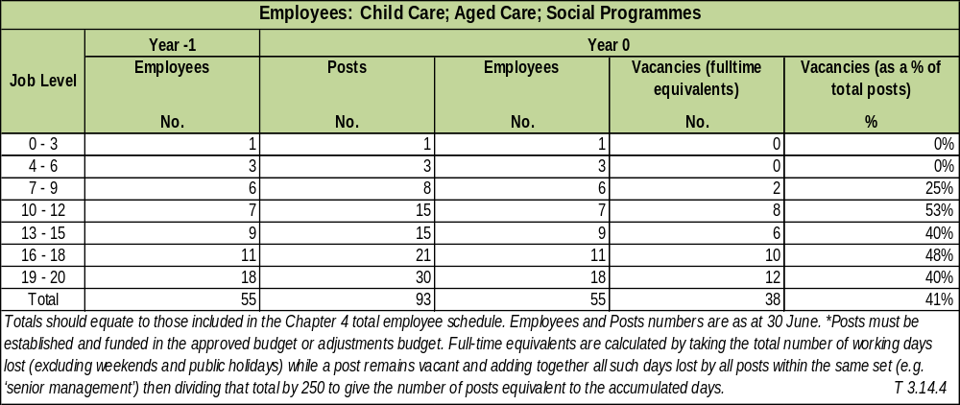

THE PERFORMANCE OF CHILD CARE; AGED CARE; SOCIAL PROGRAMMES OVERALL:

The overall performance of Social Services for this period has been successful. The department units have respectively achieved most of its objectives as stipulated in the service delivery and budget implementation plan (SDBIP) for 2017/18 financial year.

The expected outcome of coordination and support to promote social development of our communities has been achieved through collaboration with various stakeholders from our communities including the local municipalities and the provincial departments relevant for empowerment of our communities.

Number of programmes such as forum meetings, awareness programmes and stakeholder technical engagements were implemented during this period. Issues relating to children care services are a core functionality of the Province in accordance to the Child Care Act. The District continues to provide relevant support in conjunction with the locals including the ECD Steering Committee (ECD)

Three (03) ECD steering committees were held to develop and review the strategy for the Integrated ECD strategy during this period.

COMPONENT F: HEALTH

In terms of the Health Act 61 of 2003, Primary Health Care (PHC) services remains the competency of province, and Sedibeng District Municipality only coordinates and supports the district health activities through District Health Council (DHC). Most of the health activities are mainly implemented at the level of local municipalities through provincialisation. Health care services are provided by both the public and private sector.

There are three (03) public hospitals in Sedibeng District Municipality, namely; Kopanong and Sebokeng Hospitals that are located within Emfuleni Local Municipality, and Heidelberg Hospital which is within Lesedi Local Municipality. In addition to these public hospitals there are five private hospitals of which four of the hospitals are within Emfuleni and one is located in Lesedi.

Primary Health Care Facilities (Clinics) are clustered more in urban and area, whilst rural areas are serviced through mobile clinics. Emfuleni Sub-District has twenty (20) clinics, four (04) Community Health Centres (CHC) and five (05) mobile units. In Midvaal area there are four (05) clinics and four (04) mobile units. In Lesedi there are eight (08) clinics and three (03) mobile units and 69 Ward Base Outreach Teams attached to the health facilities. The following are key delivery areas identified for this financial year (2017/18):

Facilitate and coordinates District Health Council meetings and activities

To improve the quality of health care performance, SDM continually coordinates the District Health Council meetings with the involvement of the province, which District Health Council meetings was held on the 18 August 2017, 20 October 2017 with the last held on the 24 February 2018. On the 24 February 2018. All the reports which were presented with the challenges were resolved at this level, only the infrastructure challenges were escalated to MEC for Health at the Provincial Health Council.

Coordinates and implement health programmes

Primary Health Care Facility Committee (PHCFC) is a statutory body that is appointed by the MEC for Health to enhance public participation in Primary Health Care Service. On the 16 August 2017 the MEC held a consultative meeting with all the PHCFC in the region, the purpose of the meeting was to strengthens public participation in the PHC services and 110 PHCFC from 38 health facilities participated in the discussions, furthermore the PHCFC technical committee was workshoped on the new reporting template and the clinic committee workshop on the report writing was held on the 22 November 2017.PHCFC technical meeting on the way forward of the appointments of the committee members was held on the 20 June 2018 and in this meeting it was resolved that all the health facilities must continue with the committee members from 2015 to 2018 in march until further details from MEC.

To improve the health of our communities, Sedibeng in partnership with SAB and Sharpeville Community Centre NPO conducted awareness campaign on Alcohol Foetal Syndrome on the 4 August 2017, 91 participants took part inclusive of youth and pregnant mothers to be.

CLINICS

In terms of the Health Act 61 of 2003, health care services remains competency of province, including those of the Primary Health Care Facilities (Clinics) and Sedibeng District Municipality only support and coordinate the district health system through District Health Council (DHC).

Primary Health Care Facilities (Clinics) are clustered more in urban and service centres, whilst rural areas are serviced through mobile clinics. Emfuleni Sub-District has twenty (20) clinics, four (04) Community Health Centres (CHC) and five (05) mobile units. In Midvaal area there are four (04) clinics and four (04) mobile units. In Lesedi there are eight (08) clinics and three (03) mobile units.

Coordinate and Implement health programmes

To date a total of 123 Primary Health Care Facility Committee members have been appointed across the region by MEC of Health. They were further trained in various areas to ensure that they perform to required standard and support primary health care facilities accordingly.

78 Primary Health Care Facility Committee members (PHCFC) from Emfuleni area participated in a capacity building training which was held during the period; 20 – 22 September 2016 . This was followed by another capacity building training held on the 06 October 2016 at Meyerton Library with 27 PHCFC members participating. Newly 21 nominated PHCFC members were orientated on the 14 October 2016 at Ratanda Clinic.

Employees: Health & Social Development
Job Level | Year -1 | Year 0
Administrators | Employees | Posts | Employees | Vacancies (fulltime equivalents) | Vacancies (as a % of total posts)
 | No. | No. | No. | No. | %
Director: Health & Social Development (Job level 02) | 01 | 01 | 0 | 01 | 0%
Coordinator: Social Development (Job level 05) | 0 | 01 | 0 | 01 | 0%
Coordinator: Bursary & Youth Programmes (Job level 05) | 01 | 01 | 01 | 0 | 100%
Coordinator: Health Care Services (Job level 05) | 01 | 01 | 01 | 0 | 100%
Coordinator: Gender & Women (Job level 05) | 01 | 01 | 01 | 0 | 100%
Senior YAC Officer (Job level 08) | 01 | 02 | 01 | 02 | 80%
Career Guidance Officer (Job level 09) | 03 | 0 | 03 | 0 | 100%
Outreach Officer (Job level 09) | 03 | 0 | 03 | 0 | 100%
Ex combattants Liaison officers (Job level 07) | 06 | 01 | 05 | 01 | 99%
Total | 10 | 07 | 07 | 05
INTRODUCTION TO HIV & AIDS

HIV&AIDS and TB co-infections (particularly pulmonary tuberculosis), are still accounting among the top 10 leading causes of mortality in the Republic of South Africa. Sedibeng region remains among some of the districts with the highest HIV epidemic levels. In SDM, tuberculosis treatment defaulter rate is being encountered, with cases of transmittable multi-resistant (TB) prevalence contributing to substantial impact on depleting medical resources and increased mortality rate.

Common contributing factors leading to HIV & AIDS and TB transmission rate, are high levels of unemployment and poverty. Despite free availability of treatment (TB and ART) at most medical facilities, poor nutrition is rife among poverty stricken households, thus accelerating levels of vulnerability. Lack of proper nutrition and healthy environment affect significant number of households hence the epidemic progression of new HIV and TB infections. PMTCT programme has decreased material infection to unborn and babies. Free availability of life prolonging ART among HIV + people made a substantial impact on the improved health of affected communities. Other prevention educational programmes also had a crucial contribution in harnessing the disease progression. The following are key delivery areas identified for this financial year (2017/18):

Coordinating the prevention of new HIV, TB and STIs infections

Free HIV and TB testing is accessible across health care facilities and mobile services. About 316 908 people have been tested for HIV infections, and HIV+ individual cases with low viral load placed under treatment. All HIV+ people are referred to TB screening to detect co-infection and where necessary prompt treatment commenced to prevent early mortality. Male medical circumcision (MMC) uptake has also been promoted and is on the increase both in public and private facilities.

NACOSA (National Aids Convention of South Africa) and BroadReach offered capacity building to various NGOs and CBOs to address challenges posed by the epidemics on stigmatization and discrimination of people living with HIV. Commission for Rights and Linguistic (CRL) has placed a moratorium on initiation schools activities across Gauteng Province till June 2019. Coordinating ward-based HIV, STIs and TB programmes

SDM entered into a second year of memorandum of agreement with three (03) different service providers (i.e. one each local municipality). The MOA is for the implementation of ward based programmes. Each service provide has been contracted to support in their respective local municipalities , conduct door-to-door ward based HIV/AIDS, TB and STIs education programmes, train ward based educators and coordinators, including provision of administrative support and relevant tools of trade.

The 2017/18 door-to-door programme, 611 586 people have been reached and 390 households visited. She-Conquers Campaign Young Women Dialogue empowerment programme) held 9 activities, reaching with young women 15-24 years.

Monitoring and Evaluating the overall HIV, STIs and TB programme

The SDM has established AIDS Secretariat Unit, now relocated to the office of the Executive Mayor who is also chairperson of the District AIDS Council (DAC) responsible for overseeing and monitoring the Implementation of HIV, STIs and TB programmes. DAC is expected to meet on quarterly basis, and to date two district (02) and three (3) local meetings were convened and held successfully. Interdepartmental Committee (IDC) and various stakeholders as programmes implementers ,presented respective status quo reports to DAC to determine the impact of projects on communities and level achievements in that particular quarter. By the end of June 2018, 78 771 people remained on ART, 14 671 male had medical circumcision done.

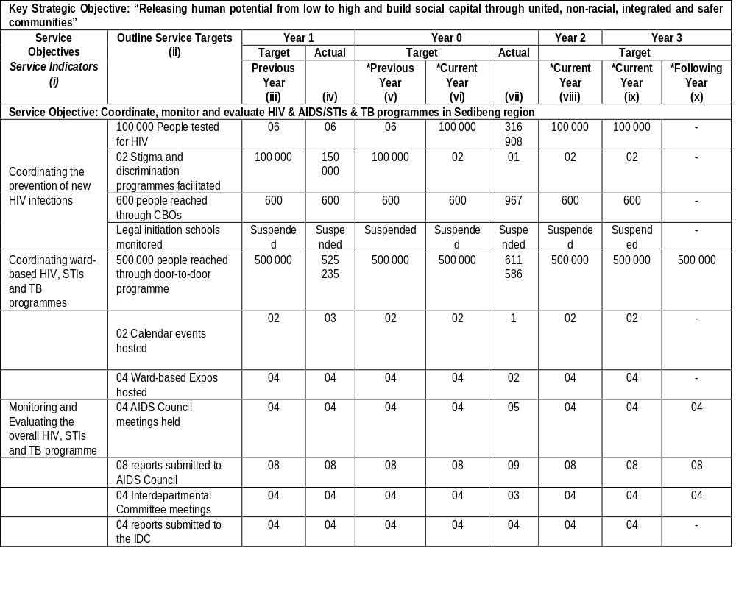
COMMENT ON THE PERFORMANCE OF HIV & AIDS

The HIV&AIDS, TB and STIs educational door to door programme was successfully implemented through three contracted service providers (i.e. NGOs. Each NGO implemented the programme in their respective local municipalities namely: Emfuleni, Lesedi and Midvaal. The programme is also monitored by IDC members through follow up system of referrals made to various services.

CoGTA assisted by SAPS closes all initiation schools across Gauteng municipalities in compliance with (CRL Commission for Rights and Linguistics (CRL). The suspension of activities pertaining to the cultural practice is pending till winter season 2019; HIV & AIDS ward based door-to-door programmes are successfully implemented through the assistance of various NGOs across the three local municipalities, namely; Emfuleni, Lesedi and Midvaal. This implementation of these programmes is conducted through a memorandum of agreements between SDM and these service providers.

Implementation of the Initiation Schools By-law is also conducted to ensure compliance and safety of the initiates. However; the current status is that these initiation schools practice has been suspended within Sedibeng by the Commission for Rights and Linguistics (CRL) until it has finalized its investigation on the practice and regulations thereof. Ward based Expos could not take place due to financial constraints, and they ended up being cancelled. In relation to World AIDS Day event, National and Provincial Health departments instructed that all regional events be consolidated into one national event that was held on the 01 December 2017 at Sinaba Stadium in Benoni.

AMBULANCE SERVICES

Sedibeng transferred back Ambulance Service to Gauteng Department of Health on the 1 September 2012. Subsequently Sedibeng developed Emergency Services Forum to deliberate and deal with cross cutting issues relating to this function. The forum meets quarterly.

HEALTH INSPECTION, FOOD AND ABATTOIR LICENSING AND INSPECTION

Sedibeng District Municipality Environmental Department prioritized surveillance of premises and food hygiene within the region. The municipality prioritized the issuing of certificate of Accessibility (CoA) to all food handling premises; in compliance with the minimum health requirements. A database of all medical waste generators is continuously updated and companies are monitored monthly.

Metropolitan and District Municipalities must ensure that appropriate municipal health services are effectively and equitably provided within their areas of jurisdiction as per Section 32 of the National Health Act of 2004. The following health inspection services /programs are rendered within the district:

- Water quality monitoring
- Food hygiene control
- Health surveillance of premises
- Waste management
- Surveillance and prevention of communicable diseases
- Vector control
- Environmental pollution control
- Disposal of the dead
- Chemical safety

The x3 top service delivery programmes are: Water quality monitoring, food hygiene control and health surveillance of premises. An audit by the National Department of health revealed that the District is in compliance with the national norms and standards for environmental health.

The SDM was able to render the above services to all the citizens within the district to all communities and as per the norms and standards for environmental health services. The services do not discriminate between rich or poor communities. However, improvement in the direct environment where poor communities live and work do have a huge impact on their health and well-being. Complaints and concerns from residents’ re-environmental health issues are prioritized and attended to within 24 hours throughout the district. Complaints which cannot be addressed by the District is referred to the relevant municipal or provincial department.

The Service level agreement between the SDM and local municipalities, who render the service on behalf of the District, provides for a monitoring protocol and a reporting regime. All the programmes are monitored for compliance with the National norms and standards on environmental health on a monthly and quarterly basis. Major efficiencies can be reported as the ability of the SDM to render MHS despite the severe resource constraints, in compliance with the national norms and standards and the fact that all citizens have access to the service. The SDM do not have any municipal abattoirs within its area of jurisdiction. However, all privately owned abattoirs fall within the jurisdiction of the Province (Veterinary services)

SERVICE STATISTICS FOR HEALTH INSPECTION, Etc

The National Norms and Standards on Environmental Health require that all food premises be inspected on a quarterly basis. The set target for the district is 90 % compliance with the National norm. Statistics on inspections done at premises for the 2017/18 financial year can be summarised as follows: Total number of health inspections conducted: 12,436

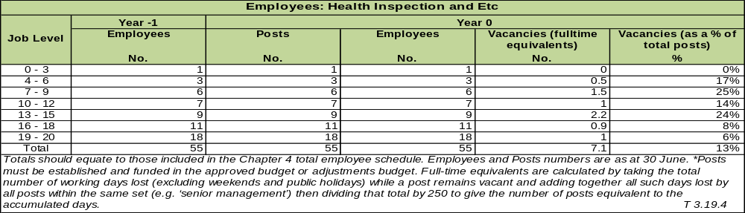

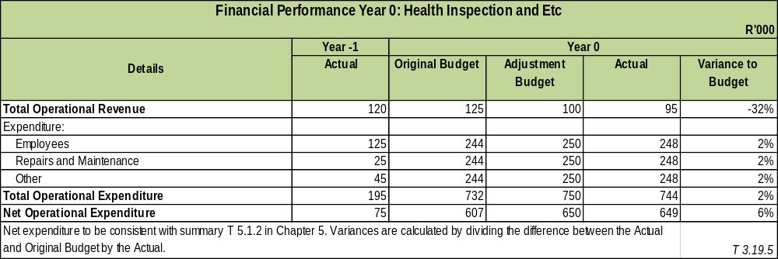

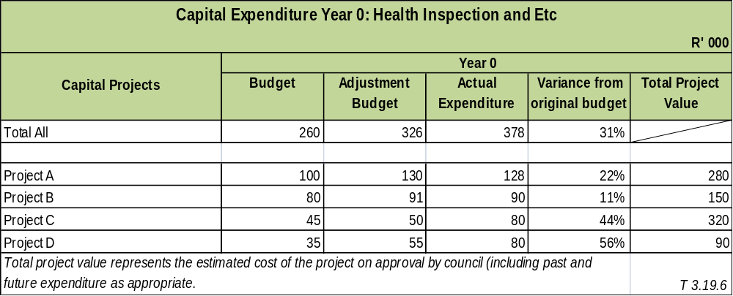

COMPONENT G: SECURITY AND SAFETY

POLICE

Sedibeng District Municipality support strategic objective of the National Development Plan which seeks to “Build safer communities” through integrated community safety programmes which are implemented across the region.

This development and implementation process of programmes is guided by the Sedibeng Community Safety Strategy 2018 – 2022. It is a multi-faceted process undertaken through a Community Safety Forum which comprises of various stakeholders from the Justice, Crime Prevention and Security Cluster across the region and province.

For the financial year 2017/18, key focus was on building safer communities of Sedibeng region through implementation of programmes that sought to address issues of gender based violence, rape, gangsterism, traffic in person, and strengthening of stakeholder relations.

NB: It should further be noted that Sedibeng District Municipality does not have a competency for Traffic Police Services, Fire and Rescue Services, and Emergency Medical Services. These competencies are held at a Local Municipality and Provincial levels, respectively.

Service Delivery Priorities:

It is common knowledge that community safety should be every person’s concern. Various organizations, community groups and the residents are expected to contribute to the development of a safe and cohesive living environments. As a result; Sedibeng District Municipality through its Community Safety IGR Forum has been actively involved in fostering joint crime and violence prevention across the region. These safety programmes include schools’ safety, community police relations, community corrections, gender based violence, social crime prevention, stakeholder relations and road safety programmes. The following are the achievements recorded within the financial year: 2017-18.

- Community Safety Strategy 2018 - 2022

After intensive stakeholders’ engagement, towards the development of the Community Safety Strategy, Council approved this Safety Strategy on the 29 November 2017 for implementation.

- Stakeholders Relations

Community Safety Forum meetings are held on monthly basis, and as a result twelve meetings were held discuss on issues of safety programmes. SDM was also actively involved in external safety programmes organized by other stakeholders across the region. Furthermore; as part of building capacity for the stakeholders, SDM arranged and hosted two trainings in partnership with the University of South Africa (UNISA). The first training was held on the 31 October 2017, and was on Stolen Vehicle Identification, followed by Drugs Identification and Concealment training on the 28 November 2018. About thirty (30) delegates from various SAPS and Traffic Services across Sedibeng region participated in this training.

Sedibeng Community Safety Forum was also recognized for the outstanding performance in the sector of justice, crime prevention and security. It was therefore; awarded an award for being the most effective IGR structure on community safety at the Gauteng Community Safety Awards Ceremony on the 22 February 2018.

- Social Crime Prevention

This is the area of intervention that forms an integral part of the Community Safety Strategy. It focuses on areas that are more vulnerable to crime such as gender based violence, gangsterism and schools safety. In October 2017, Community Safety Forum launched an Anti-Gangsterism and Rape Campaign in Evaton area. This was informed by the then high levels of contact crimes such as murder, rape and assault in the area. After crime analysis process and safety assessment conducted in the area, it was established that most these crimes are as a result of gangsters’ activities which are also linked to the initiation schools. Various awareness and educational campaigns were conducted through road shows, educational workshops and “Reclaiming our Culture Programme”. This programme was aimed at members of the gangsters and school to educate them about the culture and principles of the Initiation Schools practices.

Schools safety promotion seeks to create conducive learning environments for the learners and educators. Schools were visited to educate the learners about the dangers of engaging in criminal activities. This include search and seizure operations that have been conducted at identified problematic schools across the region.

Trafficking in Person (TIP) Campaign was also conducted in the areas such as Mamello, Vaal Marina and De Barrage. Other campaigns were conducted at shopping complexes which include, President Hyper in Vereeniging, Evaton Mall, and Thabong Mall in Sebokeng and the Vaal Mall in Vanderbijlpark. The campaign was aimed at making the residents about the rising scourge of human trafficking in our country.

- Community Corrections Programmes

Community Corrections programmes forms an integral part of community safety programmes in the region. One this programme include Cycling Awareness Tour Campaign which was held during the period; 21 – 25 May 2018. This programme is aimed at highlighting the plight of ex-offenders with regard to the stigma that goes with incarceration, and the criminal record that impedes their chances of employment. It further encourages inmates to participate in correctional programs aimed at enhancement of their reintegration, as well as to discourage other members of the community, especially the learners from schools from engaging in criminal activities. During this campaign services such as psychosocial services were also conducted whereby 298 school learners approached and engaged Social Workers from Department of Social Development in relation to their personal experiences emanating from gender based violence.

- Community Police Relations

This is the structure that supports law enforcement services especially with regard to policing interventions. Through Community Policing Forum, SDM in partnership with Gauteng Department of Community Safety and Vereeniging SAPS held a Youth Safety Dialogue on the 19 April 2018, which was followed up with the launch of the Youth Safety Desk on the 30 May 2018 at Vereeniging Police Station. About seven CPF meetings were also attended at various police stations in the region, which include Sedibeng Cluster CPF Board Strategic Workshop that was held in Vanderbijlpark on the 25 March 2018.

- Road Safety Promotion

Two problematic roads identified within our regions are Moshoeshoe Road in Sebokeng and Golden Highway which passes through Evaton and Sebokeng. As a result; road safety campaigns were conducted at the Evaton Mall on the 28 July 2017 & 29 June 2018, including Vanderbijlpark Taxi Rank on the 02 December 2017.

Key Strategic Objective: “To ensure effective service delivery”
Service Objectives  Service Indicators (i) | Outline Service Targets  (ii) | Year 1 |  | Year 0 |  |  | Year 2 | Year 3
Service Objectives  Service Indicators (i) | Outline Service Targets  (ii) | Target | Actual | Target |  | Actual | Target
Service Objectives  Service Indicators (i) | Outline Service Targets  (ii) | Previous Year  (iii) | (iv) | *Previous  Year  (v) | *Current Year  (vi) | (vii) | *Current Year  (viii) | *Current Year  (ix) | *Following Year  (x)
Service Objective: Promote and build safer communities
Implement (12) community safety programmes | 12  Community Safety Programmes | 08 | 12 | 08 | 12 | 55 | 12 | 55 | 20
Implement CCTV maintenance and repairs services, including submission of registers | 04  CCTV Maintenance & Repairs Registers submitted | 04 | 04 | 04 | 04 | 04 | 04 | 04 | 04

Employees: Community Safety
Job Level | Year -1 | Year 0
Job Level | Employees | Posts | Employees | Vacancies (fulltime equivalents) | Vacancies (as a % of total posts)
 | No. | No. | No. | No. | %
0 -3 | 01 | 01 | 01 | 0 | 0%
04 – 06 | 03 | 03 | 02 | 01 | 10%
07 - 09 | 05 | 07 | 05 | 02 | 20%
Total | 09 | 11 | 08 | 03
T3.23.3

COMMENT ON THE PERFORMANCE OF COMMUNITY SAFETY OVERALL

The IGR Structure (Community Safety Forum), is highly effective in the region, hence; this attribute was acknowledged by Gauteng Department of Community Safety by awarding the forum with the most effective community safety forum in the province.

After the launch of Anti-Gangsters and Rape Campaign in Evaton, there has been a significant decline of related crimes such as murder, rape and assault in the area. Incidents relating to bullying and gangsters at schools, as a result of initiates from the initiation schools has also dropped.

SALGA Gauteng has also come on board to support Sedibeng Community Safety Forum through capacity building training in conducting safety audits and development of community safety plans for the Local Municipality level.

Generally, crime statistics as released by the SAPS shows a decline in some problematic crimes in the area. However; emphasis still needs to be directed towards by-law enforcement in the region to address issues of alcohol and drug abuse which are some of the causal factors towards rape, domestic violence and road crashes.

FIRE

INTRODUCTION TO FIRE SERVICES

The District Municipality is only responsible for the section in the Municipal Structure Act Section 84 (1) (j) which is:

- Planning, co-ordination and regulation of fire services,
- Specialised fire fighting services such as mountain, veld and chemical fire services
- Co-ordinating of the standardising of infrastructure, vehicles, equipment and procedures
- Training of fire officials

Top 2 delivery priorities.

1. Provision of specialized fire fighting services (Payment of Claims send by the Local).
- Claims received from the local municipalities regarding specialized fire fighting services as per Section 84 (1) j have been received and processed.

- Emergency Forum Meetings.
- This meeting is to strengthen the relationship within the emergency services. Agenda items include: Training, PIER (PEAU) Public Education & Awareness, Specialised Fire Fighting Services, Operational MOA, Disaster Management matters, Emergency Communication Centre matters, Fire matters, Emergency Medical Services matters & Standard Operation Procedures on Fire & Rescue Services.

COMMENT ON THE PERFORMANCE OF FIRE SERVICES OVERALL:

Sedibeng District Municipality is only responsible for the Section 84 (1) (j) in the Municipal structure Act and do not render Fire brigade operational duties. The Directorate also coordinate the Emergency Services Forum with the Local Fire & Rescue Services to assist the Local Fire services with planning & standardizing of the Fire Brigade services and to discuss all issues pertaining to Fire Services, challenges & planning. In collaboration with Santam Sedibeng manage to procure Fire hoses & Firefighting protective gear for the three local municipalities.

OTHER (DISASTER MANAGEMENT, ANIMAL LICENCING AND CONTROL, CONTROL OF PUBLIC NUISANCES AND OTHER)
INTRODUCTION TO DISASTER MANAGEMENT

The Sedibeng Disaster Management Directorate is established within the Community Services cluster and is striving towards the eradication of all avoidable disasters in the Sedibeng District Municipality thereby supporting the social and economic development of our communities.

The key mission of the Directorate is to develop and implement a holistic and integrated disaster management planning and practice in a cost effective and participatory manner, thus ensuring the preparedness of our communities to prevent and respond to disasters.

Service Delivery priorities:

- Ensure the state of readiness and alertness aimed at combating potential disaster situations within the region through plans.

- Ensure Public Awareness programs to minimize Risks in the Sedibeng Region.

- Ensure effective service delivery of the Sedibeng Emergency Communication Centre

- Ensure effective implementation of specialised firefighting services by Locals through monitoring, managing & capacitation of Fire Services.

Sedibeng District Disaster Management Plan has been reviewed for the financial year as per the legislative requirement. The key objective for the annual review of the plan is to ensure that processes that are to be taken to prevent, mitigate and prepare to manage disasters or disasters threatening to occur within the region are updated and applicable. Sedibeng also reviewed the disaster management framework & the disaster relief policy the documents will be tabled to Council. A total of 3885 community members were attended to by Disaster Management.

During the term the directorate provided drinking clean water to the following areas: Midvaal & Emfuleni area in all a total of 89000 litres water were provided to the above areas. During this financial year Sedibeng experience a tornado in the Vaal Marina area, although the Vaal Marina tornado was not declare as a disaster Sedibeng disaster management & relevant stakeholders work hard to assist the community who was left destitute.

The directorate held & participated in the following public education campaigns: (the purpose of these campaigns are to ensure safer & resilient communities).

- National Safety week in collaboration with ESKOM. Sedibeng Focus was on Home Safety and emergency calling.
- The international day for disaster risk reduction was commemorated in Ratanda; where the following participated:
- Sedibeng Disaster Risk Management,
- PDMC,
- Vaal SANCA,
- Lesedi Traffic,
- SAPS (Hawks),
- Gauteng Emergency Medical Services,
- Fire (Local), ESKOM/Lesedi Electrical Dept.,
- Road Accident Fund,
- Dept. of Home Affairs: and
- Randwater.
- Disaster Management supported Community Safety in the 1000 men march/programme, through its forum.
- First Aid training was coordinated for Vaal Marina (working on Fire officials); the training was conducted through the National Department of Rural Development.
- Sedibeng Disaster Management also coordinated Training in Veld Management for the Midvaal community.
- Conducted Back to School Safety Awareness: Kudung Middle School 26/01/2018. Stakeholders that participated:
- Emfuleni Fire,
- Midvaal Fire,
- Midvaal Traffic,
- Department of Education,
- Community Safety,
- Gauteng EMS,
- Correctional Services,
- Social Development,
- Randwater; and
- Vaal Marina working on Fire.
- Back to School Safety Awareness: Boiketlong Christian School 02/03/2018. Stakeholders:
- Emfuleni Fire,
- Midvaal Fire,
- Department of Education,
- Community Safety,
- Social Development, and Randwater Water wise unit.
- Early Child Development Safety activity awareness: Sisonke Midvaal ECD Forum 16/03/2018.
Stakeholders:
- Midvaal Fire,
- Emfuleni Fire,
- Midvaal Traffic,
- City of Joburg Fire,
- Community Safety,
- Social Development, Randwater.
- Randwater Human Right Midvaal Rural School: Rata-Setjhaba Farm School 19/03/2018 Stakeholders:
- Midvaal Fire,
- Midvaal Traffic,
- Randwater.
- Radipeu Primary School18/05/2018 Winter Awareness.
- Nonediba Primary School 27/05/2018 Child Protection Week.
- Micheal Rua Primary School 28/05/2018 Child Protection Week.
- Awareness cycling tour 21-25/05/2018 reclaiming our Culture and Anti gangsterism Programme
- Sedibeng Cluster Youth Launch 23/06/2018 Sedibeng Custer Youth Summit.
- Gauteng Community Safety 29/06/2018 Road Safety Awareness.

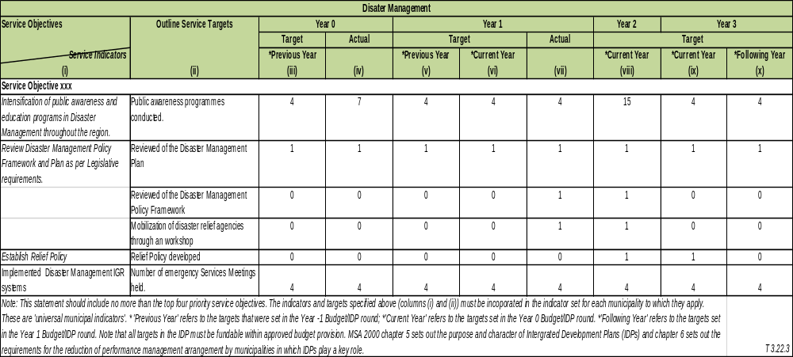
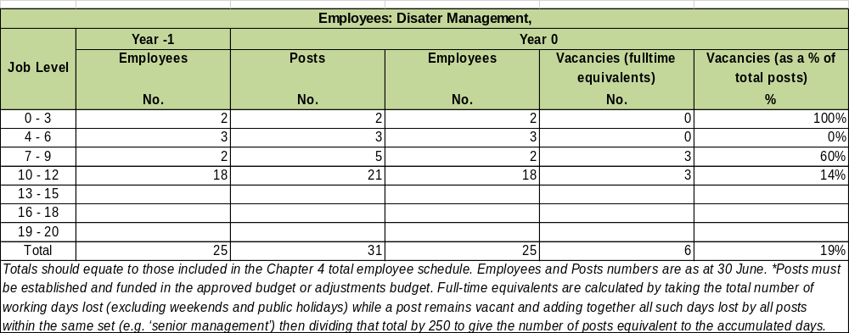

Financial Performance Year 0: Disaster Management, Animal Licensing and Control, Control of Public Nuisances, Etc
R'000
Details | Year -1 | Year 0
Details | Actual | Original Budget | Adjustment  Budget | Actual | Variance to Budget
Total Operational Revenue
Expenditure:
Employees | 11,023 | 11,487 | 11,052 | 11,094 | -4%
Repairs and Maintenance
Other | 266 |  | 142 | 145 | 100%
Total Operational Expenditure | 11,288 | 11,487 | 11,193 | 11,239 | -2%
Net Operational Expenditure | 11,288 | 11,487 | 11,193 | 11,239 | -2%
Net expenditure to be consistent with summary T 5.1.2 in Chapter 5. Variances are calculated by dividing the difference between the Actual and Original Budget by the Actual. |  |  |  |  | T 3.22.5

COMMENT ON THE PERFORMANCE OF DISASTER MANAGEMENT

The overall performance of Disaster Management for the period has been successful. The department achieved most of its objectives as stipulated in the service delivery and budget implementation plan (SDBIP). The endeavours to create disaster resilient communities within our region is achieving great momentum & this attribute to less incidents or emergencies related to informal or formal shack / house fires. This is achieved through effective public education & awareness programs.

The engagement with different stakeholders to manage some of the disasters or emergencies has been successful. The collaboration with stakeholders during the tornado in Vaal Marina attributed to effective management of the incident.

COMPONENT H: SPORT AND RECREATION

The Sedibeng Directorate of Sports, Recreation, Arts, Culture and Heritage within the Community Services Cluster is responsible at a Regional/ District level to coordinate and facilitate the strategic development objectives of Sports, Recreation, Arts, Culture and Heritage in collaboration with all Local Municipalities in the Sedibeng Region and the National and Provincial Departments of Sports and Arts & Culture including areas of competency of the Heritage Function which is a direct function of the District Municipality as the implementing agent or Heritage Authority in Sedibeng District Municipality in conjunction with PHRAG and SAHRA as a co respondent to these matters.

SPORTS & RECREATION UNIT

The Directorate of SRACH in the Sport and Recreation division, facilitates regional developmental function in collaboration with both Provincial DSACR, DE and Local Municipalities in assessing development in the 9 prioritized Sporting codes in Sedibeng.

Core Responsibilities of Sports and Recreation Division

- Is to assist in developing the 9 priority Sporting Codes as identified in Gauteng Province.
- Create Sports and Recreation as a platform that assist in understanding Cultural Diversity and tolerance in Nation Building and the development of a Patriotic Society through integration.
- Establish and assist with the continued development of Sports in collaboration with the Sports
- Councils/Confederations in the Region.
- Develop the turnaround strategy of our Region through our Sports Plan.
- Facilitate the impact of the Recreational Policy for the Region once approved.
- Facilitate Strategic Partnerships in pursuance of our goals and objectives.

This component includes: community parks; sports fields; sports halls; stadiums; swimming pools; and camp sites.

The established Sports Council’s consolidates the various participation of the different Federations of the various sports disciplines, monitored at the South Corridor Sports and Recreation IGR forum. This forum met monthly to articulate the various Sports development programs that were considered for the 2017/18 financial year, the focus was on the Premiers Social Cohesion games particularly on influencing racial and cultural integration, including foreign nationals to combat the scourge of xenophobia in Gauteng Province.

- The Annual O R Tambo Municipal games that were scheduled for October 2017 were held in abeyance due to the withdrawal of the host city and is currently under review to resuscitate the Annual Games through Salga.
- The Annual 4th December 2017 Motsepe Foundation Toy Distribution in Sedibeng went very well notwithstanding the reduction of Toys from 13 000 to 8 000; which caused some challenges for the recipient communities.
- One of the highlights of the 2017/18 period was our direct involvement in the O R Tambo/Soncini games in preparation for the International Tri-colour games played in Italy in Reggio Emilia Province in July 2018.
- We selected and prepared a District team that participated in the National Indigenous Games play offs in Polokwane October 2017.
- After consolidating regional inputs in the development of the Gauteng Recreational Policy, we then participated in the Gauteng Recreational Policy Summit which was held on the 9^{th &} 10th of March 2018 at Turfontein Race Course, the final approved Policy is still outstanding due to the Legislative processes.

ARTS & CULTURE UNIT

The Arts and Culture Unit has the responsibility to manage and operate three major Theatres in the Region i.e.
- Vereeniging Theatre,
- Mphatlalatsane Theatre and
- Sharpeville Hall/theatre.

Core Business

The thrust of the Arts and Culture Division is to
- Develop the Potential of Communities in the different Genres of the Arts.
- Create an understanding in Cultural Diversity and Tolerance in Nation Building,
- Assist in the development of the Creative Industries as a New Economic Driver, linked to Heritage Programs and unique Memorabilia development for the Region.
- Develop the turnaround strategies for Arts & Culture and Theatres in our Region.
- Develop the South Corridor “School of the Arts in our Region.
- Facilitate Strategic Partnerships.

The Unit also encourages Theatrical development of stage productions and plays in the various genres of the art; in collaboration with private sector Practitioners in the various fields of the Arts. The Unit also consistently defines developmental opportunities with underprivileged communities by giving opportunities to express themselves in the Arts, while working closely with the Provincial DSACR to roll out various annual programmes such as Dance Majeko, Inshalazi, Puisano and numerous Indigenous Gospel and Music genre festivals.

The Division is also responsible for the establishment and coordination of the Regional Craft Hub at the old Sharpeville Police Station in partnership with the Provincial DSACR and implements in conjunction with the Heritage Division through the Office of the Executive Mayor especially on the Commemorative Days Programs in the Office of the Executive Mayor in collaboration with National and Provincial Government Departments including the Gauteng Carnival as one of the most supportive regions.

The Division has been instrumental in numerous Social Cohesion workshops in the Region and is currently busy in developing a “Turnaround Strategy”. This strategy, hopefully will assist in making the function more articulate for communities and address the gaps in these specified areas of operation.

Perhaps the biggest challenge for this Division is to influence the upkeep of the facilities it manages into world class facilities that could be self-sustained; and procure various major attractions of the Arts into the Sedibeng Region.

HERITAGE & MUSEUMS UNIT

According to the National Heritage Act 25 of 1999, the Heritage Unit has a direct legislative function in the region; as Sedibeng District Municipality as the Heritage Authority in the Region.

The Core Responsibilities of the Heritage & Museums Division:

“Preserving Our Heritage’
- Identification
- Declaration
- Preservation Of All Our Heritage Sites Throughout The District:
- Establishment of Heritage Struggle Routes and Research.
- Oral History, Research and Digitization. (African Footprint Analogy
- Commemoration of Significant Historical Events and/or Individuals who impacted on Society (Persons of Interest program).
- Geographic Name Change
- Museum & Heritage Development based on our turn around “21st Century Heritage and Museums” draft document
- Reposition our Regional Historical events impact as “The Cradle of Human Rights” and align to National South African History and the achievement of Democracy
- Facilitate strategic partnerships with sector institutions, business, Government, civil society and Education/Tertiary Institutions.

In the main the Heritage Division has very broad overarching responsibilities; hence the District, through numerous Epochs of history starting from the Iron and Stone Age, Indigenous self-determination of communities, Indigenous Knowledge Systems, Colonialism, establishment of the Transvaal Boer Republic and the credentials of the struggle for Democracy; manages and operates some of the Country’s National Heritage Assets, given their Historical Struggle and Liberation Footprint..

By definition of the above summary overview, the Heritage & Museum Division manages the Sharpeville Precinct that has acquired National Heritage Status and is currently one of the World Heritage applicant sites under auspices of the “Nelson
- Mandela Legacy” Projects which incorporates;
- “Lillies Field, Robben Island,
- Qunu,
- Constitution Hill (Trails) etc,

The Sharpeville Precinct consist of the operation and management of the “Heroes Acre” and grave sites of the 69 Sharpeville Massacre Victims, the old Sharpeville Police Station and the Sharpeville Memorial centre and Peace Gardens.

The Vaal Technorama Museum which houses the collective artefacts of various historical Epochs of the Region from the Iron and Stone ages, discovery of coal, Anglo-Boer/South African War, Peace Treaty, Liberation Leaders profiles and the former President F.W. De Klerk entire collection of artefacts during his tenure as President including various Art pieces of note etc, which is also the birth place of a very strategic “Person of Interest” born on the same site as the Museum called “Topville Location” the late stalwart “ Mme Adelaide (Tsukudu) Tambo, wife of O. R. Tambo.

Due to lack of capacity (Human and fiscal), we do not manage and operate the Heidelberg Transport Museum any longer as major structural damages has occurred over the years. However we have been instrumental in facilitating a strategic partnership on BOT with SEDTRADE in restoring and developing Heritage Landscaping around the Witkop Blockhouse in Meyerton.

The Division has identified eight Liberation Struggle Routes in the Region that spans across various historical Epochs. The division is currently in strategic discussion with Vaal University of Technology to assist with their expertise of their 3D Digital printer on Design and Construct methodologies around the development of Peace Garden Monuments that can be developed into Liberation tourist precincts.

Various Historical sites have been identified and are currently being processed in collaboration with PHRAG, SAHRA and the National Heritage Council. This is done to solicit financial support from the National and Provincial Departments for the development of the Management Preservation Plans, which will include the Redan rock engravings and Bushmen paintings on the Vaal River.

The Division is also responsible for Commemorative Days Programmes; which currently honour six key and strategic events; although there are new major massacres as revealed by recent that would have to be accommodated within the four quarterly programs. There is also the Geographic Name Change facilitation and coordination with our three Local Municipalities. It should be noted that we have just during this current political term established Geographic Names Change Committees for Midvaal and Lesedi Local Municipalities. Once Emfuleni Geographic Names Change Committee is up and running, we will also be able to consolidate the Sedibeng Steering Geographic Regional Name Change Committee.

The following were key delivery areas identified for the year under review:

- Support and coordinate Sports and Recreation programmes

- The Sedibeng District won a trophy for being the Best Performing Municipality (Administratively).
- Sedibeng SRACH has signed MOA/SLA with Gauteng Department of SACR to collaborate on Football, Rugby, Cricket, Netball, Boxing, Basketball and Aquatics programs hosted in Sports Hubs located in the three local municipality’s sports facilities.
- Coordinated the SAFA Sedibeng Technical Plan 2022 Workshop on the 06th July 2017 at the Vaal Teknorama.
- Coordinated the Annual AGM of the South African Masters and Legends and Football Association in the Sedibeng Region in 14th October 2017.
- Facilitation and coordination of the annual Motsepe Foundation’s Toy Distribution Program on the 4th December 2017.
- The Sedibeng District Local Organizing Committee for the O R Tambo/Soncini Social Cohesion games meetings where held fortnightly at Technorama Museum that coordinated the District Playoffs which were held on the 30th September 2017 at General Smuts High School in Vereeniging
- Attended the Monthly O R Tambo/Soncini games Provincial Task team meetings in preparation for the Provincial final games for all Regions in Germiston 28/29 October 2017.
- Attended the Gauteng Sports Awards at the Silver Star Casino in Krugersdorp (Mogale City), on the 01st October 2017.
- Facilitated and coordinated the elective conference of the South African Masters and Legends Football Association (SAMLFA) Sedibeng Region held at the Vaal Teknorama Auditorium on the 14th October 2017.
- Team Sedibeng participated in the finals of the Gauteng OR Tambo/Soncini Games hosted at the Germiston Stadium on the 28th and 29th October 2017.
- On the 25th October 2017 attended a meeting to welcome the Italian delegation at the Johannesburg Stadium, and later the in loco inspection of the facilities at the Germiston Stadium.
- Convened the Motsepe Foundation Toy Distribution LOC meetings on the 29th November 2017, including the 01st and 06th December 2017 at the Vaal Teknorama Boardroom.
- Facilitated, in partnership with Sedibeng, the distribution of the Motsepe Foundation’s 8 000 Toys on the 04th December 2017 across the District.

- Support and coordinate Arts and Cultural Programmes

- Facilitated the drafting and processing of Arts and Culture performance contracts of various artist who performed at all our Commemorative day’s events during the entire year of 2017/18 in our 6 Commemorative days programs and associated events during the period, i.e. Human Rights Month, SODA, Boipatong Massacre week programme etc.
- A series of musicality training skills transfer workshops where arranged through the partnership of T-Music Man from the Joy of Jazz brand, Geleza Kleva and Music Learn for artist in Sedibeng where arranged in collaboration with DSACR, Sedibeng and Emfuleni Local Municipality,
- the first on the 3rd of August 2017 at the Old Sharpeville Police Station that focused on Audience Development and knowledge values of music,
- The second preparatory meeting took place on the 7th of August 2017 that focused on Promotion and Marketing of Visual Arts and Craft and the alignment of using religious music to promote the culture of Heritage learning,
- The third meeting took place on the 10th of August 2017 that focused on the utilization of audio-visual materials as a source of retrieving life skills information that could be utilized in training,
- The Fourth preparatory meeting was on the 16th August 2017 that focused on Musical Instruments skills, analysis, and effective oral music presentation, the intention was to identify 100 artist that would benefit from the collaboration for the main Workshop on the 17th August at the Sharpeville Hall.
- On the 24th of September, Gauteng DSACR in collaboration with all Municipalities celebrated National Heritage Day in Tshwane Pretoria as the Gauteng Social Cohesion Carnival where various cultures and diversity in Gauteng were showcased. Sedibeng contributed as a participate and the main event on the 24th September 2017 was a very huge success; expressing tremendous growth in creating a Carnival atmosphere in Gauteng Province; with all Local Municipalities as crafters and various artist created various artefacts, floats and costumes.
- A Visual Art and Craft Exhibition under the theme: Radical Economic Transformation through Arts and Culture was hosted from the 25th September 2017 to the 30th September 2017 as a five day programme at the Sharpeville Human Rights Precinct Exhibition Centre. This was done in collaboration and support from DSACR with all Crafters and Artist of the Regional Craft Hub as the pilot project to facilitate awareness and marketing.
- Based on the phenomenal success of the 5 day pilot project, the Directorate of Arts in the Provincial DSACR approached Sedibeng Arts & Culture to offer monthly support to Arts & Culture Market programme around the Sharpeville Monument and Precinct that started on Saturday the 7th October 2017, which was well attended locally and was marketed on National Media of ANN7.
- Sedibeng District Municipality Department of SRAC & H, Arts and Culture unit in partnership with Emfuleni Local Municipality SRAC organized the Regional Vaal River Street Parade. The event took place on 08th October 2017.
- SDM assisted with the CD launch of Bongani Majola in collaboration with the Sedibeng Jazz Foundation on the 14th of October 2017 at the Sharpeville Hall.
- The Second Arts & Culture Market was held on Saturday the 4th of November 2017 as part of facilitating growth as per the original pilot program with DSAR however the growth trajectory requires a continues marketing and distribution strategy from the LED Division in Sedibeng including the creation of access to the external market opportunities like Curio shops and Major Tourist destinations and Hotel groups.
- On the 9th November 2017 a strategic meeting was orchestrated between Sedibeng District Municipality SRACH represented by the Executive Director CS and the HOD DSAR to process the agreement and arrangement of facilitating an Anchor Tenant process for the establishment of the South Corridor Regional Offices of the NYDA at the Boipatong Museum and Youth Centre.
- On the 24th of November 2017 a joint collaboration between Sedibeng District Municipality and DSACR facilitated a Workshop and exhibition at the Boipatong Museum and Youth Centre with Crafters and Artist operating from the newly established South Corridor Hub at the Boipatong facility.
- The Third offering of the Arts & Culture Market was consolidated into the 21st Anniversary Signage of the Constitution Commemorative event on the 9th of December 2017 which impacted more positively as the attendance was much better due the events taking place around the Sharpeville Precinct
- On the 20th February 2018, we formed part of the Sedibeng Multi-Disciplinary Task Team led by the Office of the Executive Mayor in in preparing for Human Rights Month Programme with the high light on Human Right Day on the 21st of March 2018.
- On the 21st of March 2018as part of our Human Rights Month programmes we facilitated in collaboration with the Creative Industries Division of DSACR the Sharpeville Arts and Craft Exhibition at the Sharpeville Precinct as a continuum to popularize the growth and opportunity of the Creative Industry through Fashion, Music, Dance, Performing genres of the Arts and set pieces of artistic artefacts
- 8th of April 2018 the Division of Arts and Culture Sedibeng collaborated with DSAR to successfully host the Annual PUISANO JAZZ Festival at Dlomo Dam in Sharpeville that showcased 4 local bands sourced by Sedibeng amongst other Gauteng bands which was a highly successful.
- The 9th of June 2018 PUISANO Jazz Bands Auditions was conducted at the Sharpeville Hall for the next offering to be held in Gauteng Province in the future events of the DSACR in other Regions of Gauteng.
- On the 16th of June National Youth Day we facilitated an Arts and Craft Regional Expo at the Sharpeville Precinct that focused on Food, Music, Fashion and Arts and Craft Memorabilia and Artefacts for sale.

- Support and coordinate Regional Craft Hub

- Attended the Selection Criteria Workshop for the Global Exporter Passport Programme on 03 May 2017 to capacitate and give opportunity to our Local Crafters as part of Gauteng South Africa delegation which opened the process to be part of the selection of Craft Artefacts that was being considered for the Global Export Programme marketing strategy of the South African Government on all International Conferences and Meetings for the display of South African Indigenous Art.
- Created in collaboration with the DSAR Creative Industries division regular Arts and Craft Markets at the Sharpeville Precinct and the Boipatong South Corridor Craft Market Exhibitions at the Boipatong Museum and Youth Centre.

- Support and coordinate Heritage and Museums programmes

- Based on the new Executive Decision of Sedibeng District Municipality the direct Management of the Commemorative Days Programmes has become the responsibility of the Office of the Executive Mayor.
- A series of strategic discussions with Vaal University of Technology Senior Leadership was facilitated to establish the expression of interest in forging a strategic partnership in implementing the vision of processing numerous Memorial Lectures and Dialogues. This will also assist in advancing Technical expertise through their different Faculties to render support for the Design and Construction of proposals for “Peace Garden Monuments” for our eight identified Heritage Liberation Routes and the design of Heritage Memorabilia for the proposed future Liberation Tourism routes which still remains an outstanding strategic objective to enhance the entire spectrum of Heritage Tourism and associated Economic growth projections and exposure to the Township economies in the future.
- We facilitated a comprehensive strategy to commemorate the 3rd September Vaal Uprising to Ratanda Lesedi where they experienced as part of the Vaal Uprising in 1984,
- The Boipatong Massacre that is normally commemorated on the 17th of June every year was unceremoniously interrupted due to community unrest over Service Delivery protest in the area and an Executive Political decision was taken to instead to facilitate a weeklong Commemorative event in collaboration with DSAR from Saturday 29th July 2017 –Breakfast with the MEC and a Programme of Theatre set pieces, exhibitions, School visits, performing musical and dance set pieces by various local community groups continued from Monday the 31st of July 2017 through to Friday 4th of August 2017 with the close off on Saturday 5th August 2017 with a Inter prayer faith Candle light prayer session and Imbalwa story telling.
- 3rd September 2017 was commemorated in Lesedi as part of the 33rd Anniversary of the 3rd September Vaal Uprising. The event was successfully hosted in partnership with Lesedi Local Municipality and the event was hosted in three deferent venues, namely; Ratanda Cemetery (Wreath lying), Evaton Cemetery (Wreath Laying) and the main event took place at Mafatsana Community Hall in Evaton.
- A list of 10 names that are supposed to be taken through a public participatory process by the new committee were sent through to the Sedibeng Heritage division in collaboration with the Emfuleni Speakers Office on the basis of the Geographic Name Change Bank information of the Region that came through a Public Participatory Process that was developed in a Provincial Road Show that was held in 2013 in Vereeniging City Hall.
- We facilitated a strategic Wit Kop Block House meeting with the Developers, consultants, Midvaal Local Municipality and the Conservancy Group at Vaal Technorama Museum to resolve on the matter of processing a Conservancy Master Management Plan for the multi- Million Rand investment that would incorporate the National Heritage site. The main purpose of this meeting was to receive and get feedback from PHRAG and to consolidate all the required documents, The meeting also resolved that Sedibeng and Midvaal should develop a draft MOA that will outline the operations and management of the heritage site including a Working Committee consisting of both Sedibeng, Midvaal and Local Heritage Community Stakeholders was established with Sedibeng being the convener as they are the custodians of all heritage function Regionally.
- On the 22nd September 2017, there was a follow up meeting with Provincial Geographical Names Change Committee, District and the Local Municipality as part of the Provincial Committee‘s support program to the Municipalities that endorsed the approach of utilizing some of the Names in the Sedibeng Names Bank of +- 300 names of persons of interest that impacted on the Region, It was in this meeting that it was agreed that the Provincial Committee will host a Capacity Building Workshop on the 6th October 2017.
- 7th November 2017 we hosted the Provincial Declaration Committee on an in-loco inspection tour of the Sedibeng Region; and hosted a stake holder meeting at Vaal Technorama with Church Elders of ST. JOHNS Apostolic Church in Small Farms Everton to process the nomination of the Church to be declared a Provincial Heritage site during November 2017;
- 8th November 2017 second Phase Capacity building workshop with the Emfuleni Speakers Office at Boipatong Memorial & Youth Centre.
- Held a follow up meeting with PHRAG at Provincial DSACR Offices in JHB in November 2017 with all strategic stakeholders in relation to the Wit Kop Blockhouse in Midvaal to ascertain the modalities and intricate development procedures around the National Heritage site.
- 4TH December 2017 we had a meeting with the Sharpeville Foundation and National DOJ to consolidate the intended partnership of a joint Programme.
- 7th December 2017 Hosted the Provincial Heritage Resources Committee in Sedibeng District Municipality to deliberate and investigate declarations of Heritage sites in the Region.
- 8TH December 2017 a very huge Community Public participation of +- 500 people process endorsed the list of names of “Persons of Interest” presented to be implemented with immediate effect from the Emfuleni People’s Assembly at Vereeniging Civic Hall.
- 11th December 2017 we held the main event of the 21st Anniversary of the Signage of the Constitution at Constitution Square with the Executive Mayor and MEC DSACR as Key note Speakers respectively.
- During December 2017 we received confirmation from PHRAG on Heritage sites that were considered:
- Wilberforce College (Evaton) provisionally approved,
- Evaton Cemetery (Burial site of Massacre victims) status not approved subject to demarcation of the specific coordinates and maps of actual burial sites,
- Boipatong Memorial & Youth Centre –provisionally approved,
- Vuka Cemetery (Burial site for Boipatong Massacre Victims) provisionally approved.
- 12th January 2018 we facilitated in collaboration with the Office of the Executive Mayor we commemorated the Zone 7 Night Vigil Massacre through the standard 3 Phased Programme of wreath laying in Soweto and Evaton cemeteries and the final event at the Mafatsana Hall in Evaton.
- 21st February 2018 a joint Provincial Heritage Liberation Committee with the GGNC workshop with the Sharpeville Communities where held in the Sharpeville Hall to capacitate communities on the potential of processing Heritage as an Economic driver in the future.
- The Peace Treaty event of the 31st May 2018 Anglo Boer War was postponed for further research on the role of Black Communities during the period and North West University History Department was engaged on the subject matter however Professor Jacky Grobbelaar of Pretoria University has just released his new book that addresses the subject matter and gives a perspective on this side of History.
- The 17th June 2018 we commemorated the annual wreath laying ceremony of the Boipatong Massacre at the Vuka Cemetery and held a light brunch with the survivors and their families at the Boipatong Museum and Youth Center.

- Facilitate and coordinate the name change process

- The fact is that research, lobbying and support from the direct family members is a highly cumbersome process, the First Name identified was that of the National Stalwart of the ANC previous Secretary General Mr. Duma Nokwe, who was also the first Black Advocate of the Transvaal Southern High Court. We received direct support from the daughters and son of the late stalwart through the Duma Nokwe Foundation and the community to change the R82 Old Vereeniging/Johannesburg road to the Philemon Duma Nokwe Drive.
- The matter was taken to the Gauteng Geographic Names Change Committee and the MEC of DSACR and a meeting was convened with the Provincial Department of Roads with MEC Ismail Vadi as the R82 is a Provincial road that cuts across various areas both Sedibeng and COJ, the pending decision is awaiting final approvals in this regard.
- The second road that has been sanctioned and endorsed by the Emfuleni People’s Assembly on the 8th December 2017 at the Vereeniging City Hall is the change of Houtkop road from Vanderbijlpark to Three Rivers Vereeniging to Autshumato Road after the Great Khoekhoe Leader warrior who was disposed of his vocation and land by the VOC in 1652 through Jan Van Riebeeck, also known as Herrie die Strandloper who was the first Political Prisoner to escape alive from Robben Island, this was fully supported by the South African Indigenous Peoples Association and SAHA Dr Geraldine Frielaar.
- The other roads for consideration is the Boy Louw road and off-ramp, the R42 to Heidelberg.

- Facilitate and coordinate the declaration of Heritage resources

All previous 7 declarations have finally been endorsed through the PRHAG Committee responsible and the new list provisional agreed on through PRHAG is:

- The Wilberforce College in Evaton as a National Site given its Historical context.
- St. Johns Church in Small Farms.
- Evaton Cemetery.
- Vuka Cemetery in Sharpeville/Boipatong
- Boipatong Museum and Youth Centre.
- National SAHRA has declared Sharpeville Monument, Old Police Station and the Heroes Acre in Phelindaba Cemetery as part of the National Heritage site on the 30th of December 2016 when it was Gazetted with pending World Heritage site status through UNESCO as part of the “Nelson Mandela Legacy Heritage sites” project in conjunction with the National Heritage Council of South Africa and is still an outstanding pending process currently that has to undergo vigorous processes through UNESCO

Key Strategic Objective: “Releasing human potential from low to high and build social capital through united, non-racial, integrated and safer communities”
Service Objectives  Service Indicators (i) | Outline Service Targets  (ii) |  | Year 0 (2016/17) |  | Year 1 (2015/16) |  |  | Year 2 (2017/18)
Service Objectives  Service Indicators (i) |  |  | Target | Actual | Target |  | Actual | Target
Service Objectives  Service Indicators (i) |  |  | (iii) | (iv) | *Previous  Year  (v) | *Current Year  (vi) | (vii) | Previous  Year  (2015/16) | Current  Year  (2016/17) | Following Year  (2017/18)
Service Objective: Promote and develop sports and recreation, arts, culture and heritage of our region
04 Sports and Recreation programmes supported | Support Sports and Recreation programmes | 04 |  | 11 | 10 | 04 | 9 | 11 | 04 | 04
04 Arts and Cultural programmes supported | Support Arts and Cultural Programmes | 04 |  | 05 | 12 | 04 | 10 | 12 | 04 | 04
02 Regional Craft Hub programmes supported | Support Arts and Cultural Programmes | 02 |  | 02 | 3 | 02 | 3 | 3 | 02 | 02
06 Commemorative events hosted | Host commemorative events in partnership with other spheres of government. | 06 |  | 06 | 6 | 06 | 6 | 6 | 06 | 06
04 Stakeholder engagements on name change processes facilitated | Facilitate the name change process | 04 |  | 06 | 5 | 04 | 5 | 6 | 04 | 04
04 Stakeholder engagements for declaration of Heritage resources held | Facilitate declaration of Heritage resources | 04 |  | 05 | 6 | 04 | 5 | 4 | 04 | 04

Financial Performance Year 0: Sport and Recreation
R'000
Details | Year -1 | Year 0
Details | Actual | Original Budget | Adjustment  Budget | Actual | Variance to Budget
Total Operational Revenue
Expenditure:
Employees | 1,217 | 1,302 | 1,881 | 1,641 | 21%
Repairs and Maintenance
Other | 305 |  | 24 | 20 | 100%
Total Operational Expenditure | 1,522 | 1,302 | 1,905 | 1,661 | 22%
Net Operational Expenditure | 1,522 | 1,302 | 1,905 | 1,661 | 22%
Net expenditure to be consistent with summary T 5.1.2 in Chapter 5. Variances are calculated by dividing the difference between the Actual and Original Budget by the Actual. |  |  |  |  | T 3.23.4

COMMENT ON THE PERFORMANCE OF SPORTS, RECREATION, ARTS, and CULTURE & HERITAGE:

The SRACH Department has met its obligations of the SDBIP for the period with some challenges in Heritage and Museums around the slow process the Municipalities in Sedibeng advances the elements of both Geographic Name Changes and declaration processes that goes through other Provincial and National responding Agencies/Departments, In Arts and Culture we have very serious capacity challenges and financial challenges that impacts the outcome of the impact of the division, the same can be classified for Sports and Recreation.

In the main the process of finding additional budgetary resources and the spending of our grants become very cumbersome including the funding for developmental programmes and maintenance of our facilities which is in a serious state of decline. The lack of Senior Management to implement the correct rightsizing of the SRACH Organogram as per the required prerequisite skills and expertise further hampers the potential of the Directorate.

COMPONENT I: CORPORATE POLICY OFFICES AND OTHER SERVICES

Sedibeng District Municipality Corporate Policy Offices are up and running and functioning at full potential. Obliged by legislation, Policies of the municipality are either developed or reviewed, based on the situation and circumstances prevailing as change is constant.

All these policies, before they get implemented are exposed to councillors in workshops for them to familiarise themselves with their contents and make political inputs. Political and administrative offices are fully functional and all are geared towards implementing strategies of council in an endeavour to achieve goals and objectives of the municipality.

EXECUTIVE AND COUNCIL

On the 3rd of August 2016, South Africa conducted Local Government Elections. Emanating from this process, there were changes in the municipality; where new Councillors were ushered in Council. Subsequently Sedibeng Council was established on the 18th of August 2016; with new political parties constituting Sedibeng Council. Effective corporate governance is a central focus that distinguishes Sedibeng District Municipality from other municipalities. The District Municipality has established important committees to encourage compliance with all legislation and to enhance ethical consideration by all its employees and Councillors.

SERVICE STATISTICS FOR THE EXECUTIVE AND COUNCIL

Political Head | Functions
Executive Mayor:  Cllr. Busisiwe Joyce Modisakeng | - Presides as the Chair in the Mayoral Committee Meetings.  - Recommends to the municipal council strategies, programmes and services to address priority needs through the IDP, and the estimates of revenue and expenditure, taking into account any applicable national and provincial development plans
Speaker of Council:  Cllr. Melina Gomba | - Chairs Council meetings, and advice on major legislative compliance issues  - Coordinates public participation in line with legislation
Chief Whip of Council:  Cllr. Assistance Mshudulu | - Oversee that roles and responsibilities of Councillors are implemented, thus provide full political councillors support.  - Oversee that political mandate and policies are implemented by Councilors  - Chairing of Caucus and Whippery meetings
MEMBERS OF MAYORAL COMMITTEE
Name | Portfolio Committee
Councillor S. Maphalla | - Administration
Councillor P.B. Tsotetsi | - Finance
Councillor Y. Mahomed | - Sport, Recreation, Arts, Culture and Heritage
Councillor Z. Raikane | - Health and Social Development
Councillor M. Kgomoeasera | - Human Settlement
Councillor G. Hlongwane | - Strategic Planning and Economic Development
Councillor L. Gumede | - Environment
Councilor Dlangamandla | - Transport and Infrastructure

COMMENT ON THE PERFORMANCE OF THE EXECUTIVE AND COUNCIL

The Executive Mayor has embarked on quarterly one-on-one sessions with MMCs in an effort to ensure that monitoring of the management of the Municipality’s administration is in accordance with the directions of the Council.

In addition, the SDM must ensure that regard is given to the public views and to report on the effect of consultation on the decisions of the Council. This program is supported by spontaneous unannounced visits to service delivery points within the area of jurisdiction of the Municipality.

The Executive Mayor, assisted by the Members of Mayoral Committee, recommends to the municipal council strategies, programmes and services to address priority needs through the IDP, and the estimates of revenue and expenditure, taking into account any applicable national and provincial development plans.

FINANCIAL SERVICES

The Cluster; which is the engine of the municipality; is run effectively and efficiently. It is divided into two divisions i.e. Supply Chain Management and financial management Directorates. The Cluster capacitated, albeit through National Treasury Directive, most of the employees working in both Directorates. The purpose was to ensure that they are competent in the finance Cluster and serve the user departments and the community at large with aplomb.

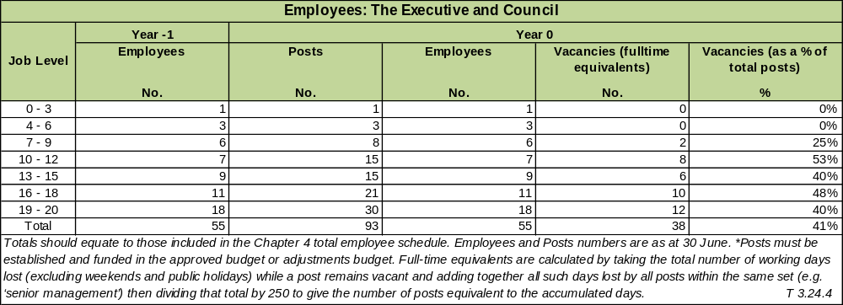
Financial Performance Year 0: The Executive and Council
R'000
Details | Year -1 | Year 0
Details | Actual | Original Budget | Adjustment  Budget | Actual | Variance to Budget
Total Operational Revenue
Expenditure:
Employees | 42 874 | 33 111 | 31 635 | 31 456 | -5%
Repairs and Maintenance
Other | 10 553 | 23 273 | 28 251 | 27 938 | 17%
Total Operational Expenditure | 53 427 | 56 384 | 59 886 | 59 394 | 5%
Net Operational Expenditure | 53 427 | 56 384 | 59 886 | 59 394 | 5%
Net expenditure to be consistent with summary T 5.1.2 in Chapter 5. Variances are calculated by dividing the difference between the Actual and Original Budget by the Actual. |  |  |  |  | T 3.24.5

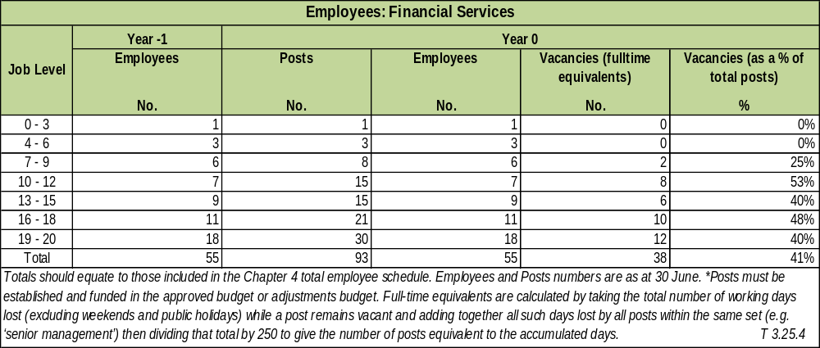

Financial Performance Year 0: Financial Services
R'000
Details | Year -1 | Year 0
Details | Actual | Original Budget | Adjustment  Budget | Actual | Variance to Budget
Total Operational Revenue | 261,206 | 260,416 | 261,004 | 262,378 | 1%
Expenditure:
Employees | 11,145 | 10,465 | 9,705 | 10,001 | -5%
Repairs and Maintenance
Other | 32,458 | 26,906 | 24,675 | 23,593 | -14%
Total Operational Expenditure | 43,602 | 37,371 | 34,380 | 33,594 | -11%
Net Operational Expenditure | (217,603) | (223,046) | (226,624) | (228,783) | 3%
Net expenditure to be consistent with summary T 5.1.2 in Chapter 5. Variances are calculated by dividing the difference between the Actual and Original Budget by the Actual. |  |  |  |  | T 3.25.5

HUMAN RESOURCE SERVICES

Section 51 of Municipal Systems Act, requires that municipality must within its administrative and financial capacity establish and organize its administration in a manner that would enable the municipality to-

(a) be responsive to the needs of the local community;(b) facilitate a culture of public service and accountability amongst its staff;(c) be performance orientated and focused on the objects of local government set out in section 152 of the Constitution and its developmental duties as required by section 153 of the Constitution;(d) ensure that its political structures, political office bearers and managers and other staff members align their roles and responsibilities with the priorities and objectives set out in the municipality's integrated development plan;(e) establish clear relationships, and facilitate co-operation, co-ordination and communication; (f) organize its political structures, political office bearers and administration in a flexible way in order to respond to changing priorities and circumstances;(g) perform its functions; (h) assign clear responsibilities for the management and co-ordination of these administrative units and mechanisms;(i) hold the municipal manager accountable for the overall performance of the administration;(j) maximize efficiency of communication and decision-making within the administration; (k) delegate responsibility to the most effective level within the administration ;(l) involve staff in management decisions as far as is practicable; and(m) provide an equitable, fair, open and non-discriminatory working environment.

The Directorate is designed to maximize employees’ performance of municipality’s IDP Strategies and Objectives; paying particular attention to policies, systems and processes. The Directorate is responsible for overseeing employees’ benefits design, employee recruitment, training and Development, performance appraisal, and rewarding. It is also tasked with organizational change and industrial relations such as the balancing of organizational practices with requirements arising from collective bargaining and governmental laws.

To date, this Directorate is fully functional with most of the positions filled for effective and efficient support services to the Clusters of the municipality; and has carried out the following important activities:

- Reviewed not less than 6 policies, some new and old
- Introduced electronic time and attendance
- Effectively managed the management of employees’ leaves
- Successfully submitted Workplace Skills Plan and Training Plan with LGSETA within prescribed time period.
- Accommodated and mentors 100 interns within various Municipality departments. We are helping to address youth unemployment and close the shortage of skills gaps through our learnership programme.
- Effectively implementing Employment Equity Plan to have a workforce reflective of the demographics of South Africa.
- The Directorate continued to offer external bursary to employees based on their PDP
- We continue to strive for zero fatalities and injuries in the workplace.
- Wellness department continued with sustained employee engagement and mitigation against Chronic Diseases of
- Lifestyle, including personal one-on-one Psycho-social support; and regular testing for risk factors in ad hoc roadshows.
- The directorate is continuing to address labour issues in an endeavour to harness a conducive environment for all employees.

Sedibeng District Municipality has successfully maintained harmonious workplace relations by proactively preventing disputes, disruptive workplace activities and resolving workplace disputes by application of various dispute resolution mechanisms, more important through continuous interaction with workplace stakeholders. Testimony to the successes in dispute resolution is evidenced in labour laws journals that reports on findings that have been influenced.
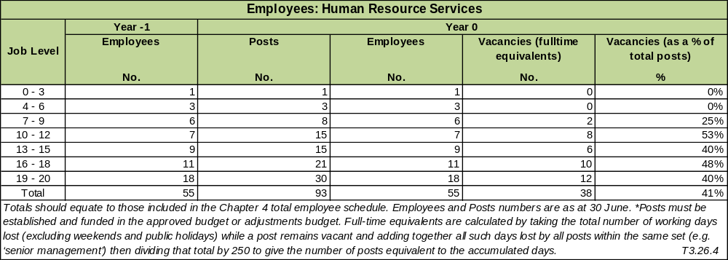

Financial Performance Year 0: Human Resource Services
R'000
Details | Year -1 | Year 0
Details | Actual | Original Budget | Adjustment  Budget | Actual | Variance to Budget
Total Operational Revenue | 306 | 7 | 407 | 425 | 98%
Expenditure:
Employees | 7,639 | 7,813 | 7,755 | 7,801 | 0%
Repairs and Maintenance |  |  |  |  | #DIV/0!
Other | 1,494 | 193 | 374 | 340 | 43%
Total Operational Expenditure | 9,133 | 8,006 | 8,129 | 8,141 | 2%
Net Operational Expenditure | 8,827 | 7,999 | 7,722 | 7,715 | -4%
Net expenditure to be consistent with summary T 5.1.2 in Chapter 5. Variances are calculated by dividing the difference between the Actual and Original Budget by the Actual. |  |  |  |  | T 3.26.5

INFORMATION AND COMMUNICATION TECHNOLOGY (ICT) SERVICES

INTRODUCTION

Information and Communications Technology (ICT) Governance has been described as the effective and efficient management of ICT resources to facilitate the achievement of organisational goals and objectives. ICT does not exist for its own sake within an organisation; ICT is there to make sure that organisations achieve sustainable success using their ICT. ICT is an integral part of enterprise governance and consists of the leadership, organisational structures, and processes that ensure that Sedibeng District Municipality’s ICT sustain and extend the organisation’s strategies and objectives.

Information and communication technologies (ICT) are increasingly used as a strategic enabler in local government. Through the strategic leadership of the Sedibeng District Municipal Council, there is a continuous closer alignment between the municipality’s IDP and the use of ICT in its delivery. In this regard, service delivery, in all its aspects contains information in any of its life cycle phases: creation, transport, storage, retention and retirement. Information is carried in processes and processes are enabled using ICT. This positions the municipality to use ICT in the realisation of value in all aspects of service provision whether it be supporting operations or management, service delivery or serving the citizenry more effectively. In this, ICT facilitates interaction between people, process and the delivery of management practice. ICT then also inevitably finds its way into enabling monitoring and evaluation. ICT will thus influence all areas of the municipality.

The ICT Department in this period focused on three objectives, namely Information security management, communication infrastructure and connectivity. To achieve these objectives, the IM Department focussed on the following outputs in line with the approved IDP:

- Develop and implement policies regarding security standards and procedures policies.

During the period, the ICT Department presented four policies to the Council for approval. These included (i) the Corporate Governance of ICT policy and framework (A1680); (ii) a reviewed ICT usage policy (A1648); (iii) ICT controls policy and (iv) ICT operating systems controls policies (A1678). All policies were approved and implemented. Quarterly reports present the status quo on these policies.

- Maintain the Council’s optic fibre network ensuring high availability and efficient and effective use.

The installation of fibre optic as a “backbone” for communications technology is one of the major projects for the Sedibeng District Municipality in the IDP. The installation of fibre optic was primarily driven by the installation of CCTV cameras at various points throughout the District. Significant fibre optic cables for communication were laid down from 2006 onwards. The installation of this fibre is informed by the objectives that seek to create data connectivity to every municipal office, library, clinic and youth centres across the District. This will, amongst other things, increase participation by the broader society. This project will contribute to reshaping the District’s economy to be more inclusive and broad-based by opening up new opportunities for the marginalized communities. In the period the fibre optic network was available at 100%. Effective maintenance and a well-planned expansion plan ensured delivery of high uptime.

- Coordinate and implement ICT shared service connectivity with local municipalities.

In line with this objective, a memorandum of understanding (MOU) was signed between the Gauteng Provincial Government (GPG) Department of e-Government and the ICT Departments of the Sedibeng District Municipality (SDM), Midvaal Local Municipality and Emfuleni Local Municipality. The agreement aligns e-Government resources to the 10-pillar program of the GPG, and promotes the following:
• build an enabling ICT infrastructure;
• promote the usage of e-Government services;
• stimulate the ICT economy through incubation and innovation;
• co-operate in providing e-Governance, management of ICT and e-Services in the municipality;
• Parties in the MOU further undertake to mobilise and utilise resources to avoid duplication, increase
efficiency and Cost-effectiveness through sharing.

The MOU with the GPG will realise substantial benefits for SDM. The MOU formalises the already good working relationship the SDM ICT Department has with GPG. The agreement positions SDM to benefit from the various projects that GPG is currently rolling out in our District and will promote an enabling environment through for ICT.

ICT Services Policy Objectives Taken From IDP
Service Objectives | Outline Service Targets | Year -1 |  | Year 0 |  |  | Year 1 | Year 3
 | Outline Service Targets | Target | Actual | Target |  | Actual | Target
Service Indicators | Outline Service Targets | *Previous Year |  | *Previous Year | *Current Year |  | *Current Year | *Current Year | *Following Year
(i) | (ii) | (iii) | (iv) | (v) | (vi) | (vii) | (viii) | (ix) | (x)
WORLD-CLASS ICT INFRASTRUCTURE IN SUPPORT OF A “SMART SEDIBENG”
Develop and implement policies regarding security standards and procedures policies | Number of Security Standards, Policies and Procedures tabled at Mayoral Committee | 0 | 0 | 0 | 4 | 4 | 2 | 2 | 2
Maintain the Council’s optic fibre network ensuring high availability and efficient and effective | Report on repairs, maintenance and performance of optic fibre network | 4 | 4 | 4 | 4 | 4 | 4 | 4 | 4
Coordinate and implement ICT shared service connectivity with local municipalities | Number of municipalities participating in the ICT related shared services | 0 | 0 | 0 | 4 | 4 | 4 | 4 | 4
Note:

Employees: ICT Services
Job Level | Year -1 | Year 0
Job Level | Employees | Posts | Employees | Vacancies (fulltime equivalents) | Vacancies (as a % of total posts)
Job Level | No. | No. | No. | No. | %
0 - 3 |  | 4 | 4 | 0 | 0%
4 - 6 |  | 10 | 10 | 0 | 0%
7 - 9 |  | 23 | 23 | 0 | 0%
10 - 12 |  | 0 | 0 | 0 | 0%
13 - 15 |  | 0 | 0 | 0 | 0%
16 - 18 |  | 0 | 0 | 0 | 0%
19 - 20 |  | 0 | 0 | 0 | 0%
Total |  | 37 | 37 | 0 | 0%
T3.27.4

Financial Performance Year 0: ICT Services
R'000
Details | Year -1 | Year 0
Details | Actual | Original Budget | Adjustment  Budget | Actual | Variance to Budget
Total Operational Revenue | 8 811 | 7 953 | 11 399 | 10 456 | 24%
Expenditure:
Employees | 16 122 | 15 954 | 18 984 | 18 488 | 14%
Repairs and Maintenance | 1 127 | 411 | 180 | 486 | 16%
Other | 4 555 | 7 542 | 5 431 | 5 801 | -30%
Total Operational Expenditure | 21 804 | 23 906 | 24 595 | 24 775 | 4%
Net Operational Expenditure | 12 993 | 15 953 | 13 196 | 14 319 | -11%
 |  |  |  |  | T 3.27.5
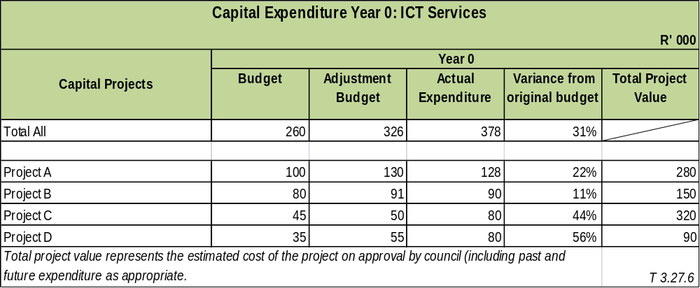

PROPERTY; LEGAL; RISK MANAGEMENT AND PROCUREMENT SERVICES

The topic addresses Property. Legal, Risk Management and Procurement Services. Each of these functions is managed in different departments. This comment will therefore address only the Legal Services function.

Legal Services:

The key objective for Legal Services is to ensure an enabling legal environment for Council to operate in. This is achieved by the, inter alia, rendering of support in the development and vetting of contract, the provision of legal advice to council committees and other functionaries, the perusal of reports and other documents and providing legal comments thereon and the rendering of legal support in the development of by-laws, policies and other documents. Legal Services is also tasked with the management of legal cases instituted by the municipality and the defense of actions that are instituted against the municipality.

The overall objective for the department is ensuring the proper management of Council business. Its other divisions are the committee administration section which renders effective secretarial services to Council and its committees, the records section which continues to be the best nationally and auxiliary services, which provides a courier service and a printing service to the organisation.

The presence of Legal Services is felt in every aspect of Council work, municipalities being a highly regulated environment with a myriad of legislation and regulations that need to be complied with. Legal Services assist in this regard by providing advice when called upon to do so, maintaining a presence at meetings, providing advice in relation to the interpretation of legislation and other legal instruments.

A crucial part of the service that this unit provides is in the development or vetting of contracts. This function is potentially fertile ground for legal challenges and consumes a lot of time and expertise to perform effectively. It is an important indicator of the department`s effectiveness in this regard that there has not been a single instance where the municipality was sued as a result of its contracts, this despite the large number of contracts that were dealt with in the period being reported on.

Contract management and administration in particular, and legal services in general cannot be done by the staff in the department. It is a support services department and its work feeds off the inputs and instructions provided by the rest of the organisation. The quarterly contract management meetings are an example of the symbiotic relationship the department has with the other offices, and are aimed at improving the understanding of each functionary of what contract administration entails, the red flags that all should be on the look-out for etc. It is intended that information sessions that go beyond the administration and management of contracts be held going forward, in order to improve performance, efficiencies and co-operation among the internal stake-holders. The key objective for Legal Services is to provide legal services to the political and administrative arms and to ensure an enabling legal environment for Council to operate in. This can be achieved by ensuring that Legal Services performs its core functions accurately. The core functions of the directorate include, but are not limited to the following:

Litigation management

- Defending all legal action/applications instituted against SDM by third parties,
- Instituting legal action/applications on behalf of the SDM against third parties,
- Management of external attorneys and service providers.

Corporate and Council legal compliance

- Providing legal comments on all reports submitted to SDM committees, the Mayoral Committee and the
- Council,
- Providing legal opinions to the Council and the Directorates,
- Drafting SDM by-laws and assisting directorates with policy-making that are pertinent to the Municipality,
- Providing legal support to the Council,
- Providing specialised legal services in respect of projects or initiatives of the SDM and serving on the technical task teams concerned,
- providing specialised legal support in respect of commercial ventures and related contracts,
- Managing the legal process to recover damages from third parties regarding SDM property Alienation, acquisitions and development law,
- Administering and rendering effective secretarial services to Council and its committees.

Procurement Services

The Supply Chain Management Unit resides within the Finance Cluster. The Local Government: Municipal Finance Management Act (Act 56 of 2003) requires the municipality to have and implement a Supply Chain Management Policy (SCM Policy) which gives effect to the provisions of Part 1 of Chapter 11 of the Act that deals with 'Supply Chain Management'.

In addition, the Preferential Procurement Policy Framework Act (Act 5 of 2000) requires an organ of state to determine its Preferential Procurement Policy and to implement it within the framework prescribed. The following bid committees were established and are fully functional:

• Bid Specification Committee;
• Bid Evaluation Committee; and
• Bid Adjudication Committee.

All municipal procurement is conducted against the annual procurement plan that has been approved by the Accounting Officer. Demand management performance has been monitored and reported on a monthly basis to the senior management team for oversight and control purposes.

SERVICE STATISTICS FOR PROPERTY; LEGAL; RISK MANAGEMENT AND PROCUREMENT SERVICES

A number of contracts were drafted and vetted. Monthly Mayoral and Council meetings are attended. Ad hoc committee meetings are also attended. There were litigation matters for the financial year. Some of these matters were instituted against the municipality; while other matters were the municipality instituting proceedings against third parties.

Financial Performance Year 0: Property; Legal; Risk Management and Procurement Services
R'000
Details | Year -1 | Year 0
Details | Actual | Original Budget | Adjustment  Budget | Actual | Variance to Budget
Total Operational Revenue |  |  |  |  | #DIV/0!
Expenditure:
Employees | 2,721 | 3,221 | 3,631 | 3,795 | 15%
Repairs and Maintenance | 3,497 | 3,144 | 2,921 | 2,282 | -38%
Other | 8,269 | 10,089 | 10,369 | 9,469 | -7%
Total Operational Expenditure | 14,487 | 16,453 | 16,920 | 15,546 | -6%
Net Operational Expenditure | 14,487 | 16,453 | 16,920 | 15,546 | -6%

COMPONENT J: MISCELLANEOUS

Sedibeng manages both the Vereeniging and Heidelberg Airports. These are fully functional and for the period under review, Vereeniging has continued to improve its services, amidst old infrastructure, of supply of fuel and general maintenance.

The Heidelberg Airport is operated by the local flying club and a pilot training school is also based at the facility.
The former Vanderbijlpark Airport has been deregistered.

COMPONENT K: ORGANISATIONAL PERFOMANCE SCORECARD

The purpose of this report is to provide summary analysis of Sedibeng District Municipal performance for the 2017/2018 financial year. This is dictated to by the Municipal Systems Act 32 of 2000; which prescribes that the municipality must establish performance management system that is:

I. Commensurate with its resources
II. Best suited to its circumstances and:
III. In line with its priorities, objectives, indicators and targets as contained in the Integrated Development Plan

Currently, Sedibeng is implementing an ePMS; which is in line and compatible with all the legislation that governs performance. The system has been in use for about 6 years now and has become second nature to eligible employees, currently i.e. level 1-4 employees.

The municipality performance system is in line with the vision and mission of the municipality; and also juxtaposed with the 5Rs+2 of the second generation GDS2; which are: Reinvent the Economy; Renew our Communities; Reviving a Sustainable Environment; Reintegrating our Region; Releasing Human Potential; Good and Financial Sustainable Governance; Vibrant Democracy.

The system allows employees to, on quarterly basis, update progress reports and upload evidence; where continuously the system will indicate through the dashboard, areas of improvement and underperformance. For the year under review, there is an observation of an improvement as compared to the last financial year. The municipality had intended to achieve 179 targets; however only 141 were ultimately achieved; with 38 targets not met. The reasons for non-achievement varied from financial constraints to no accountability of evidence, in line with the indicators.

The tabulation below illustrates that the overall annual performance of the municipality for financial year 2017/18 is 79%. This means that the performance of the municipality has dropped by 5%. Calculation of Annual Achievement was based the overall achievement of targets by 30 June 2018 as supported by evidence made available for the purposes of this report.

The tabulation below illustrates that the overall annual performance of the municipality for financial year 2017/18 is 79%. Calculation of Annual Achievement was based the overall achievement of targets by 30 June 2018 as supported by evidence made available for the purposes of this report. This report was concluded after verification and confirmation of Portfolio of Evidence by Internal Audit.
OFFICE /CLUSTER | TOTAL TARGETS PLANNED | TOTAL TARGETS ACHIEVED | VARIANCE | PERCENTAGE (%) ACHIEVEMENT | VS | 2016/17 Performance Achievements
Office of the Executive Mayor | 10 | 6 | 4 | 60% |  | 77%
Office of the Speaker | 11 | 11 | 0 | 100% |  | 83%
Office of the Chief Whip | 5 | 5 | 0 | 100% |  | 100%
Office of the Municipal Manager | 11 | 9 | 2 | 82% |  | 88%
Finance | 46 | 46 | 0 | 100% |  | 100%
Corporate Services | 40 | 25 | 15 | 63% |  | 86%
Community Services | 25 | 17 | 8 | 68% |  | 80%
Transport, Infrastructure & Environment & Licensing | 14 | 9 | 5 | 64% |  | 66%
Strategic Planning & Local Economic Development | 17 | 14 | 3 | 82% |  | 100%
TOTAL | 179 | 142 | 37 | 79% |  | 84%

Take note the Auditor General selected only a sampling of performance indicators from three out of council’s seven clusters.
The auditor- general could not confirm the validity accuracy and completeness of all the reported indicators during the 17-18 audit. Audited Annual Performance Report is attached.

CHAPTER 4

(PERFORMANCE REPORT PART II)

ORGANISATIONAL DEVELOPMENT AND PERFORMANCE

Some of the interventions implemented include the review of policies and those workshoped to councillors, the meetings of Local Labour Forum, the Finalisation and submission of the Skills Development Plan, training of more than 70 employees to a technical matric course and many workshops with employees through EAP, which included individual financial management.

It is important that the municipality adapts to increasingly complex and uncertain technological, economic, political, and cultural changes; as these invariably proactively influence the strategic direction of the municipality.

COMPONENT A: INTRODUCTION TO THE MUNICIPAL PERSONNEL

EMPLOYEE TOTALS, TURNOVER AND VACANCIES

Employees
Description | Year -1 | Year 0
Description | Employees | Approved Posts | Employees | Vacancies | Vacancies
 | No. | No. | No. | No. | %
Water |  | – | – | –
Waste Water (Sanitation) |  | – | – | –
Electricity |  | – | – | –
Waste Management |  | 2 | 2 | –
Housing |  | 0 | 2 | 1 | 60
Waste Water (Stormwater Drainage) |  | – | – | –
Roads |  | – | – | –
Transport |  | 179 | 179 | _
Planning |  | 6 | 6 | –
Local Economic Development |  | 7 | 7 | –
Planning (Strategic & Regulatary) |  | – | – | –
Community & Social Services |  | 124 | 116 | 8 | 6
Environmental Protection |  | 10 | 7 | 3 | 30
Health |  | – | – | –
Security and Safety |  | 30 | 30 | –
Sport and Recreation |  | 4 | 4 | –
Corporate Policy Offices and Other |  | 202 | 194 | 8 | 4
Totals |  | 644 | 622 | 22 | 3

Vacancy Rate: Year 0
Designations | *Total Approved Posts | *Vacancies (Total time that vacancies exist using fulltime equivalents) | *Vacancies  (as a proportion of total posts in each category)
 | No. | No. | %
Municipal Manager | 1 | 0.156 | 15.60
CFO | 1 | 0 | 0.00
Other S57 Managers (excluding Finance Posts) | 4 | 0 | 0.00
Senior management: Levels 13-15 (excluding Finance Posts) | 44 | 0 | 0.00
Senior management: Levels 13-15 (Finance posts) | 2 | 0 | 0.00
Highly skilled supervision: levels 9-12 (excluding Finance posts) | 86 | 0 | 0.00
Highly skilled supervision: levels 9-12 (Finance posts) | 5 | 0 | 0.00
Total | 143 | 0.156 | 0.11

COMMENT ON VACANCIES AND TURNOVER:

Sedibeng is a relatively stable municipality; and the municipality has also finalised the appointment of section 57 managers. The municipality, although still shows some vacancies; the staff bill is well above the 35%-65% principle as directed by National Treasury. The biggest challenge with the municipality is not about the staff cost but rather the hierarchical structure as opposed to a flat structure.

The district is not implementing but rather coordinating. Therefore the municipality has more employees at higher levels than lower levels and this contributes to high staff costs as there are still critical vacancies to be filled; but this cannot happen due to already bloated structure.

Turn-over Rate
Details | Total Appointments as of beginning of Financial Year | Terminations during the Financial Year | Turn-over Rate*
Details | No. | No. | Turn-over Rate*
Year -2 | 2 | 183 | 32%
Year -1 | 1 | 27 | 6%
Year 0 | 9 | 31 | 5%

COMPONENT B: MANAGING THE MUNICIPAL WORKFORCE

Sec 67 of the Municipal Systems Act requires municipalities to develop and adopt appropriate systems and procedures to ensure fair; efficient; effective; and transparent personnel administration in accordance with the Employment Equity Act 1998.

In an effort to uphold the provisions of legislation, the municipality reviewed and workshop were held on policies for councilors. Conducted road shows for staff to reinforce and enlighten them about some crucial systems such biometric for time and attendance, code of conduct; and procedures such as grievance procures.

POLICIES

HR Policies and Plans
 | Name of Policy | Completed | Reviewed | Date adopted by council or comment on failure to adopt
 |  | % | % | Date adopted by council or comment on failure to adopt
1 | Affirmative Action |  | 9-Apr-00
2 | Attraction and Retention |  | 9-Apr-00
3 | Code of Conduct for employees |  | 9-Apr-00
4 | Delegations, Authorisation & Responsibility |  | 9-Apr-00
5 | Disciplinary Code and Procedures |  | 9-Apr-00
6 | Essential Services |  | 9-Apr-00
7 | Employee Assistance / Wellness | 100% | 100% | 26-Nov-14
8 | Employment Equity | 100% | 100% | 26-Nov-14
9 | Exit Management | 100% | 100% | 26-Nov-14
10 | Grievance Procedures |  | 9-Apr-00
11 | HIV/Aids | 100% | 100% | 26-Nov-14
12 | Human Resource and Development | 100% | 100% | 26-Nov-14
13 | Information Technology |  | 9-Apr-00
14 | Job Evaluation |  | 9-Apr-00
15 | Leave |  | 9-Apr-00
16 | Occupational Health and Safety |  | 26-Sep-02
17 | Official Housing |  | 9-Apr-00
18 | Official Journeys | 100% | 100% | 26-Nov-14
19 | Official transport to attend Funerals |  | 9-Apr-00
20 | Official Working Hours and Overtime |  | 9-Apr-00 | 26-Nov-14
21 | Organisational Rights |  | 9-Apr-00
22 | Payroll Deductions | 100% | 100% | 26-Nov-14
23 | Performance Management and Development | 9-Apr-00 | 9-Apr-00
24 | Recruitment, Selection and Appointments |  | 9-Apr-00
25 | Remuneration Scales and Allowances |  | 9-Apr-00
26 | Resettlement | 100% | 100% | 26-Nov-14
27 | Sexual Harassment | 100% | 100% | 26-Nov-14
28 | Skills Development |  | 26-Sep-02
29 | Smoking | 100% | 100% | 26-Nov-14
30 | Special Skills | 100% | 100% | 26-Nov-14
31 | Work Organisation |  | 9-Apr-00
32 | Uniforms and Protective Clothing | 100% | 100% | 26-Nov-14
33 | Other:

COMMENT ON WORKFORCE POLICY DEVELOPMENT:

In any organisation, policies are instrumental for orderly and logical carrying of particular duties. The review and development of policies are influenced in the main by the changing circumstances and situations such as the municipality trajectory in pursuing particular vision and information technology.

Most policies carry reviewal period with them; while others are reviewed based on circumstances. The exercise of the development and/or review of policies is not desk- or laptop driven, but rather a concerted, coordinated and synergised effort; where a committee is established to carry out this function; and all and sundry in the municipality is involved.

INJURIES, SICKNESS AND SUSPENSIONS

Number and Cost of Injuries on Duty
Type of injury | Injury Leave Taken | Employees using injury leave | Proportion employees using sick leave | Average Injury Leave per employee | Total Estimated Cost
Type of injury | Days | No. | % | Days | R'000
Required basic medical attention only | 2 | 2 | 100% | 0 | 0
Temporary total disablement | 43 | 1 | 2% | 43 | 19952
Permanent disablement | 0 | 0 |  | 0
Fatal | 0 | 0 |  | 0
Total | 45 | 3 | 7% | 9 | 19952
 |  |  |  |  | T 4.3.1

Salary band | Total sick leave | Proportion of sick leave without medical certification | Employees using sick leave | Total employees in post* | *Average sick leave per Employees
Salary band | Days | % | 7-Jan-00 | No. | Days
Lower skilled (Levels 1-2) | 622 | 60% | 165 | 188 | 4.00
Skilled (Levels 3-5) | 1137 | 40% | 106 | 143 | 11.00
Highly skilled production (levels 6-8) | 988 | 30% | 100 | 158 | 6.00
Highly skilled supervision (levels 9-12) | 179 | 30% | 40 | 68 | 4.00
Senior management (Levels 13-15) | 466 | 1% | 11 | 34 | 42.00
MM and S57 | 3 | 0% | 1 | 6 | 3.00
Total

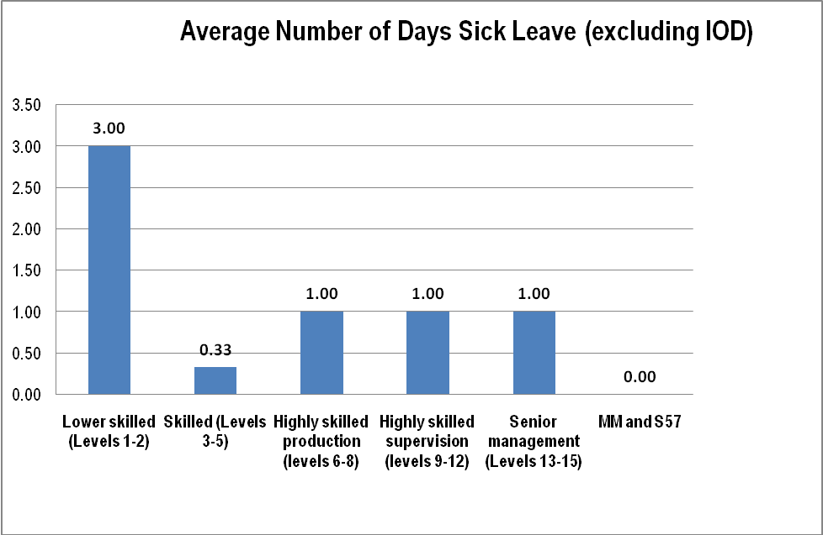

Generally the number of injuries on duty remain stable. This may be attributed to the appointment of an Occupational Health and Safety officer’ who amongst others, established the committee and is in the process of exposing them to capacity building programmes. At the same the officer is hard at work in implementing preventative measures against injuries. The officer ensures that whenever an employee gets injured, is attended to promptly and referred, if needs be, to the hospital.

The municipality only had one temporary disablement due to injury on duty, no fatal or serious injuries on duty experienced. Employees who were injured on duty were taken to hospital for examination, processed Workman’s Compensation claims to Department of Labour. Maintained employees’ personal records.

Number and Period of Suspensions
Position | Nature of Alleged Misconduct | Date of Suspension | Details of Disciplinary Action taken or Status of Case and Reasons why not Finalised | Date Finalised
Executive Director | Insubordination, bringing the municipality into disrepute, dereliction of duty and dishonest behavior | Nov-16 | The contract of the Executive Director expired | June 2016

Disciplinary Action Taken on Cases of Financial Misconduct
Position | Nature of Alleged Misconduct and Rand value of any loss to the municipality | Disciplinary action taken | Date Finalised
N/A | N/A | N/A | N/A
N/A | N/A | N/A | N/A

PERFORMANCE REWARDS

Performance Rewards By Gender
Designations | Beneficiary profile
Designations | Gender | Total number of employees in group | Number of beneficiaries | Expenditure on rewards Year 1 | Proportion of beneficiaries within group
 |  |  |  | R' 000 | %
Lower skilled (Levels 1-2) | Female | n/a | n/a | n/a | n/a
Lower skilled (Levels 1-2) | Male | n/a | n/a | n/a | n/a
Skilled (Levels 3-5) | Female | n/a | n/a | n/a | n/a
Skilled (Levels 3-5) | Male | n/a | n/a | n/a | n/a
Highly skilled production (levels 6-8) | Female | n/a | n/a | n/a | n/a
Highly skilled production (levels 6-8) | Male | n/a | n/a | n/a | n/a
Highly skilled supervision (levels 9-12) | Female | n/a | n/a | n/a | n/a
Highly skilled supervision (levels 9-12) | Male | n/a | n/a | n/a | n/a
Senior management (Levels 13-15) | Female | n/a | n/a | n/a | n/a
Senior management (Levels 13-15) | Male | n/a | n/a | n/a | n/a
MM and S57 | Female | n/a | n/a | n/a | n/a
MM and S57 | Male | n/a | n/a | n/a | n/a

COMMENT ON PERFORMANCE REWARDS:

For the year under review there has not been rewards given to employees, including section 56 and 57employees/managers.

COMPONENT C: CAPACITATING THE MUNICIPAL WORKFORCE

Note: MSA 2000 S68 (1) requires municipalities to develop their human resource capacity to a level that enables them to perform their functions and exercise their powers in an economical, effective, efficient and accountable way.

Like any other municipality currently in the country, there are no sufficient funds to capacitate employees that need personal development. However, the municipality provided financial assistance (bursary) to employees who needed to further their education; most in line with their Personal Development Plans.

Human Resources just embarked on a Skills Audit to determine skills gaps to develop the capacity of the workforce.

SKILLS DEVELOPMENT AND TRAINING

Skills Matrix
Management level | Gender | Employees in post as at 30 June Year 0 | Number of skilled employees required and actual as at 30 June Year 0
Management level | Gender | Employees in post as at 30 June Year 0 | Learnerships |  |  | Skills programmes & other short courses |  |  | Other forms of training |  |  | Total
Management level | Gender | No. | Actual: End of Year -1 | Actual: End of Year 0 | Year 0 Target | Actual: End of Year -1 | Actual: End of Year 0 | Year 0 Target | Actual: End of Year -1 | Actual: End of Year 0 | Year 0 Target | Actual: End of Year -1 | Actual: End of Year 0 | Year 0 Target
MM and s57 | Female |  | 0 | 0 | 0 | 0 | 0 | 0 | 0 | 0 | 0 | 0 | 0 | 0
MM and s57 | Male | 5 | 0 | 0 | 0 | 0 | 1 | 0 | 0 | 0 | 0 | 0 | 1 | 0
Councillors, senior officials and managers | Female | 21 | 0 | 0 | 0 | 0 | 4 | 0 | 0 | 3 | 0 | 0 | 7 | 0
Councillors, senior officials and managers | Male | 55 | 0 | 0 | 0 | 0 | 9 | 0 | 0 | 7 | 0 | 0 | 16 | 0
Technicians and associate professionals* | Female | 22 | 0 | 0 | 0 | 0 | 0 | 0 | 0 | 3 | 0 | 0 | 3 | 0
Technicians and associate professionals* | Male | 30 | 0 | 0 | 0 | 0 | 3 | 0 | 0 | 1 | 0 | 0 | 4 | 0
Professionals | Female | 102 | 0 | 0 | 0 | 0 | 4 | 0 | 0 | 9 | 0 | 0 | 13 | 0
Professionals | Male | 70 | 0 | 0 | 0 | 0 | 0 | 0 | 0 | 3 | 0 | 0 | 3 | 0
Sub total | Female | 145 | 0 | 0 | 0 | 0 | 8 | 0 | 0 | 0 | 0 | 0 | 8 | 0
Sub total | Male | 160 | 0 | 0 | 0 | 0 | 13 | 0 | 0 | 0 | 0 | 0 | 13 | 0
Total |  | 307 |  | 0 | 0 | 0 | 42 | 0 | 0 | 26 |  | 0 | 68 | 0
*Registered with professional Associate Body e.g. CA (SA) |  |  |  |  |  |  |  |  |  |  |  |  |  | T 4.5.1

Financial Competency Development: Progress Report*
Description | A.  Total number of officials employed by municipality (Regulation 14(4)(a) and (c)) | B.  Total number of officials employed by municipal entities (Regulation 14(4)(a) and (c) | Consolidated: Total of A and B | Consolidated: Competency assessments completed for A and B (Regulation 14(4)(b) and (d)) | Consolidated: Total number of officials whose performance agreements comply with Regulation 16 (Regulation 14(4)(f)) | Consolidated: Total number of officials that meet prescribed competency levels (Regulation 14(4)(e))
Financial Officials
Accounting officer | 1 | 0 | 1 | 0 | 0 | 0
Chief financial officer | 0 | 0 | 0 | 0 | 0 | 0
Senior managers | 0 | 0 | 0 | 0 | 0 | 0
Any other financial officials | 0 | 0 | 0 | 0 | 0 | 0
Supply Chain Management Officials
Heads of supply chain management units | 0 | 0 | 0 | 0 | 0 | 0
Supply chain management senior managers | 0 | 0 | 0 | 1 | 1 | 1
TOTAL | 1 | 0 | 1 | 1 | 1 | 1
 |  |  |  |  |  | T 4.5.2

Skills Development Expenditure
R'000
Management level | Gender | Employees as at the beginning of the financial year | Original Budget and Actual Expenditure on skills development Year 1
Management level | Gender | Employees as at the beginning of the financial year | Learnerships |  | Skills programmes & other short courses |  | Other forms of training |  | Total
Management level | Gender | No. | Original Budget | Actual | Original Budget | Actual | Original Budget | Actual | Original Budget | Actual
MM and S57 | Female | 2 | 0 | 0 | 10502 | 0 | 0 | 0 | 10502 | 0
MM and S57 | Male | 5 | 0 | 0 | 26255 | 53950 | 1706 | 1706 | 26225 | 53950
Legislators, senior officials and managers | Female | 21 | 0 | 0 | 20307 | 83550 | 38947 | 38947 | 59254 | 122497
Legislators, senior officials and managers | Male | 55 | 0 | 0 | 53185 | 247144 | 133413 | 132955 | 186598 | 380099
Professionals | Female | 22 | 0 | 0 | 18040 | 20090 | 7555 | 7555 | 25595 | 27645
Professionals | Male | 30 | 0 | 0 | 24600 | 74230 | 4143 | 4143 | 28743 | 78373
Technicians and associate professionals | Female | 102 | 0 | 0 | 83640 | 28482 | 15354 | 15354 | 98994 | 43836
Technicians and associate professionals | Male | 70 | 0 | 0 | 57400 | 0 | 4143 | 4143 | 61543 | 4143
Clerks | Female | 97 | 0 | 0 | 159080 | 0 | 3412 | 3412 | 162492 | 3412
Clerks | Male | 48 | 0 | 0 | 78720 | 0 | 3412 | 3412 | 82132 | 3412
Service and sales workers | Female | 0 | 0 | 0 | 0 | 0 | 0 | 0 | 0 | 0
Service and sales workers | Male | 0 | 0 | 0 | 0 | 0 | 0 | 0 | 0 | 0
Plant and machine operators and assemblers | Female | 0 | 0 | 0 | 0 | 0 | 0 | 0 | 0 | 0
Plant and machine operators and assemblers | Male | 0 | 0 | 0 | 0 | 0 | 0 | 0 | 0 | 0
Elementary occupations | Female | 77 | 0 | 0 | 82064 | 0 | 0 | 0 | 82064 | 0
Elementary occupations | Male | 78 | 0 | 0 | 121360 | 16016 | 0 | 0 | 121360 | 16016
Sub total | Female | 321 | 0 | 0 | 373569 | 132122 | 65268 | 65268 | 438837 | 197390
Sub total | Male | 286 | 0 |  | 361520 | 391340 | 146817 | 146359 | 508337 | 537699
Total |  | 607 | 0 | 0 | 735153 | 523462 | 212085 | 211627 | 947238 | 735153
 |  |  |  |  |  |  |  |  |  | T4.5.3

COMMENT ON SKILLS DEVELOPMENT AND RELATED EXPENDITURE AND ON THE FINANCIAL COMPETENCY REGULATIONS:

There are adequate training plans (Workplace Skills Plan) and implementation was effective. The level of spending may increase, for the current year, due to new planned training needs and the Municipal Finance Required Competencies training that managers have to undergo. The training activity is assessed using Return on Investment Principle

COMPONENT D: MANAGING THE WORKFORCE EXPENDITURE

Sedibeng District Municipality has one of the highest employees’ cost. This is as a result of reducing equitable share, at the same time an increase in Local Government Bargaining Council salary agreements. This became apparent when the levy was replaced by the equitable share. Since then the equitable share has been reducing annually, disregarding the annual salary increases. As a result, very little is left for operational costs and capital projects

This has forced the municipality to, amongst others, implementing the austerity measures. These are applicable from recruitment to catering, office refreshments and vehicles repairs and maintenance. Although there are still vacancy, one other compounding the problem is the hierarchical nature of the municipality structure as compared to a flat structure. This means that many employees are the higher levels and increase staff budget; at the same time the municipality did not dispose-off of staff whose functions went to local municipalities during reallocation of powers and functions.

Other challenges the municipality is facing is that of unfunded mandate; where the municipality is carrying out the provincial function without compensation i.e. communication center, heritage sites and sports.

Number Of Employees Whose Salaries Were Increased Due To Their Positions Being Upgraded
Beneficiaries | Gender | Total
Lower skilled (Levels 1-2) | Female | 0
Lower skilled (Levels 1-2) | Male | 0
Skilled (Levels 3-5) | Female | 0
Skilled (Levels 3-5) | Male | 0
Highly skilled production (Levels 6-8) | Female | 0
Highly skilled production (Levels 6-8) | Male | 0
Highly skilled supervision (Levels9-12) | Female | 0
Highly skilled supervision (Levels9-12) | Male | 0
Senior management (Levels13-16) | Female | 0
Senior management (Levels13-16) | Male | 0
MM and S 57 | Female | 0
MM and S 57 | Male | 0
Total |  | 0

COMMENT ON UPGRADED POSTS AND THOSE THAT ARE AT VARIANCE WITH NORMAL PRACTICE:

There were no employees whose salaries were increased because of promotion; as such no upgrading of positions.

DISCLOSURES OF FINANCIAL INTERESTS

In line with Performance Management Regulations 805 of 2006, Human Resources annually engages employees and the latter sign a disclosure of financial interest form and send for filing by the same department. This practice is also applicable and implemented separately to councillors, through the Office of the Speaker.

CHAPTER 5

FINANCIAL PERFORMANCE

INTRODUCTION

Chapter 5 contains information regarding financial performance and highlights specific accomplishments. The chapter comprises of three components:
• Component A: Statement of Financial Performance
• Component B: Spending Against Capital Budget
• Component C: Other Financial Matters

COMPONENT A: STATEMENTS OF FINANCIAL PERFORMANCE

INTRODUCTION TO FINANCIAL STATEMENTS

Note: Statements of Revenue Collection Performance by vote and by source are included at Appendix K. This component provides an overview of the financial performance of the municipality and focuses on the financial health of the municipality.

STATEMENTS OF FINANCIAL PERFORMANCE

Financial Summary
R' 000
Description | Year -1 | Current: Year 0
Description | Actual | Original Budget | Adjusted Budget | Actual | Original Budget | Adjustments Budget
Financial Performance
Property rates |  |  |  |  | % | %
Service charges |  |  |  |  | % | %
Investment revenue | 2,138 | 1,680 | 1,680 | 2,836 | 68.80% | 68.80%
Transfers recognised - operational | 267,282 | 268,290 | 271,717 | 269,415 | 0.42% | -0.85%
Other own revenue | 89,745 | 94,217 | 93,265 | 85,842 | -8.89% | -7.96%
Total Revenue (excluding capital transfers and contributions) | 359,164 | 364,187 | 366,662 | 358,094 | -1.67% | -2.34%
Employee costs | 245,455 | 250,029 | 249,383 | 255,310 | 2.11% | 2.38%
Remuneration of councillors | 11,500 | 12,639 | 13,087 | 12,826 | 1.48% | -2.00%
Depreciation & asset impairment | 16,230 | 16,896 | 14,871 | 25,866 | 53.09% | 73.93%
Finance charges | – | – | – | – | % | %
Materials and bulk purchases |  |  |  |  | % | %
Transfers and grants | 12,370 | 10,280 | 10,257 | 10,239 | -0.40% | -0.18%
Other expenditure | 106,282 | 95,599 | 100,960 | 143,204 | 49.80% | 41.84%
Total Expenditure | 391,837 | 385,443 | 388,559 | 447,444 | 16.09% | 15.15%
Surplus/(Deficit) | (32,673) | (21,256) | (21,896) | (89,351) | 320.35% | 308.06%
Transfers recognised - capital |  |  |  |  | % | %
Contributions recognised - capital & contributed assets |  |  |  |  | % | %
Surplus/(Deficit) after capital transfers & contributions | (32,673) | (21,256) | (21,896) | (89,351) | 320.35% | 308.06%
Share of surplus/ (deficit) of associate |  |  |  |  | % | %
Surplus/(Deficit) for the year | (32,673) | (21,256) | (21,896) | (89,351) | 320.35% | 308.06%
Capital expenditure & funds sources
Capital expenditure
Transfers recognised - capital | – | – | – | – | % | %
Public contributions & donations |  |  |  |  | % | %
Borrowing |  |  |  |  | % | %
Internally generated funds | 5,648 | 6,000 | 5,350 | 3,126 | -47.90% | -41.57%
Total sources of capital funds | 5,648 | 6,000 | 5,350 | 3,126 | -47.90% | -41.57%
Financial position
Total current assets | 60,022 | 55,150 | 55,150 | 21,908 | -60.28% | -60.28%
Total noncurrent assets | 133,341 | 118,858 | 118,207 | 110,959 | -6.65% | -6.13%
Total current liabilities | 161,628 | 132,121 | 132,121 | 190,283 | 44.02% | 44.02%
Total noncurrent liabilities | – | – | – | – | % | %
Community wealth/Equity | 31,735 | 41,886 | 41,236 | (57,416) | -237.07% | -239.24%
Cash flows
Net cash from (used) operating | 15,087 | (4,460) | (7,125) | (2,007) | -54.99% | -71.83%
Net cash from (used) investing | (5,337) | (5,900) | (5,250) | (3,038) | -48.50% | -42.13%
Net cash from (used) financing | 3,221 | – | – | –
Cash/cash equivalents at the year end | 12,971 | (10,360) | (12,375) | (5,046) | -51.30% | -59.23%
Cash backing/surplus reconciliation
Cash and investments available | 21,874 | (605) | 9,502 | 16,828 | -2881.34% | 77.10%
Application of cash and investments | – | – | – | – | % | %
Balance - surplus (shortfall) | 21,874 | (605) | 9,502 | 16,828 | -2881.34% | 77.10%
Asset management
Asset register summary (WDV) | 133,341 | 118,858 | 118,207 | 110,959 | -6.65% | -6.13%
Depreciation & asset impairment | 16,230 | 16,896 | 14,871 | 25,866 | 53.09% | 73.93%
Renewal of Existing Assets | – | – | – | – | % | %
Repairs and Maintenance | 5,261 | 6,449 | 6,495 | 6,166 | -4.39% | -5.06%
Free services
Cost of Free Basic Services provided | – | – | – | – | % | %
Revenue cost of free services provided | – | – | – | – | % | %
Households below minimum service level
Water: | - | - | - | - | % | %
Sanitation/sewerage: | - | - | - | - | % | %
Energy: | - | - | - | - | % | %
Refuse: | - | - | - | - | % | %
Variances are calculated by dividing the difference between actual and original/adjustments budget by the actual. This table is aligned to MBRR table A1 |  |  |  |  |  | T 5.1.1

Financial Performance of Operational Services
R '000
Description | Year -1 | Year 0 |  |  | Year 0 Variance
Description | Actual | Original Budget | Adjustments Budget | Actual | Original Budget | Adjustments Budget
Operating Cost
Water |  |  |  |  | #DIV/0! | #DIV/0!
Waste Water (Sanitation) |  |  |  |  | #DIV/0! | #DIV/0!
Electricity |  |  |  |  | #DIV/0! | #DIV/0!
Waste Management |  |  |  |  | #DIV/0! | #DIV/0!
Housing | 1,569 | 2,013 | 1,403 | 1,391 | -44.73% | -0.86%
Component A: sub-total | 1,569 | 2,013 | 1,403 | 1,391 | -44.73% | -0.86%
Waste Water (Stormwater Drainage) |  |  |  |  | #DIV/0! | #DIV/0!
Roads |  |  |  |  | #DIV/0! | #DIV/0!
Transport | 3,339 | (13,569) | (8,278) | (1,357) | -900.02% | -510.09%
Component B: sub-total | 3,339 | (13,569) | (8,278) | (1,357) | -900.02% | -510.09%
Planning |  |  |  |  | #DIV/0! | #DIV/0!
Local Economic Development |  |  |  |  | #DIV/0! | #DIV/0!
Component B: sub-total | – | – | – | – | #DIV/0! | #DIV/0!
Planning (Strategic & Regulatary) | 18,065 | 20,349 | 21,549 | 21,807 | 6.68% | 1.18%
Local Economic Development |  |  |  |  | #DIV/0! | #DIV/0!
Component C: sub-total | 18,065 | 20,349 | 21,549 | 21,807 | 6.68% | 1.18%
Community & Social Services | 39,094 | 53,761 | 52,153 | 49,455 | -8.71% | -5.45%
Environmental Protection | 21,660 | 4,646 | 4,306 | 4,303 | -7.96% | -0.07%
Health |  |  |  |  | #DIV/0! | #DIV/0!
Security and Safety | 8,183 | 7,413 | 7,953 | 8,219 | 9.81% | 3.24%
Sport and Recreation |  |  |  |  | #DIV/0! | #DIV/0!
Corporate Policy Offices and Other | (59,237) | (53,358) | (57,189) | 5,532 | 1064.46% | 1133.71%
Component D: sub-total | 9,699 | 12,462 | 7,222 | 67,510 | 81.54% | 89.30%
Total Expenditure | 32,673 | 21,256 | 21,896 | 89,351 | 76.21% | 75.49%
In this table operational income is offset against operational expenditure leaving a net operational expenditure total for each service as shown in the individual net service expenditure tables in chapter 3. Variances are calculated by dividing the difference between actual and original/adjustments budget by the actual. |  |  |  |  |  | T 5.1.2

COMMENT ON FINANCIAL PERFORMANCE:

- Variances greater than 10% between Budget and Actual (refer to Note 44 of the Annual Financial Statements for detail)

- There was a decrease by 20.2% on rental income due to decline in utilization of the facilities and letting out of the facilities on pro bono basis to community structures.

- There was a 12.4% decrease in agency fees as a result of licensing renewals now also be done at the South African Post office .

- Other Income realized higher than anticipated income by 26.7% based on increase in commission and staff recoveries.

- The municipality also realized higher than anticipated Interest on investments made of 40, 8%.

- There was only a Gain on disposal of PPE of R13 857 due to more losses on assets than anticipated during the financial year.

- There was a variance of 17, 1% on Depreciation and 100% on Amortization as there was no split between the two categories on the budget.

GRANTS

Grant Performance
R' 000
Description | Year -1 | Year 0 |  |  | Year 0 Variance
Description | Actual | Budget | Adjustments Budget | Actual | Original Budget (%) | Adjustments Budget (%)
Operating Transfers and Grants
National Government: | 252,168 | 256,029 | 256,029 | 256,029 | 0.00% | 0.00%
Equitable share
Municipal Systems Improvement | 24 | – | – | – | #DIV/0! | #DIV/0!
Department of Water Affairs
Levy replacement | 250,882 | 254,779 | 254,779 | 254,779 | 0.00% | 0.00%
Other transfers/grants NDPG
Other transfers/grants FMG | 1,262 | 1,250 | 1,250 | 1,250 | 0.00% | 0.00%
Provincial Government: | 15,114 | 12,711 | 15,688 | 13,386
Health subsidy
Housing
Ambulance subsidy
Sports and Recreation
MSP
EPWP grant | 666 | 2,490 | 2,490 | 2,490 | 0.00% | 0.00%
LED grant
Other transfers / Grants | 7,010 | 2,431 | 5,431 | 3,146 | 22.72% | -72.65%
HIV & AIDS grant | 7,438 | 7,790 | 7,767 | 7,751 | -0.51% | -0.21%
District Municipality: | – | – | – | –
[insert description]
Other grant providers: | – | – | – | –
[insert description]
Total Operating Transfers and Grants | 267,282 | 268,740 | 271,717 | 269,415
Variances are calculated by dividing the difference between actual and original/adjustments budget by the actual. Full list of provincial and national grants available from published gazettes. |  |  |  |  |  | T 5.2.1

COMMENT ON OPERATING TRANSFERS AND GRANTS

The municipality was not a recipient of any capital grants for the reporting year. The municipality brought forward a balance of R13, 264,193 in unspent grants from the previous year and received an additional R15, 687,985 in the 17/18 year. R13, 453,239 (48%) of these grants were spent in the 17/18 year, carrying forward an unspent balance of R15 million (52%).
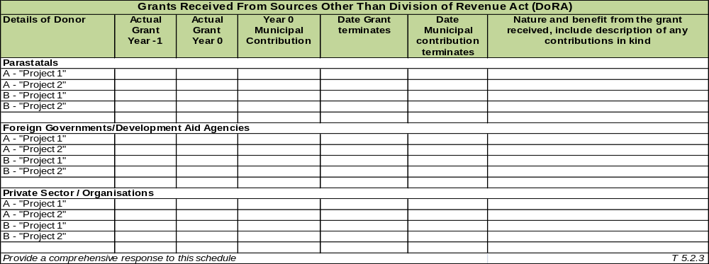
COMMENT ON CONDITIONAL GRANTS AND GRANT RECEIVED FROM OTHER SOURCES

The municipality did not receive grants from other sources during the 17/18 financial year.

ASSET MANAGEMENT

INTRODUCTION TO ASSET MANAGEMENT

The municipality is not involved in infrastructure assets projects and the bulk of the asset register is comprised of movable assets. Assets are capitalized once procured and will be depreciated over the expected life span of the asset as per the accounting policy and asset management policy

TREATMENT OF THE THREE LARGEST ASSETS ACQUIRED YEAR 0
Asset 1
Name | Fibre optic-External network
Description | Optic Fibre network for the district for Information Technology
Asset Type | Computer Hardware (Own Assets)
Key Staff Involved | Information Management Department
Staff Responsibilities
Asset Value | 2014/15 | 2015/16 | 2016/17 | 2017/18
Asset Value | 10 571 129 | 4 699 366 | 1 081 757 | 0
Capital Implications
Future Purpose of Asset | IT Communication
Describe Key Issues
Policies in Place to Manage Asset | Asset Management- , IT policies

Asset 2
Name | Internal Networks
Description | Cabelling of Council buildings to link IT network with different servers and hubs.
Asset Type | Computer Hardware (Own Assets)
Key Staff Involved | Information Management Department
Staff Responsibilities
Asset Value | 2014/15 | 2015/16 | 2016/17 | 2017/18
Asset Value | 921 147 | 537 499 | 490 493 | 666 623
Capital Implications
Future Purpose of Asset | IT Communication
Describe Key Issues
Policies in Place to Manage Asset | Asset Management- , IT policies

Asset 3
Name | Fibre optic-External network
Description | Computer equipment
Asset Type | Computer Hardware (Own Assets)
Key Staff Involved | Information Management Department
Staff Responsibilities
Asset Value | Year -3 | Year -2 | Year -1 | Year 0
Asset Value |  |  |  | 1717010
Capital Implications
Future Purpose of Asset | IT Communication
Describe Key Issues
Policies in Place to Manage Asset | Asset Management- , IT policies
 |  |  |  | T 5.3.2

COMMENT ON ASSET MANAGEMENT:

Assets are capitalized once procured and will be depreciated over the expected life span of the asset

Repair and Maintenance Expenditure: Year 0
R' 000
 | Original Budget | Adjustment Budget | Actual | Budget variance
Repairs and Maintenance Expenditure | 6 449 | 6 495 | 6 166 | 5%
 |  |  |  | T 5.3.4

COMMENT ON REPAIR AND MAINTENANCE EXPENDITURE:

Due to financial constraints, the municipality was not in a position to budget at the 8% benchmark for repairs & maintenance as prescribed by Treasury Norms and Standards.

FINANCIAL RATIOS BASED ON KEY PERFORMANCE INDICATORS

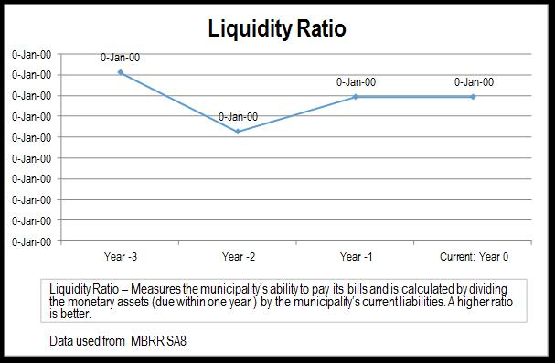

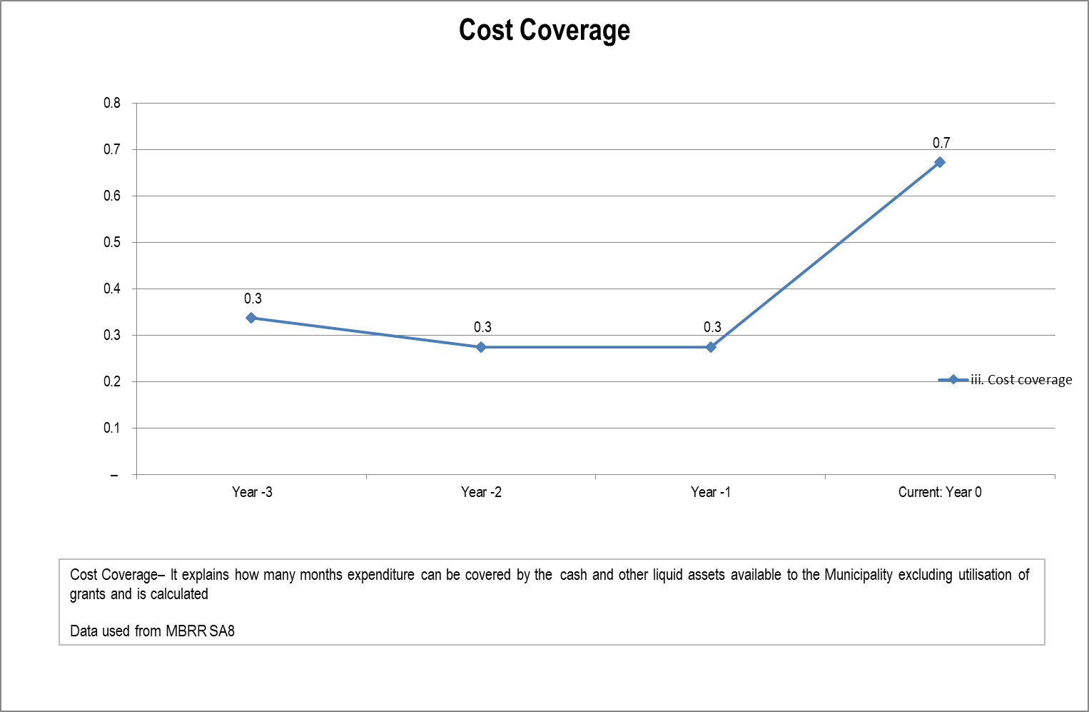

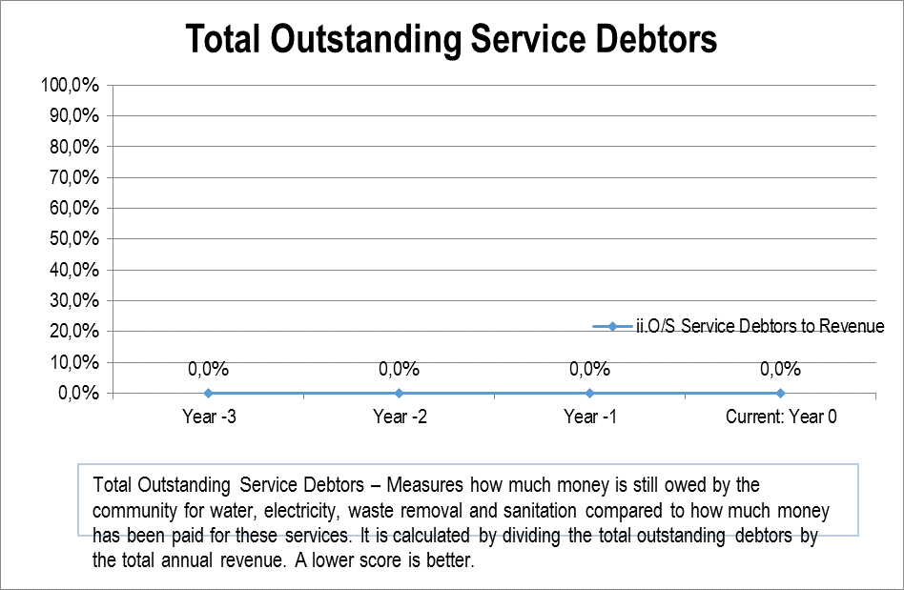

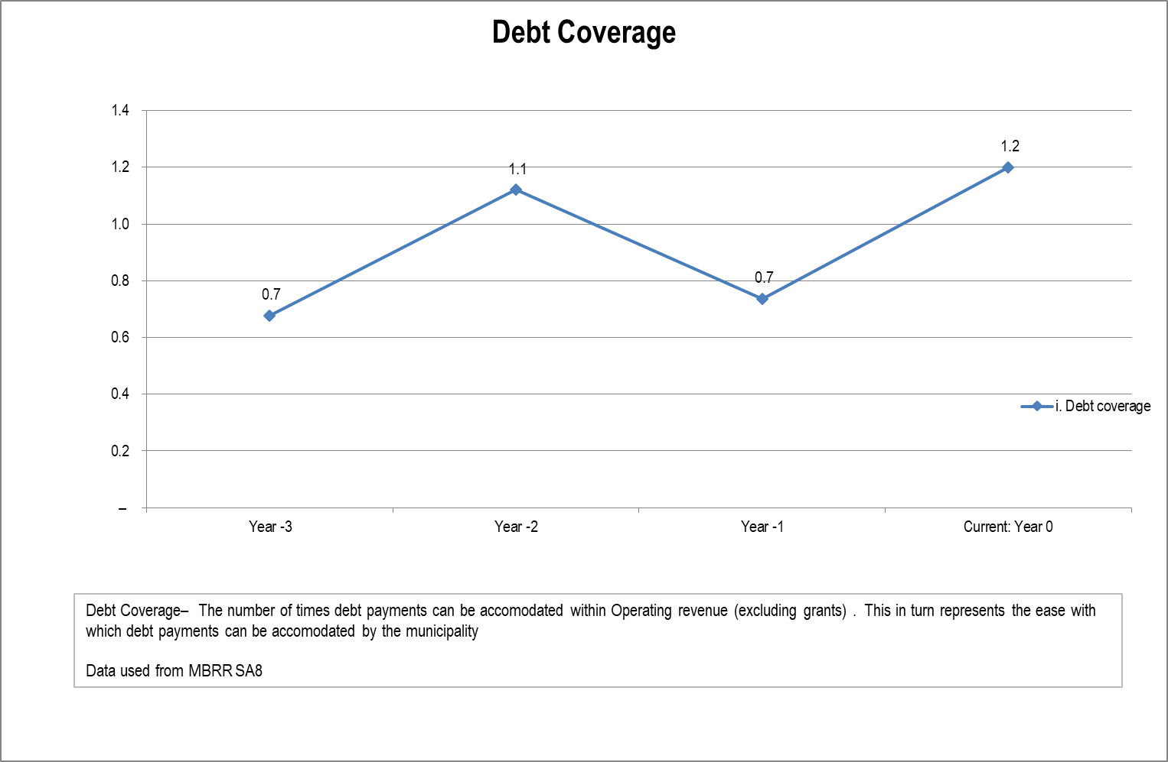
T 5.4.4

T 5.4.5

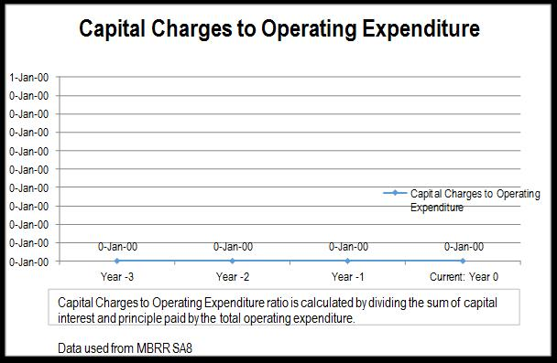T 5.4.6

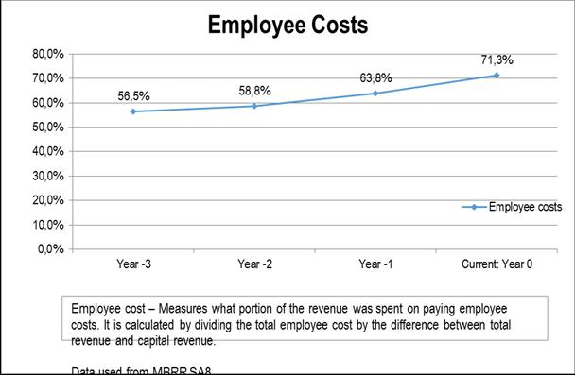
T 5.4.7

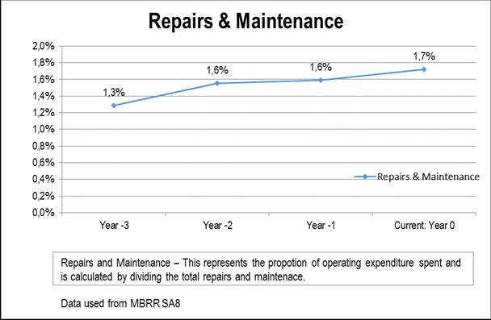
T 5.4.8

COMMENT ON FINANCIAL RATIOS:

MFMA Circular 71 issued 17 January 2014 prescribes the framework for a holistic financial analysis of the municipality of all financial aspects of the institution that should be considered. Ratios are divided into various categories to address the different financial aspects and operations of a municipality or municipal entity.

• Financial Position
• Financial Performance
• Budget Implementation

The application of financial ratio analysis enables and informs our public office bearers and stakeholders decision making with regards to:

• Ability to meet long-term commitments;
• Ability to meet short-term commitments from liquid resources;
• Determine whether investments are yielding acceptable returns;
• Reduce risks arising from below average performance; and
• Make recommendations to address challenges.

COMPONENT B: SPENDING AGAINST CAPITAL BUDGET

INTRODUCTION TO SPENDING AGAINST CAPITAL BUDGET

The municipality does not have any bulk infrastructure grant funding and all capital expenditure was budgeted from internal funds. Due to financial constraints, the municipality could not afford to provision for major capital works, and portions of the work budgeted for 17/18 was rolled over into the 18/19 MTREF due to the cash flow constraints experienced.

CAPITAL EXPENDITURE

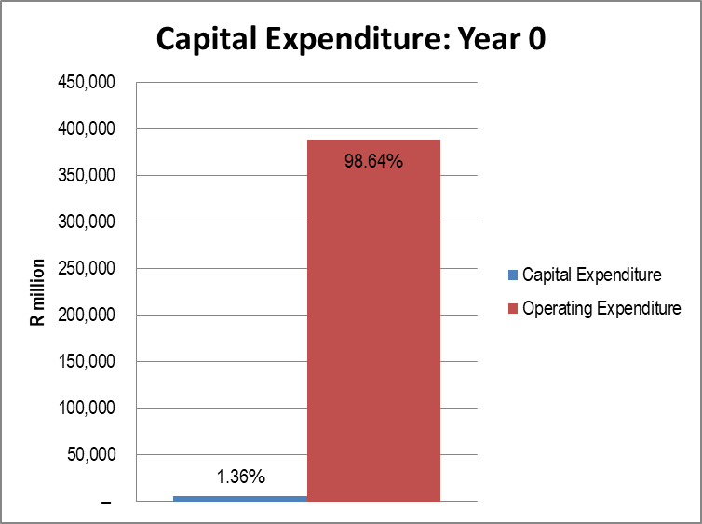
T 5.5.1

SOURCES OF FINANCE

Capital Expenditure - Funding Sources: Year -1 to Year 0
R' 000
Details |  | Year -1 | Year 0
 |  | Actual | Original Budget (OB) | Adjustment Budget | Actual | Adjustment to OB Variance (%) | Actual to OB Variance (%)
Source of finance
 | External loans
 | Public contributions and donations
 | Grants and subsidies | 46 |  |  | –
 | Other | 5,572 | 6,000 | 5,350 | 3,126 | -10.84% | -47.90%
Total |  | 5,618 | 6,000 | 5,350 | 3,126 | -10.84% | -47.90%
Percentage of finance
 | External loans | 0.0% | 0.0% | 0.0% | 0.0% | 0.0% | 0.0%
 | Public contributions and donations | 0.0% | 0.0% | 0.0% | 0.0% | 0.0% | 0.0%
 | Grants and subsidies | 0.8% | 0.0% | 0.0% | 0.0% | 0.0% | 0.0%
 | Other | 99.2% | 100.0% | 100.0% | 100.0% | 100.0% | 100.0%
Capital expenditure
 | Water and sanitation
 | Electricity
 | Housing
 | Roads and storm water
 | Other | 5,618 | 6,000 | 5,350 | 3,126 | -922.7% | -208.8%
Total |  | 5,618 | 6,000 | 5,350 | 3,126 | -922.68% | -208.77%
Percentage of expenditure
 | Water and sanitation | 0.0% | 0.0% | 0.0% | 0.0% | 0.0% | 0.0%
 | Electricity | 0.0% | 0.0% | 0.0% | 0.0% | 0.0% | 0.0%
 | Housing | 0.0% | 0.0% | 0.0% | 0.0% | 0.0% | 0.0%
 | Roads and storm water | 0.0% | 0.0% | 0.0% | 0.0% | 0.0% | 0.0%
 | Other | 100.0% | 100.0% | 100.0% | 100.0% | 100.0% | 100.0%
 |  |  |  |  |  |  | T 5.6.1
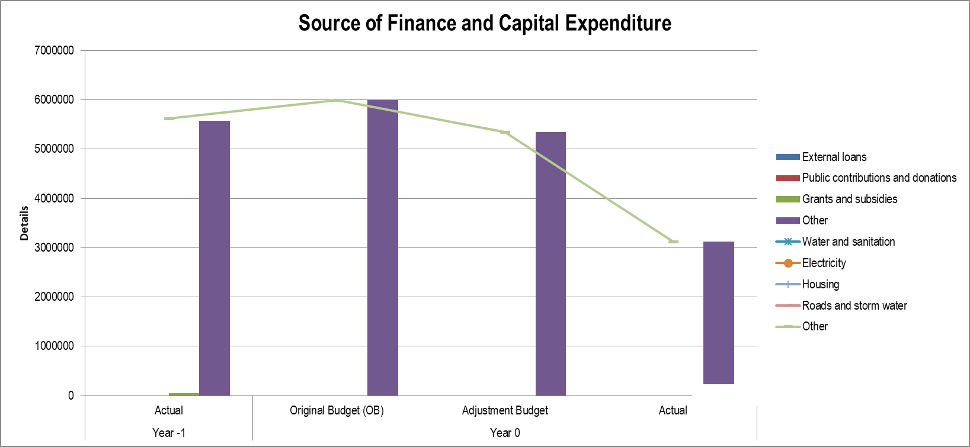

COMMENT ON SOURCES OF FUNDING:

The municipality was not a recipient of capital projects grant funding and the two capital projects were funded internally.

CAPITAL SPENDING ON 5 LARGEST PROJECTS

Capital Expenditure of 5 largest projects*
R' 000
Name of Project | Current: Year 0 |  |  | Variance: Current Year 0
Name of Project | Original Budget | Adjustment Budget | Actual Expenditure | Original Variance (%) | Adjustment variance (%)
A - Furniture Equipment | 800 | 710 | 631 | 21% | 11%
B - Computer Equipment | 2 000 | 1 440 | 1 881 | 6% | 28%
C - MSCOA implementation | 3 200 | 3 200 | 872 | 73% | 0%
D - Name of Project
E - Name of Project
* Projects with the highest capital expenditure in Year 0
Name of Project - A
Objective of Project | Furniture and Equipment
Delays
Future Challenges
Anticipated citizen benefits
Name of Project - B
Objective of Project | Computer Equipment
Delays
Future Challenges | none
Anticipated citizen benefits | Internal IT connectivity
Name of Project - C
Objective of Project | MSCOA compliant by July 2017
Delays
Future Challenges | Upgrading of financial system to new technology
Anticipated citizen benefits
Name of Project - D
Objective of Project
Delays
Future Challenges
Anticipated citizen benefits
Name of Project - E
Objective of Project
Delays
Future Challenges
Anticipated citizen benefits
T 5.7.1

COMMENT ON CAPITAL PROJECTS:

The capital budget was decreased during the adjustment budget process from R6, 000,000 to R5, 349,717. The amount on the capital budget was financed internally from the accumulated surplus as determined by the GRAP principles and accounting standards.

The two capital projects of the municipality for the 17/18 year were the “SCOA Implementation and system upgrade” and the “IT Fibre Optic /Wi-Fi” project. The SCOA project was partially rolled forward into 18/19 due to delays in the delivery and commissioning of computer hardware while the Fibre Optic project was reduced during the adjustment budget and the scope was amended in accordance with the MOU entered into between the municipality and Gauteng E-Governance Department.

BASIC SERVICE AND INFRASTRUCTURE BACKLOGS – OVERVIEW

INTRODUCTION TO BASIC SERVICE AND INFRASTRUCTURE BACKLOGS
Explain that need and cost of backlogs are the result of migration into an area; migration out of an area; the trend towards disaggregation of families into more than one housing unit; and the cost of renewing and upgrading core infrastructure. Explain how this balance effects net demand in your municipality and how your municipality is responding to the challenges created.
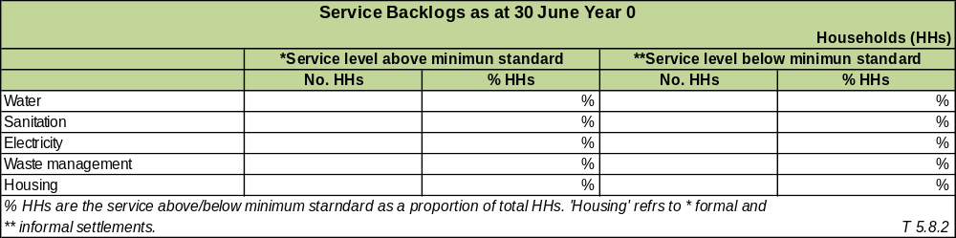

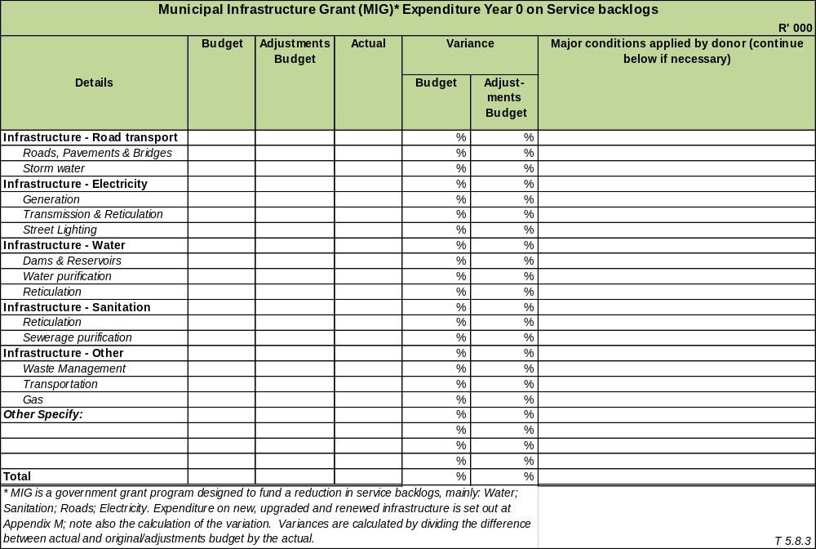

COMMENT ON BACKLOGS

Municipality is not a MIG recipient.

COMPONENT C: CASH FLOW MANAGEMENT AND INVESTMENTS

INTRODUCTION TO CASH FLOW MANAGEMENT AND INVESTMENTS

Information about cash flows may be useful to users of the municipality’s financial statements in assessing Council’s cash flows, assessing Council’s compliance with legislation and regulations (including authorised budgets) and for making decisions about whether to provide resources to, or enter into transactions with Council. These users and stakeholders are generally interested in how Council generates and uses cash and cash equivalents. Municipalities need cash for operations related to service delivery. Municipalities use cash to pay for the goods and services they consume, to meet ongoing debt servicing costs, and, in some cases, to reduce levels of debt. According to the standards of GRAP all entities are required to present a cash flow statement.

It must be noted that the municipality is heavily dependent on the equitable share as its main source of revenue and cash in-flows are determined around the triennial disbursement cycle of the equitable share. The municipality closed with a cash balance of R17 million which shows a drop of R4 million from the previous year (22%).
The municipality held no investments during the 17/18 year.

CASH FLOW

Cash Flow Outcomes
R'000
Description | Year -1 | Current: Year 0
Description | Audited Outcome | Original Budget | Adjusted Budget | Actual
CASH FLOW FROM OPERATING ACTIVITIES
Receipts
Ratepayers and other | 281,260 | 94,217 | 93,265 | 264,652
Government - operating | 267,282 | 268,290 | 271,717 | 271,807
Government - capital
Interest | 2,138 | 1,680 | 1,680 | 2,836
Dividends
Payments
Suppliers and employees | (532,372) | (368,647) | (373,788) | (541,303)
Finance charges
Transfers and Grants
NET CASH FROM/(USED) OPERATING ACTIVITIES | 18,308 | (4,460) | (7,125) | (2,007)
CASH FLOWS FROM INVESTING ACTIVITIES
Receipts
Proceeds on disposal of PPE | 311 | 100 | 100 | 88
Decrease (Increase) in non-current debtors
Decrease (increase) other non-current receivables
Decrease (increase) in non-current investments
Payments
Capital assets | (5,648) | (6,000) | (5,350) | (3,126)
NET CASH FROM/(USED) INVESTING ACTIVITIES | (5,337) | (5,900) | (5,250) | (3,038)
CASH FLOWS FROM FINANCING ACTIVITIES
Receipts
Short term loans
Borrowing long term/refinancing
Increase (decrease) in consumer deposits
Payments
Repayment of borrowing |  |  |  | –
NET CASH FROM/(USED) FINANCING ACTIVITIES | – | – | – | –
NET INCREASE/ (DECREASE) IN CASH HELD | 12,971 | (10,360) | (12,375) | (5,046)
Cash/cash equivalents at the year begin: | 8,903 | 9,755 | 21,877 | 21,874
Cash/cash equivalents at the year-end: | 21,874 | (605) | 9,502 | 16,828
Source: MBRR A7 |  |  |  | T 5.9.1

COMMENT ON CASH FLOW OUTCOMES:

The municipality under-collected against projections on the sale of aviation fuel, rental of municipal facilities, agency services rendered on behalf of the Department of Transport, and Gains on disposal of assets. The municipality did realise higher than anticipated collection on air quality license and permits.

Grants and subsidies received were lower than projected due to withholding of unspent conditional grants.
The municipality overspent on employee costs mostly due to overtime payments which exceeded the budget and adjusted budget.

There was a favourable variance of R7 million between the budgeted and actual net cash flow.

BORROWING AND INVESTMENTS

The municipality had no borrowings and investments during the reporting year

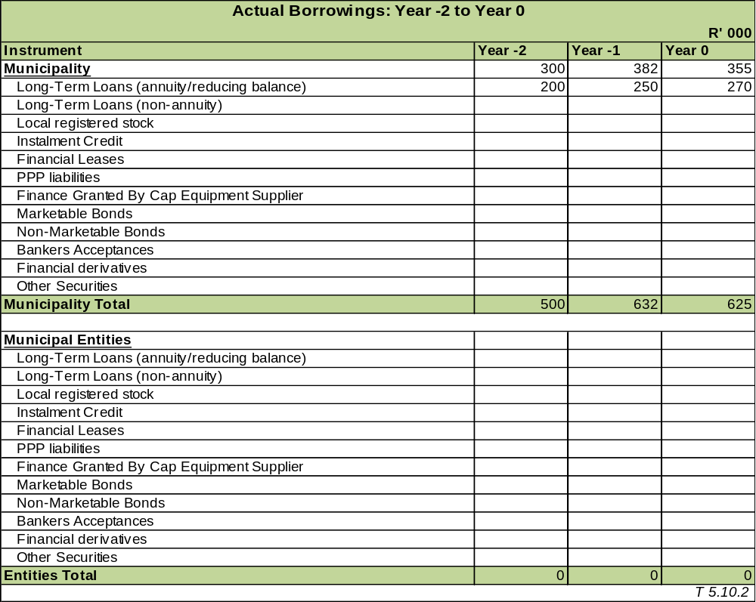

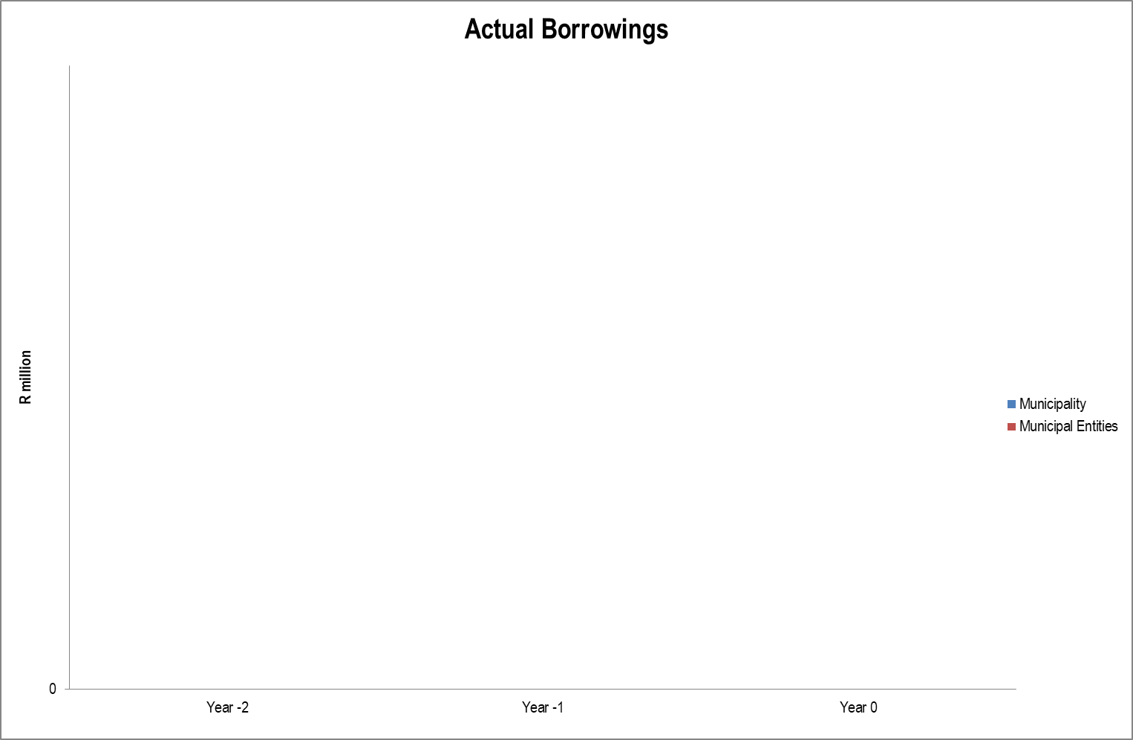
T 5.10.3

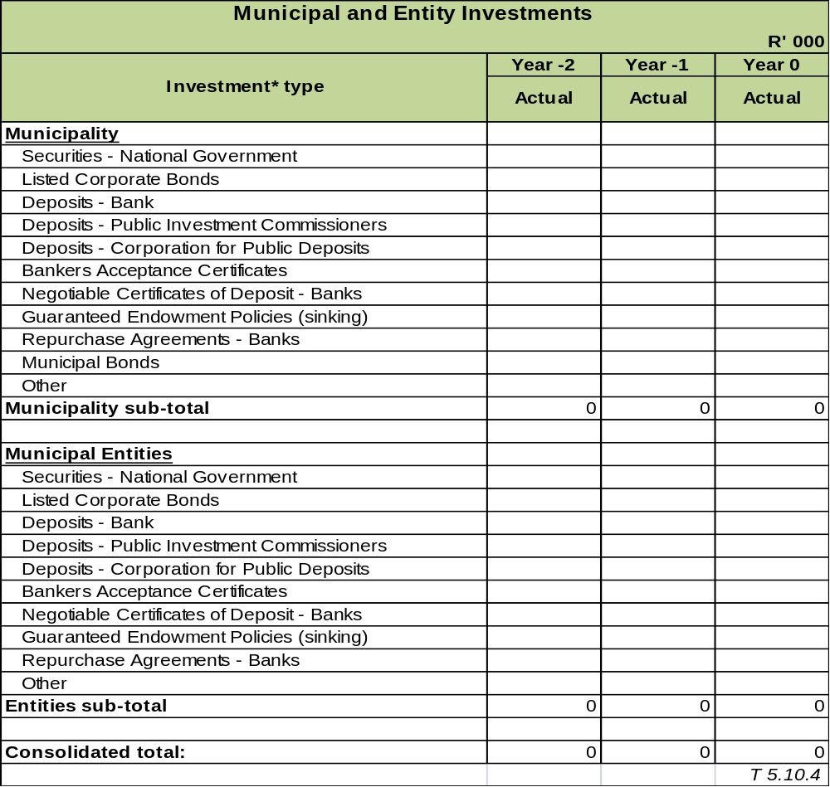

COMMENT ON BORROWING AND INVESTMENTS:

The municipality had no borrowings and investments during the reporting year.

PUBLIC PRIVATE PARTNERSHIPS

No public-private partnerships were entered into during the reporting year.

COMPONENT D: OTHER FINANCIAL MATTERS

SUPPLY CHAIN MANAGEMENT

The Supply Chain Management Unit resides within the Finance Cluster.

The Local Government: Municipal Finance Management Act (Act 56 of 2003) requires the municipality to have and implement a Supply Chain Management Policy (SCM Policy) which gives effect to the provisions of Part 1 of Chapter 11 of the Act that deals with 'Supply Chain Management'.

In addition, the Preferential Procurement Policy Framework Act (Act 5 of 2000) requires an organ of state to determine its Preferential Procurement Policy and to implement it within the framework prescribed.
The following bid committees were established and are fully functional:

• Bid Specification Committee;
• Bid Evaluation Committee; and
• Bid Adjudication Committee.

All municipal procurement above R200, 000 is conducted against the annual procurement plan that has been approved by the Accounting Officer. Demand management performance has been monitored and reported on a monthly basis to the senior management team for oversight and control purposes.

National Treasury have developed a centralised supplier database (CSD) to optimise the efficiency of service delivery. The CSD is interfaced to South African Revenue Service (SARS) to enable tax clearance status verification of suppliers throughout the Procure-to-Pay process and the Companies and Intellectual Property Commission (CIPC) for vetting of business registration and business ownership. All municipalities were required to migrate onto the CSD by 01 July 2016. The SCM unit at the municipality is registered onto the CSD and the SCM Demand Unit has begun incorporating information from CSD onto the existing Venus database, on an as and when required basis.

The Venus system has the database of suppliers and is updated on a daily basis. It gives effect to all the SCM and legislative requirements. The department receives new applications on a daily basis which show the interest of suppliers in the local economy, while existing suppliers are required to update their vendor information as and when required The Acquisition Unit sources quotations between R1, 000 up to R30, 000 on the CSD in compliance with the directive from Treasury. Procurement above R30, 000 is subject to competitive bidding practices.

The Executive Mayor provided general political guidance over fiscal and financial affairs of the municipality. She also monitored and oversaw the exercising of responsibilities assigned to the Accounting Officer and the Chief Financial Officer. Municipal policy and national legislation prescribe that Councillors are not permitted to serve as members in any bid committee or participate in the supply chain management processes.

The municipality has established Contracts Management Committee which meets on a quarterly basis to monitor progress on implementation of all available contracts within the municipality. The Committee is coordinated by Corporate Services, and resides in the Directorate: Legal Services.

GRAP COMPLIANCE

GRAP is the acronym for Generally Recognized Accounting Practice and it provides the rules by which municipalities are required to maintain their financial accounts. Successful GRAP compliance will ensure that municipal accounts are comparable and more informative for the municipality. It will also ensure that the municipality is more accountable to its citizens and other stakeholders. Information on GRAP compliance is needed to enable National Treasury to assess the pace of progress and consider the implications.

The Annual Financial Statements have been prepared on an accrual basis of accounting and are in accordance with the historical cost basis unless otherwise stated. Under this basis the effects of transactions and other events are recognised when they occur and are recorded in the financial statements within the period to which they relate.

The annual financial statements have been prepared in accordance with the effective Standards of Generally Recognised Accounting Practices (GRAP) prescribed by the Minister of Finance in terms of General Notices 991 of 2005 and General Notice 516 of 2008, including any interpretations and directives issued by the Accounting Standards Board Accounting policies for material transactions, events or conditions not covered by the above GRAP have been developed in accordance with paragraphs 7, 11 and 12 of GRAP 3.

The Minister of Finance has, in terms of General Notice 1290 of 2008 exempted compliance with certain of the above-mentioned standards and aspects or parts of these standards. Details of the exemptions applicable to the municipality have been provided in the notes to the annual statements. These accounting policies are consistent with those of the previous financial year.

The following GRAP standards have been approved and are effective:

GRAP 1 - Presentation of financial statements
GRAP 2 - Cash flow statements
GRAP 3 - Accounting policies, changes in accounting estimates and errors
GRAP 4 - The effects of changes in foreign exchange rates
GRAP 5 - Borrowing costs
GRAP 6 - Consolidated and separate financial statements
GRAP 7 - Investments in associates
GRAP 8 - Interest in joint ventures
GRAP 9 - Revenue from exchange transactions
GRAP 10 - Financial reporting in hyperinflationary economies
GRAP 11 - Construction contracts
GRAP 12 - Inventories
GRAP 13 - Leases
GRAP 14 - Events after the reporting date
GRAP 16 - Investment property
GRAP 17 - Property, plant and equipment
GRAP 19 - Provisions, contingent liabilities and contingent assets
GRAP 20 - Related party disclosure
GRAP 21 - Impairment of non-cash generating assets
GRAP 23 - Revenue from non-exchange transactions
GRAP 24 - Presentation of budget information
GRAP 25 - Employee Benefits
GRAP 26 - Impairment of cash generating assets
GRAP 31 - Intangible assets
GRAP 103 - Heritage assets
GRAP 104 - Financial instruments
GRAP 100 - Discontinued operations
GRAP 27 - Agriculture

The following GRAP statements have been approved but are not yet effective:
GRAP 18 - Segment reporting
GRAP 105 - Transfer of functions between entities under common control
GRAP 106 - Transfer of functions between entities not under common control
GRAP 107 – Mergers
GRAP 108 - Statutory Receivables
GRAP 32 – Service Concession Arrangements: Grantor
GRAP 17 – Service concession arrangements where a grantor controls a significant residual interest in an asset

CHAPTER 6 – AUDITOR GENERAL AUDIT FINDINGS


INTRODUCTION

The Constitution S188 (1) (b) states that the functions of the Auditor-General includes the auditing and reporting on the accounts, financial statements and financial management of all municipalities. MSA section 45 states that the results of performance measurement… must be audited annually by the Auditor-General.

COMPONENT A: AUDITOR-GENERAL OPINION OF FINANCIAL STATEMENTS Year -1

AUDITOR GENERAL REPORTS Year -1 (Previous year)

Audit Action Plan 2016/17 Audit Findings by Auditor General
MANAGEMENT COMMENTS AND CORRECTIVE MEASURES TO ADDRESS ISSUES RAISED IN THE REPORT OD THE AUDITOR GENERAL FOR THE FINANCIAL YEAR ENDED 30 JUNE 2017
Ref. | Finding | Root Cause | Management Comment | Responsibility | Implementation Target Date | Progress to Date
PRFORMANCE OBJECTIVES
AOPO1 | Performance targets are not specific | Management did not adequately review the indicators to ensure that they are well defined to ensure that data can be collected consistently and is easy to understand and use. | The municipality is plans to review the crafting of its performance indicators and targets to ensure compliance with the SMART criteria as well as how those targets are reported thereafter. This will be done through the mid-year review process. | Director Office of the Municipal Manager | 30-Jan-18 | Finding addressed  The Mid-year review process of the SDBIP has been conducted. The revised SDBIP has been approved by the Executive Mayor
AOPO2 | Performance indicators are not consistent | Management did not adequately review the targets /indicators in the APR to ensure that they were consistently disclosed in accordance with the revised SDBIP. | Recommendation will be implemented. The municipality is in the process of developing a new SDBIP template which will also be used for reporting. This will ensure consistence and alignment in reporting of performance information. | Director Office of the Municipal Manager | 30-Jan-18 | Finding Addressed  Following the revised SDBIP, the new reporting template is now used for reporting. Alignment with the planning documents is ensured
AOPO3 | Changes to indicators or targets not approved | Management did not follow the appropriate legislated steps in the preparation of the APR. | Going forward, no changes will be made in the SDBIP unless it is during the mid-year review process that goes through council. | Director Office of the Municipal Manager | 30-Jan-18 | Finding Addressed  No changes are made in the indicators during the year. Only targets may be revised during mid-year reviews.
AOPO4 | Performance indicators are not consistent | Management did not adequately review the targets /indicators in the APR to ensure that they were consistently disclosed in accordance with the revised SDBIP. | Recommendation will be implemented. The municipality is in the process of developing a new SDBIP template which will also be used for reporting. This will ensure consistence and alignment in reporting of performance information. | Director Office of the Municipal Manager | 30-Jan-18 | Finding Addressed  Following the revised SDBIP, the new reporting template is now used for reporting. Alignment with the planning documents is ensured
AOPO5 | Performance targets are not specific | Management did not adequately review the indicators to ensure that they are well defined to ensure that data can be collected consistently and is easy to understand and use. | The municipality is plans to review the crafting of its indicators and targets to ensure compliance with the SMART criteria as well as how those targets are reported thereafter. This will be done through the mid-year review process. | Director Office of the Municipal Manager | 30-Jan-18 | Finding addressed  The Mid-year review process of the SDBIP has been conducted. The revised SDBIP has been approved by the Executive Mayor
AOPO6 | Changes to indicators or targets not approved | Management did not follow the appropriate legislated steps in the preparation of the APR. | Going forward, no changes will be made in the SDBIP unless it is during the mid-year review process. | Director Office of the Municipal Manager | 30-Jan-18 | Finding Addressed  No changes are made in the indicators during the year. Only targets may be revised during mid-year reviews.
AOPO7 | Performance indicators are not consistent | Management did not adequately review the targets /indicators in the APR to ensure that they were consistently disclosed in accordance with the revised SDBIP. | Recommendation will be implemented. The municipality is in the process of developing a new SDBIP template which will also be used for reporting. This will ensure consistence and alignment in reporting of performance information. | Director Office of the Municipal Manager | 30-Jan-18 | Finding Addressed  Following the revised SDBIP, the new reporting template is now used for reporting. Alignment with the planning documents is ensured
AOPO8 | Performance targets are not specific | Management did not adequately review the indicators to ensure that they are well defined to ensure that data can be collected consistently and is easy to understand and use. | The municipality is plans to review the crafting of its indicators and targets to ensure compliance with the SMART criteria as well as how those targets are reported thereafter. This will be done through the mid-year review process. | Director Office of the Municipal Manager | 30-Jan-18 | Finding addressed  The Mid-year review process of the SDBIP has been conducted. The revised SDBIP has been approved by the Executive Mayor
AOPO9 | Performance targets are not specific | Management did not adequately review the indicators to ensure that they are well defined to ensure that data can be collected consistently and is easy to understand and use. | The municipality is plans to review the crafting of its indicators and targets to ensure compliance with the SMART criteria as well as how those targets are reported thereafter. This will be done through the mid-year review process. | Director Office of the Municipal Manager | 30-Jan-18 | Finding addressed  The Mid-year review process of the SDBIP has been conducted. The revised SDBIP has been approved by the Executive Mayor
AOPO10 | Performance targets are not specific | Management did not adequately review the targets to ensure that they are specific in clearly identifying the nature and required level of performance in what needs to be achieved as required by the FMPPI. | The municipality is plans to review the crafting of its indicators and targets to ensure compliance with the SMART criteria as well as how those targets are reported thereafter. This will be done through the mid-year review process. | Director Office of the Municipal Manager | 30-Jan-18 | Finding addressed  The Mid-year review process of the SDBIP has been conducted. The revised SDBIP has been approved by the Executive Mayor
AOPO11 | Indicators/measure not well defined | Management did not adequately review the indicators to ensure that they are well defined to ensure that data can be collected consistently and is easy to understand and use. | The municipality is plans to review the crafting of its indicators and targets to ensure compliance with the SMART criteria as well as how those targets are reported thereafter. This will be done through the mid-year review process. | Director Office of the Municipal Manager | 30-Jan-18 | Finding addressed  The Mid-year review process of the SDBIP has been conducted. The revised SDBIP has been approved by the Executive Mayor
AOPO12 | Measures taken to improve not disclosed | Management did not follow the appropriate legislated steps in the preparation of the APR. | The new reporting template will cater for that and proper reviews of Performance Information will be conducted | Director Office of the Municipal Manager | 30-Jan-18 | Finding Addressed  All Non /underperformances now require corrective measures in the new reporting template
AOPO13 | Measures taken to improve not disclosed | Management did not follow the appropriate legislated steps in the preparation of the APR. | The new reporting template will cater for that and proper reviews of Performance Information will be conducted | Director Office of the Municipal Manager | 30-Jan-18 | Finding Addressed  All Non /underperformances now require corrective measures in the new reporting template
AOPO14 | Performance targets are not specific | Management did not adequately review the targets to ensure that they are specific in clearly identifying the nature and required level of performance in what needs to be achieved as required by the FMPPI. | The municipality is plans to review the crafting of its performance indicators and targets to ensure compliance with the SMART criteria as well as how those targets are reported thereafter. This will be done through the mid-year review process. | Director Office of the Municipal Manager | 30-Jan-18 | Finding addressed  The Mid-year review process of the SDBIP has been conducted. The revised SDBIP has been approved by the Executive Mayor
AOPO15 | Performance targets are not specific | Management did not adequately review the targets to ensure that they are specific in clearly identifying the nature and required level of performance in what needs to be achieved as required by the FMPPI. | The municipality is plans to review the crafting of its performance indicators and targets to ensure compliance with the SMART criteria as well as how those targets are reported thereafter. This will be done through the mid-year review process. | Director Office of the Municipal Manager | 30-Jan-18 | Finding addressed  The Mid-year review process of the SDBIP has been conducted. The revised SDBIP has been approved by the Executive Mayor
AOPO16 | Performance targets are not specific | Management did not adequately review the targets to ensure that they are specific in clearly identifying the nature and required level of performance in what needs to be achieved as required by the FMPPI. | The municipality is plans to review the crafting of its performance indicators and targets to ensure compliance with the SMART criteria as well as how those targets are reported thereafter. This will be done through the mid-year review process. | Director Office of the Municipal Manager | 30-Jan-18 | Finding addressed  The Mid-year review process of the SDBIP has been conducted. The revised SDBIP has been approved by the Executive Mayor
AOPO17 | Performance indicators are not consistent | Management did not adequately review the targets /indicators in the APR to ensure that they were consistently disclosed in accordance with the revised SDBIP. | Recommendation will be implemented. The municipality is in the process of developing a new SDBIP template which will also be used for reporting. This will ensure consistence and alignment in reporting of performance information. | Director Office of the Municipal Manager | 30-Jan-18 | Finding Addressed  Following the revised SDBIP, the new reporting template is now used for reporting. Alignment with the planning documents is ensured
AOPO18 | Changes to indicators or targets not approved | Management did not adequately review the targets /indicators in the APR to ensure that they were consistently disclosed in accordance with the revised SDBIP. | Going forward, no changes will be made in the SDBIP unless it is during the mid-year review process. | Director Office of the Municipal Manager | 30-Jan-18 | Finding Addressed  The new template covers this.
AOPO19 | Measures taken to improve not disclosed | Management did not follow the appropriate legislated steps in the preparation of the APR. | The new reporting template will cater for that and proper reviews of Performance Information will be conducted | Director Office of the Municipal Manager | 30-Jan-18 | Finding Addressed  All Non /underperformances now require corrective measures in the new reporting template
AOPO20 | Reported strategic or development objectives not complete when compared with planned strategic or development objectives | Management did not adequately review the APR to ensure that they were consistently reporting on strategic objectives as per the revised SDBIP. | Going forward, no changes will be made in the SDBIP unless it is during the mid-year review process. | Municipal Manager | 30-Jan-18 | Finding Addressed.  During the development of 2018/19 IDP and SDBIP alignment of strategic objectives have been considered.
AOPO21 | Key Performance targets not reliable | • Due to a lack of proper review when indicators and targets were decided on and formulated for inclusion in the IDP.  • Lack of specified level of performance the municipality strive to achieve because of key performance indicators not suitably developed.  • Lack of proper checks to ensure that all work reported on was performed. | Recommendation will be implemented. The municipality is in the process of developing a new SDBIP template which will also be used for reporting. This will ensure consistence and alignment in reporting of performance information. | Stanley Khanyile (Municipal Manager) | 30-Jan-18 | Finding addressed  The Mid-year review process of the SDBIP has been conducted. Targets have been revised to meet the SMART criteria. The revised SDBIP has been approved by the Executive Mayor
GOVERNANCE
F3/P101 | No Established Audit Committee | Management did not implement sufficient monitoring controls to ensure adherence to the MFMA. | Finding Acknowledged. Appointment of Audit Committee is in Progress | Municipal Manager | 30-Jan-18 | Finding Addressed  Audit Committee is in place and fully functional
F2/P111 | Inadequacies in the creation of committees | There was a delay in finding suitable candidates to serve on the audit committee as the individuals applying are not meeting the standard set by the municipality. | We agree with the finding as there was no Audit committee during the year. It should be noted that approval was provided in August 2017 for the Sedibeng district municipality to use the audit committee members from Emfuleni municipality in the interim. | Municipal Manager | Implemented | Finding Addressed  Audit Committee is in place and fully functional
BUSINESS CONTINUITY PLAN
F3/P113 | Business continuity plan not approved | The implementation process of the BCP was delayed due to the approval process by Council. | The Business Continuity Plan was approved in July when the Council sat for the approvals. The Business Continuity Plan is now being conducted. | Municipal Manager  (Risk Management) | 30-Nov-17 | Finding Addressed.  The BCP was presented to Council for approval and employee awareness workshops for BCP will be conducted.
 | Finding Addressed
 | In Progress
 | Finding not addressed
Summary
All twenty-four (24) finding have been addressed.

COMPONENT B: AUDITOR-GENERAL OPINION YEAR 0 (CURRENT YEAR)

AUDITOR GENERAL REPORT YEAR 0

AUDITOR GENERAL REPORT ON THE FINANCIAL STATEMENTS: YEAR 0

Report is attached

COMMENTS ON AUDITOR-GENERAL’S OPINION YEAR 0:

As disclosed in note 37 to the financial statements the municipality incurred a net loss of R89 350 698 (2017: R32 752 252) during the year ended 30 June 2018, and as of that date the municipality’s current liabilities exceeded its current assets by R168 374 668 (2017: R116 887 773). These conditions indicate the existence of a material uncertainty that may cast significant doubt on the municipality’s ability to operate as a going concern. The municipality is therefore interacting with the Gauteng Provincial Treasury and COGTA to assist in resolving the current financial constraint the municipality is experience

COMMENTS ON MFMA SECTION 71 RESPONSIBILITIES:

Section 71 of the MFMA requires municipalities to return a series of financial performance data to the National Treasury at specified intervals throughout the year. The Chief Financial Officer states that these data sets have been returned according to the reporting requirements.

Signed (Chief Financial Officer)………………………………………………………..... Dated

GLOSSARY

Accessibility indicators | Explore whether the intended beneficiaries are able to access services or outputs.
Accountability documents | Documents used by executive authorities to give “full and regular” reports on the matters under their control to Parliament and provincial legislatures as prescribed by the Constitution. This includes plans, budgets, in-year and Annual Reports.
Activities | The processes or actions that use a range of inputs to produce the desired outputs and ultimately outcomes. In essence, activities describe "what we do".
Adequacy indicators | The quantity of input or output relative to the need or demand.
Annual Report | A report to be prepared and submitted annually based on the regulations set out in Section 121 of the Municipal Finance Management Act. Such a report must include annual financial statements as submitted to and approved by the Auditor-General.
Approved Budget | The annual financial statements of a municipality as audited by the Auditor General and approved by council or a provincial or national executive.
Baseline | Current level of performance that a municipality aims to improve when setting performance targets. The baseline relates to the level of performance recorded in a year prior to the planning period.
Basic municipal service | A municipal service that is necessary to ensure an acceptable and reasonable quality of life to citizens within that particular area. If not provided it may endanger the public health and safety or the environment.
Budget year | The financial year for which an annual budget is to be approved – means a year ending on 30 June.
Cost indicators | The overall cost or expenditure of producing a specified quantity of outputs.
Distribution indicators | The distribution of capacity to deliver services.
Financial Statements | Includes at least a statement of financial position, statement of financial performance, cash-flow statement, notes to these statements and any other statements that may be prescribed.
General Key performance indicators | After consultation with MECs for local government, the Minister may prescribe general key performance indicators that are appropriate and applicable to local government generally.
Impact | The results of achieving specific outcomes, such as reducing poverty and creating jobs.
Inputs | All the resources that contribute to the production and delivery of outputs. Inputs are "what we use to do the work". They include finances, personnel, equipment and buildings.
Integrated Development Plan (IDP) | Set out municipal goals and development plans.
National Key performance areas | - Service delivery & infrastructure  - Economic development  - Municipal transformation and institutional development  - Financial viability and management  - Good governance and community participation
Outcomes | The medium-term results for specific beneficiaries that are the consequence of achieving specific outputs. Outcomes should relate clearly to an institution's strategic goals and objectives set out in its plans. Outcomes are "what we wish to achieve".
Outputs | The final products, or goods and services produced for delivery. Outputs may be defined as "what we produce or deliver". An output is a concrete achievement (i.e. a product such as a passport, an action such as a presentation or immunization, or a service such as processing an application) that contributes to the achievement of a Key Result Area.
Performance Indicator | Indicators should be specified to measure performance in relation to input, activities, outputs, outcomes and impacts. An indicator is a type of information used to gauge the extent to  which an output has been achieved (policy developed, presentation delivered, service rendered)
Performance Information | Generic term for non-financial information about municipal services and activities. Can also be used interchangeably with performance measure.
Performance Standards: | The minimum acceptable level of performance or the level of performance that is generally accepted. Standards are informed by legislative requirements and service-level agreements. Performance standards are mutually agreed criteria to describe how well work must be done in terms of quantity and/or quality and timeliness, to clarify the outputs and related activities of a job by describing what the required result should be. In this EPMDS performance standards are divided into indicators and the time factor.
Performance Targets: | The level of performance that municipalities and its employees strive to achieve. Performance Targets relate to current baselines and express a specific level of performance that a municipality aims to achieve within a given time period.
Service Delivery Budget Implementation Plan | Detailed plan approved by the mayor for implementing the municipality’s delivery of services; including projections of the revenue collected and operational and capital expenditure by vote for each month. Service delivery targets and performance indicators must also be included.
Vote: | One of the main segments into which a budget of a municipality is divided for appropriation of money for the different departments or functional areas of the municipality. The Vote specifies the total amount that is appropriated for the purpose of a specific department or functional area.  Section 1 of the MFMA defines a “vote” as:  a) one of the main segments into which a budget of a municipality is divided for the appropriation of money for the different departments or functional areas of the municipality; and  b) which specifies the total amount that is appropriated for the purposes of the department or functional area concerned

APPENDICES

APPENDIX A – COUNCILLORS; COMMITTEE ALLOCATION AND COUNCIL ATTENDANCE

Council Members | Full Time / Part  Time  FT/PT | Committees Allocated | Ward and / or Party  Represented | %Percentage Council Meetings  Attendance | Parentage  Apologies for non-  attendance
Cllr Baloyi PB | FT | Council Sitting (10) | DA | 75% | 25%
Cllr Baloyi HH | FT | Council Sitting (10) | EFF | 75% | 25%  3 Apologies
Cllr Buthongo CT | FT | Council Sitting (10) | ANC | 100% | -
Cllr Coertze Y | PT | Council Sitting (10) | DA | 80% | 20%  2 Apologies
MMC Dlangamandla JM | FT | Council Sitting (10) | ANC | 80% | 25%  2 Absent
MMC Gamede LSA | FT | Council Sitting (10) | ANC | 85% | 15%  2 Apologies
Speaker Gomba MM | FT | Council Sitting (10) | ANC | 100% | -
Cllr Gomes MM | FT | Council Sitting (10) | DA | 90% | 10%  1 Apology
MMC Hlongwane NG | FT | Council Sitting (10) | ANC | 90% | 10%
Cllr Hlophe NC | PT | Council Sitting (10) | DA | 90% | 10%  1Apology
Cllr Hoffman JJ | FT | Council Sitting (10) | EFF+ | 100% | -  1 Apology
Cllr Jones RF | FT | Council Sitting (10) | DA | 100% | -
Cllr Khoali AN | PT | Council Sitting (10) | ANC | 80% | 20%  1 apology
1MMC Khomoeasera ML | FT | Council Sitting (10) | ANC | 80% | 20%  1 Apology
Cllr Machitje LM | FT | Council Sitting (10) | EFF | 80% | 20%  1 Apology
Cllr Mahlase KM | PT | Council Sitting (10) | ANC | 85% | 15%  1 Apology
MMC Mahommed YJ | FT | Council Sitting (10) | ANC | 80% | 20%  1 Apology
MMC Maphalla TS | FT | Council Sitting (10) | ANC | 85% | 15%  2 Apologies
Cllr Maraka TPE | PT | Council Sitting (10) | DA | 100% | -
Cllr Masisa LL | PT | Council Sitting (10) | AIC | 75% | 15%  3 Apologies
Cllr Mkhwanazi OA | PT | Council Sitting (10) | ANC | 100% | -
Cllr Mochawe JS | FT | Council Sitting (10) | ANC | 85% | 15%  3 Apologies
Cllr Mncube ME |  | Council Sitting (10) | DA | 100% | -
Executive Mayor Cllr Modisakeng BJ | FT | Council Sitting (10) | ANC | 100% | -
Cllr Mofokeng NT | PT | Council Sitting (10) | ANC | 85% | 15%  1 Apologies
Cllr Mohono S | PT | Council Sitting (10) | EFF | 85% | 15%
Cllr Mokoena TA | PT | Council Sitting (10) | DA | 100% | -
Cllr Mollo DS | PT | Council Sitting (10) | DA | 95% | 15%  1 Apology
Cllr Motaung PM | PT | Council Sitting (10) | EFF | 85% | 15%  1 Absent
Cllr Motsei LA | PT | Council Sitting (10) | ANC | 95% | 5%
CHIEF WHIP Mshudulu SA | FT | Council Sitting (10) | ANC | 100% | -
Cllr Mulder M | PT | Council Sitting (10) | DA | 70% | 30%  1 Apology
Cllr Ndlovu MP | PT | Council Sitting (10) | ANC
Cllr Nyaku DS | PT | Council Sitting (10) | DA | 60% | 40%  1 Apology
Cllr Ntuthu VJ | PT | Council Sitting (10) | ANC | 100% | -
Cllr Nxongo NPG | PT | Council Sitting (10) | ANC | 85% | 15%  2 Apologies
Cllr Pretorius PC | PT | Council Sitting (10) | DA | 50% | 50%  3 Apologies
MMC Raikane MD | FT | Council Sitting (10) | ANC | 100% | -
Cllr Ramongalo TR | FT | Council Sitting (10) | DA | 80% | 20%
Cllr Rapakeng OD | PT | Council Sitting (10) | ANC | 80% | 20%  3 Apologies
Cllr Raphesu MR | PT | Council Sitting (10) | EFF | 95% | 5%
Cllr Seloane LJ | PT | Council Sitting (10) | ANC | 95% | 5%

APPENDIX B – COMMITTEES AND COMMITTEE PURPOSES

Committees (other than Mayoral/Executive Committee) and Purposes of Committees
Rules committee | - Recommends rules and orders to Council concerning the smooth  running of its business
Ethics & Integrity Committee | - Promote a culture within the institution which is intolerant to unethical  conduct.
Municipal Public Accounts Committee (MPAC). | - Reviews the municipal annual report in line with Auditor -General's  findings.  - Provide political oversight to financial management and accounts.
Public Participation & Petitions Committee | - Promotes the active involvement of the general public in municipal  affairs.  - Receive petitions from ordinary community members on service  delivery matters.
Gender Committee | - Responsible for gender mainstreaming within the municipal  environment.  - Monitor gender perspective of policies , programmes, projects and  practices in the municipality
Section 80 Committees | - Administrative oversight.
Budget Steering Committee | - Coordinate and oversee budgeting processing
Note * Councillors appointed on a proportional basis do not have wards allocation to them TA

APPENDIX C –THIRD TIER ADMINISTRATIVE STRUCTURE

THIRD TIER STRUCTURE
DIRECTORATE | MANAGERS/ASSISTANT MANAGERS (State title and name)
OFFICE OF THE EXECUTIVE MAYOR
A MOKONANE (DIRECTOR) | T MALEKA (ASSISTANT MANAGER)
A MOKONANE (DIRECTOR) | S KGASWANE (ASSISTANT MANAGER)
A MOKONANE (DIRECTOR) | S NDLENGETHWA (ASSISTANT MANAGER)
OFFICE OF THE SPEAKER OF COUNCIL
M. MPONTSHANE (DIRECTOR) | MOKAKO (MANAGER)
OFFICE OF THE CHIEF WHIP OF COUNCIL
J. TSOHO (DIRECTOR) | MGUDLWA (MANAGER)
OFFICE OF THE MUNICIPAL MANAGER
S. MPETA (DIRECTOR) | T. MOKOARI (ASSISTANT MANAGER)
 | B. MASIBEHLELE
R. MHLWATIKA (DIRECTOR) | L. NGAKE (MANAGER)
G. DEYZEL (DIRECTOR)
FINANCE
SUPPLY CHAIN
K. WIESE (Director) | S. Zwedala (ASSISTANT MANAGER)
FINANCIAL MANAGEMENT
C STEYN (DIRECTOR) | A LUBBE (ASSISTANT MANAGER)
 | E LOUW (ASSISTANT MANAGER)
CORPORATE SERVICES
HR
M.W. RAMOTSEDISI (DIRECTOR) | TS MALOKA (MANAGER)
M.W. RAMOTSEDISI (DIRECTOR) | P. MODIMOENG (MANAGER)
M.W. RAMOTSEDISI (DIRECTOR) | L NKOLI (ASSISTANT MANAGER)
M.W. RAMOTSEDISI (DIRECTOR) | C. SERAME (ASSISTANT MANAGER)
M.W. RAMOTSEDISI (DIRECTOR) | O. MORAJANE (ASSISTANT MANAGER)
INFORMATION TECHNOLOGY
Y. CHAMDA (DIRECTOR) | C. VISSER (MANAGER)
Y. CHAMDA (DIRECTOR) | T.XABA (ASSISTANT MANAGER)
Y. CHAMDA (DIRECTOR) | N. MONGA (ASSISTANT MANAGER)
Y. CHAMDA (DIRECTOR) | B. MASHIYA (MANAGER)
Y. CHAMDA (DIRECTOR) | HAJ MANS (MANAGER)
FACILITIES
D. MARANDA (DIRECTOR) | B. JOHNSON (MANAGER)
D. MARANDA (DIRECTOR) | T. MOKOENA (MANAGER)
PROTECTION SERVICES
T. MIYA (MANAGER) | N. MABULA (SUPERINTENDENT)
RECORDS AND COMMITTEE SECTION
N. TSHABALALA (MANAGER) | P. NZUNGA (CORDINATOR)

STRATEGIC PLANNING AND ECONOMIC

DEVELOPMENT
LED & TOURISM
K MBONGO (DIRECTOR) | MD.KANTSO (MANAGER)
 | R. PELSER (MANAGER)
 | M DLADLA (ASSISTANT MANAGER)
 | M MOKGATLE (ASSISTANT MANAGER)
 | S.P VAN WYK (ASSISTANT MANAGER)
R. NETSHIVHALE | S. MAETSO (MANAGER)
DEVELOPMENT PLANNING AND HUMAN SETTLEMENT
T. MUTLANENG (ACTING DIRECTOR) (ACTDIRECTOR) | S. PITSO (MANAGER)
 | MAJOLA (MANAGER)
TRANPORT AND INFRASTRUCTURE
TM.MANQA (DIRECTOR) | M KHALEMA (MANAGER)
 | NS MOFOKENG (MANAGER)
LICENSING
 | T. LENAKE (ASSISTANT MANAGER)
 | E VAN ZYL (ASSISTANT MANAGER)
 | A. MSIBI (ASSISTANT MANAGER)
 | M. MOKGACHANE (ASSISTANT MANAGER)
ENVIRONMENT
 | M.S. DUBE (MANAGER)
 | Z VAN ZYL (MANAGER)
 | MF THEKISO (ASSISTANT MANAGER)
 | M.K.MTHEMBU (ASSISTANT MANAGER
 | J. SENOKOANE (MANAGER)
 | C. RADEBE (MANAGER)
COMMUNITY SERVICES
HEALTH
D MASUKELA (ACTING DIRECTOR) | B MOHAPELOA (ASSISTANT MANAGER)
DISASTER
S. HLAPOLOSA (DIRECTOR) | P. NIEWENHEIZEN (ASSISTANT MANAGER)
S. HLAPOLOSA (DIRECTOR) | M. M TAALJARD (MANAGER)
 | S. MOTHAPO (ASSISTANT MANAGER)
SRAC & H
N. FELIX (DIRECTOR) | B. MOSEBI (ASSISTANT MANAGER)
N. FELIX (DIRECTOR) | S KHUMALO (ASSISTANT MANAGER)
N. FELIX (DIRECTOR) | A. VAN WYK (ASSISTANT MANAGER)
SAFETY
M LEACWE (DIRECTOR) | P. KELE (ASSISTANT MANAGER)

APPENDIX D – FUNCTIONS OF MUNICIPALITY / ENTITY

Municipal / Entity Functions
MUNICIPAL FUNCTIONS | Function Applicable to Municipality (Yes / No)* | Function Applicable to Entity (Yes / No)
Constitution Schedule 4, Part B functions:
Air pollution | Y | N/A
Building regulations | N | N/A
Child care facilities | N | N/A
Electricity and gas reticulation | N | N/A
Firefighting services | N | N/A
Local tourism | Y | N/A
Municipal airports | Y | N/A
Municipal planning | N | N/A
Municipal health services | Y | N/A
Municipal public transport | Y | N/A
Municipal public works only in respect of the needs of municipalities in the discharge of  their responsibilities to administer functions specifically assigned to them under this  Constitution or any other law | N | N/A
Pontoons, ferries, jetties, piers and harbors, excluding the regulation of international and  national shipping and matters related thereto | N | N/A
Stormwater management systems in built-up areas | N | N/A
Trading regulations | N | N/A
Water and sanitation services limited to potable water supply systems and domestic  waste-water and sewage disposal systems | N | N/A
Beaches and amusement facilities | N | N/A
Billboards and the display of advertisements in public places | N | N/A
Cemeteries, funeral parlors and crematoria | N | N/A
Cleansing | N | N/A
Control of public nuisances | N | N/A
Control of undertakings that sell liquor to the public | N | N/A
Facilities for the accommodation, care and burial of animals | N | N/A
Fencing and fences | N | N/A
Licensing of dogs | N | N/A
Licensing and control of undertakings that sell food to the public | N | N/A
Local amenities | N | N/A
Local sport facilities | N | N/A
Markets | Y | N/A
Municipal abattoirs | Y | N/A
Municipal parks and recreation | N | N/A
Municipal roads | N | N/A
Noise pollution | N | N/A
Pounds | N | N/A
Public places | N | N/A
Refuse removal, refuse dumps and solid waste disposal | N | N/A
Street trading | N | N/A
Street lighting | N | N/A
Traffic and parking | N | N/A
* If municipality: indicate (yes or No); * If entity: Provide name of entity |  | T D

APPENDIX E – WARD REPORTING

NOT APPLICABLE TO SEDIBENG DISTRICT MUNICIPALITY

APPENDIX F – WARD INFORMATION

NOT APPLICABLE TO SEDIBENG DISTRICT MUNICIPALITY

APPENDIX G – RECOMMENDATIONS OF THE MUNICIPAL AUDIT COMMITTEE YEAR 2017/18

Date of Audit Committee | Committee Recommendation during year 2017/18 | Recommendation adopted/ not adopted
29 August 2017 | The Committee Recommended that:  THAT the following are to be taken into consideration in order to better the financial situation of the municipality:  - Skills audit for all employees;  - Organisational review;  - Powers and functions to be finalized where COGTA must assist and intervene;  - Shared services to be implemented;  - Engage Treasury Department together with Provincial Treasury to assist in the process of enhancing the financial position;  - And the appointment of the Audit Committee must be a priority. | Adopted
29 August 2017 | The Committee recommended that:  - AFS be amended based on discussions and submit to the Auditor General  - Draft Annual report be amended and submitted to the Auditor General | Adopted
30 November 2017 | The Committee recommended that:  - Auditor-General’s report on the financial statements and performance information of Sedibeng District Municipal Municipality for the 2016/2017 financial year, attached as Annexure “A” to the report, be noted.  - Municipal Manager or his nominee be hereby delegated to invite the Auditor-General to the Ordinary Council Meeting at which this report will be tabled in terms of MFMA Section 130(1) a, b (2), as referred to in the report.  - The Municipal Public Accounts Committee be hereby delegated to follow up and evaluate all issues contained in the Auditor-General’s Report and table their findings or/ and recommendations within two months (60 days) from the date on which the Auditor-General’s Report is tabled before Council,  - Audit Committee accepts the Auditor-General Report with amendments, and that it should be submitted to Council for approval.  - Audit Committee be invited to attend the meeting of the Council where the AG report will be tabled.  - Audit Committee tables its report to the council. | Adopted
22 January 2018 | The Committee recommended that:  - The final management report be noted  - The final audit report be noted  - Annual report be submitted to Internal Audit for inputs before tabling it to council  - The Revised SBBIP be amended with the discussed changes before approval by the Executive Mayor  - Midyear Performance Management report be emailed to Audit Committee Members for further inputs | Adopted
17 May 2018 | The Committee recommended that:  - Draft IDP 2018/19 be submitted to internal audit for further review in order to give assurance to the Audit Committee  - Draft annual Budget 2018/19 has a huge deficit therefore it must be accompanied by an action plan on how the municipality will cover the deficit  - The municipality should consider other sources of revenue as Equitable Share will not sustain the municipality  - The committee will present their concerns about the budget in the council meeting where the budget will be tabled | Adopted

APPENDIX H - LONG TERM CONTRACTS

Long Term Contracts (20 Largest Contracts Entered into during Year 0)
R' 000
Name of Service Provider (Entity or Municipal Department) | Description of Services Rendered by the Service Provider | Start Date of Contract | Expiry date of Contract | Contract Value
FACILITIES
Vereeniging Trust on behalf of Alhilal investments | Lease of City Centre, House & Home building 1st and 2nd Floor | 1/11/2015 | 30/10/2018 | R265 348.81pm
Vereeniging Trust on behalf of MMM investments | Lease of Ventura Mansions | 1/11/2015 | 30/10/2018 | R52 487.51pm
Fleet Horizon Solutions | Fleet Management services (Integrated Fleet Management Services, Lease, Fuel management & Tracking ) | 9/1/2018 | 1/3/2020 | R26 490.70 monthly management fee for 34 vehicles
 |  |  |  | Mercedes C180 Lease R14 528.93 linked to prime rate.
 |  |  |  | Mercedes E250 Finance Lease R32 341.90 linked to prime rate.
 |  |  |  | Mercedes C200 Lease R21 939.33 linked to prime rate.
 |  |  |  | Toyota Etios R6 560.43 each, Total of (7) Seven Vehicles R45 637.76
AEIM Air & Electrical Services cc | Service & Repair of Chillers at Town Halls | 9/15/2016 | 9/14/2019 | R197 881.20 for major service incl. VAT
 |  |  |  | R8 950.00 per month excluding VAT for routine service
HUMAN RESOURCES
Shosholoza | To offer personal financial rescue plans employees | 1/9/2017 | 30/08/2020 | At no cost to Council.
INFORMATION TECHNOLOGY
Netplus | Network cabling and repairs | 5/3/2018 | 4/3/21 | R670 000
Amtronics CC | Computer hardware | 20/07/2018 | 20/01/2019 | R 500 000
Securelink | Telecommunication system | 1/11/2017 | 31/10/2020 | R245 000 monthly (depending on usage).
PROTECTION SERVICES
Mafoko Security Patrols | Security Services | 1/9/2017 | 31/06/2020 | R 991,585.70
FINANCE
Nedbank | Commercial banking Services. | 1/9/2017 | 30/09/2021 | Use account as and when need arises
Standard bank | Commercial banking Services. | 1/07/2013 | 30/06/2016 Extended till December 2018 | Use account as and when need arises.
Business Connexion | Maintenance of the Venus System | Annual | Annual license fee payable every November | R307 850
Payday | Supply Software | Annual | Annual license fee Payable every July | R156 967.74 pa
PricewaterhouseCoopers | Baud Asset Management System | Annual | Annual license fee Payable every July | Based on quotation if the system requires maintenance
COMMUNITY SAFETY
Securelink International (Pty) Ltd | Maintenance, repairs and equipment replacement on CCTV Surveillance System at various identified locations across the region. | 3/01/2018 | 31/12/2018 | R173 751.00 pm
DISASTER MANAGEMENT
Sysman Public Safety Systems (Pty) Ltd | Licensing of Software & Support. | 7-Jan-17 | 30/06/2020 | R221 863.11 pa
ECONOMIC DEVELOPMENT
EPWP Grant Agreement | The National Department of Public Works in its EPWP Programme has allocated a budget for the EPWP Integrated Grant to Provinces and Municipalities for the 2017/18 to 2019/20. MTEF period, for Infrastructure, Social and Environment & Culture programmes. | 7-Jan-17 | 30/06/2018 | R2 490 000.00
Rafique Baba Attorneys | Verifications, registration and transfer of individual ervens in Sebokeng and Evaton. | 1-Jun-15 | 1-Jun-17 | R2 736 (for verifications) and R2 052 (for registration and transfer). Funding received from Province
TRANSPORT, INFRASTRUCTURE & DEVELOPMENT

CORE JV | Development of a Rural Road Asset Management System (RRAMS) | 23-Dec-16 | 30-Jun-18 | R2 467 000
Lesedi Local Municipality | Maintenance of Heidelberg and Shalimar Ridge taxi rank | 3 years contract ended Feb 2018 |  | R300 000pa
Midvaal Local Municipality | Maintenance of Meyerton Taxi Rank | 3 years contract ended Feb 2018 |  | R300 000pa
Gauteng Dept. Roads and Transport (GDRT) | Agency agreement for the operation of the licensing centers in Sedibeng. | 11-Feb-17 | 17/12/2018 | 20% of the all fees collected is retained by the SDM and the rest paid over to GDRT
ENVIRONMENT
Local Municipalities obo the SDM | Agency Agreement for the rendering of Municipal Health Services | 7-Jan-17 | 30/06/2018 | Differs from municipality to municipality. Total approved budget for 2017/18 is R18 800 770
MUNICIPAL MANAGER
Vision Activ | ePMS | 6-Jan-16 | 30/06/2019 | R600 000 per annum (varied on number of users per annum /licensing fees)

APPENDIX I – MUNICIPAL ENTITY/ SERVICE PROVIDER PERFORMANCE SCHEDULE

NOT APPLICABLE TO SEDIBENG DISTRICT MUNICIPALITY

APPENDIX J – DISCLOSURES OF FINANCIAL INTERESTS

Disclosures of Financial Interests
Period 1 July to 30 June of Year 0 (Current Year)
Position | Name | Description of Financial interests*  (Nil / Or details)
Executive Mayor | Cllr Modisakeng BJ | NIL
Members of Mayoral Committee | MMC P Tsotetsi | NIL
 | MMC Maphalla TS | NIL
 | MMC Mahommed YJ | NIL
 | MMC Hlongwane NG | NIL
 | MMC Dlangamandla JM | NIL
 | MMC Gamede LSA | NIL
 | MMC Khomoeasera ML | NIL
 | MMC Raikane MD | NIL
Councillor | SPEAKER Gomba MM | NIL
 | CHIEF WHIP Mshudulu SA | NIL
 | Cllr Baloyi PB | NIL
 | Cllr Baloyi HH | NIL
 | Cllr Buthongo CT | NIL
 | Cllr Coertze Y | NIL
 | Cllr Gomes MM | NIL
 | Cllr Hlophe NC | NIL
 | Cllr Hoffman JJ | NIL
 | Cllr Jones RF | NIL
 | Cllr Khoali AN | NIL
 | Cllr Machitje LM | NIL
 | Cllr Mahlase KM | NIL
 | Cllr Maraka TPE | NIL
 | Cllr Masisa LL | NIL
 | Cllr Mkhwanazi OA | NIL
 | Cllr Mochawe JS | NIL
 | Cllr Mncube ME | NIL
 | Cllr Mofokeng NT | NIL
 | Cllr Mohono S | NIL
 | Cllr Mokoena TA | NIL
 | Cllr Mollo DS | NIL
 | Cllr Motaung PM | NIL
 | Cllr Motsei LA | NIL
 | Cllr Mulder M | NIL
 | Cllr Ndlovu MP | NIL
 | Cllr Nyaku DS | NIL
 | Cllr Ntuthu VJ | NIL
 | Cllr Nxongo NPG | NIL
 | Cllr Pretorius PC | NIL
 | Cllr Ramongalo TR | NIL
 | Cllr Rapakeng OD | NIL
 | Cllr Raphesu MR | NIL
 | Cllr Seloane LJ | NIL
Municipal Manager | Mr. S. Khanyile | NIL
Acting Chief Financial Officer | Mrs. K. Wiese | NIL
Executive Directors/Other S57 Officials | Mr. M. Makhutle | NIL
 | Mr. Z. Majola | NIL
 | Mrs. J. Nxumalo | NIL
 | Mrs. N. Baleni | NIL
* Financial interests to be disclosed even if they incurred for only part of the year. See MBRR SA34A T J

APPENDIX K: REVENUE COLLECTION PERFORMANCE BY VOTE AND BY SOURCE

APPENDIX K (i): REVENUE COLLECTION PERFORMANCE BY VOTE

Revenue Collection Performance by Vote
 |  |  |  |  |  | R' 000
Vote Description | Year -1 | Current: Year 0 |  |  | Year 0 Variance
Vote Description | Actual | Original Budget | Adjusted Budget | Actual | Original Budget | Adjustments Budget
Vote 1 - Executive and Council | – | (300) | – | –
Vote 2 - Finance & Administration | 280,705 | 287,401 | 292,070 | 293,758 | 2% | 1%
Vote 3 - Transport, Infrastructure & Environment | 64,802 | 73,920 | 68,602 | 60,727 | -22% | -13%
Vote 4 - Community & Social Services | 10,230 | 485 | 560 | 463 | -5% | -21%
Vote 5 - Planning & Development | 3,427 | 2,431 | 5,431 | 3,146 | 23% | -73%
Example 6 - Vote 6
Example 7 - Vote 7
Example 8 - Vote 8
Example 9 - Vote 9
Example 10 - Vote 10
Example 11 - Vote 11
Example 12 - Vote 12
Example 13 - Vote 13
Example 14 - Vote 14
Example 15 - Vote 15
Total Revenue by Vote | 359,164 | 363,937 | 366,662 | 358,094 | -2% | -2%
Variances are calculated by dividing the difference between actual and original/adjustments budget by the actual. This table is aligned to MBRR table A3 |  |  |  |  |  | T K.1

APPENDIX K (ii): REVENUE COLLECTION PERFORMANCE BY SOURCE

Revenue Collection Performance by Source
R '000
Description | Year -1 | Year 0 |  |  | Year 0 Variance
Description | Actual | Original Budget | Adjustments Budget | Actual | Original Budget | Adjustments Budget
Property rates |  |  |  |  | #DIV/0! | #DIV/0!
Property rates - penalties & collection charges |  |  |  |  | #DIV/0! | #DIV/0!
Service Charges - electricity revenue |  |  |  |  | #DIV/0! | #DIV/0!
Service Charges - water revenue |  |  |  |  | #DIV/0! | #DIV/0!
Service Charges - sanitation revenue |  |  |  |  | #DIV/0! | #DIV/0!
Service Charges - refuse revenue |  |  |  |  | #DIV/0! | #DIV/0!
Service Charges - other | – | – | – | – | #DIV/0! | #DIV/0!
Rentals of facilities and equipment | 800 | 620 | 686 | 571 | -9% | -20%
Interest earned - external investments | 2,138 | 1,680 | 1,680 | 2,836 | 41% | 41%
Interest earned - outstanding debtors |  |  |  |  | #DIV/0! | #DIV/0!
Dividends received |  |  |  |  | #DIV/0! | #DIV/0!
Fines |  |  |  |  | #DIV/0! | #DIV/0!
Licenses and permits | 517 | – | 860 | 2,255 | 100% | 62%
Agency services | 69,515 | 81,873 | 80,001 | 71,183 | -15% | -12%
Transfers recognised - operational | 267,282 | 268,290 | 271,717 | 269,415 | 0% | -1%
Other revenue | 18,913 | 11,624 | 11,617 | 11,820 | 2% | 2%
Gains on disposal of PPE | – | 100 | 100 | 14 | -622% | -622%
Environmental Protection |  |  |  |  | #DIV/0! | #DIV/0!
Total Revenue (excluding capital transfers and contributions) | 359,164 | 364,187 | 366,662 | 358,094 | -1.70% | -2.39%
Variances are calculated by dividing the difference between actual and original/adjustments budget by the actual. This table is aligned to MBRR table A4. |  |  |  |  |  | T K.2

APPENDIX L: CONDITIONAL GRANTS RECEIVED: EXCLUDING MIG

COMMENT ON CONDITIONAL GRANTS EXCLUDING MIG:

Conditional Grants: excluding MIG
R' 000
Details | Budget | Adjustments  Budget | Actual | Variance |  | Major conditions applied by donor (continue below if necessary)
 |  |  |  | Budget | Adjustments  Budget
HIV and AIDS Grant | 7,790,000 | 7,766,985 | 7,750,649 | -1% | 0%
EPWP Grant | 2,490,000 | 2,490,000 | 2,490,000 | 0% | 0%
Rural Roads Grant | 2,431,000 | 2,431,000 | 2,504,769 | 3% | 3%
Agricultural Grant | 3,000,000 | 3,000,000 | 714,725 | -320% | -320% | Money receive in March 2018 and implementation could not be completed within a 3 month period
Finance Management Grant | 1,250,000 | 1,250,000 | 1,250,000 | 0% | 0%
Total | 16,961,000 | 16,937,985 | 14,710,143
*. |  |  |  |  |  | T L

APPENDIX M: CAPITAL EXPENDITURE – NEW & UPGRADE/RENEWAL PROGRAMMES

APPENDIX M (i): CAPITAL EXPENDITURE - NEW ASSETS PROGRAMME

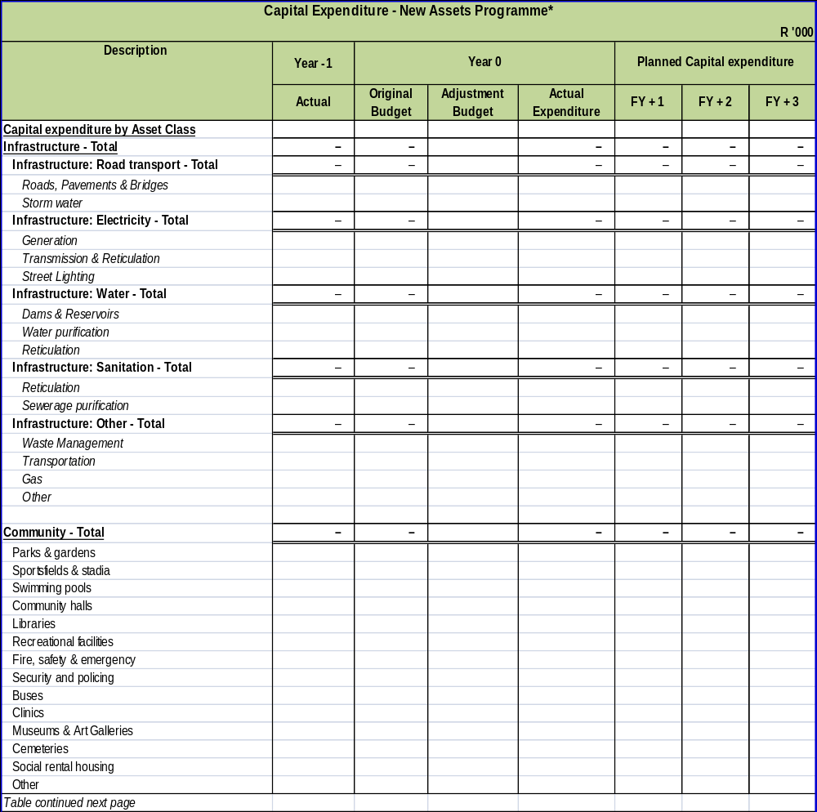
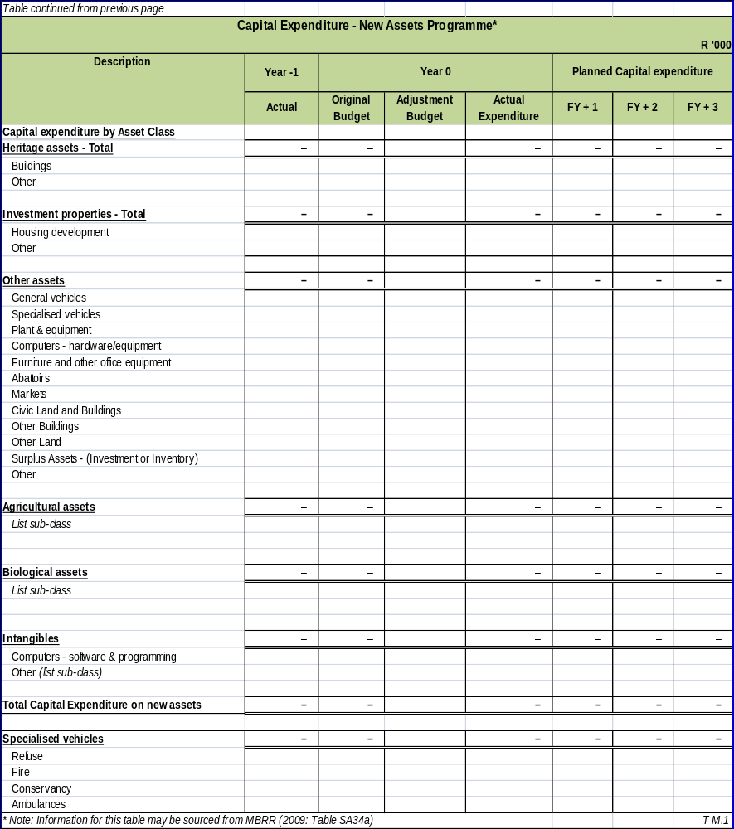

APPENDIX M (ii): CAPITAL EXPENDITURE – UPGRADE/RENEWAL PROGRAMME
Capital Expenditure - Upgrade/Renewal Programme*
R '000
Description | Year -1 | Year 0 |  |  | Planned Capital expenditure
Description | Actual | Original Budget | Adjustment Budget | Actual Expenditure | FY + 1 | FY + 2 | FY + 3
Capital expenditure by Asset Class
Investment properties | – | – |  | – | – | – | –
Housing development
Other
Other assets | 4,444 | 2,800 | 2,150 | 2,809 | 2,100 | – | –
General vehicles
Specialised vehicles
Plant & equipment | 915 | 600 | 710 | 631 | 600
Computers - hardware/equipment | 2,475 | 2,000 | 1,140 | 1,881 | 1,200
Furniture and other office equipment | 368 | 200 | 300 | 297 | 300
Abattoirs
Markets
Civic Land and Buildings
Other Buildings
Other Land
Surplus Assets - (Investment or Inventory)
Other | 687
Agricultural assets | – | – |  | – | – | – | –
List sub-class
Biological assets | – | – |  | – | – | – | –
List sub-class
Intangibles | 1,204 | 3,200 | 3,200 | 317 | 1,500 | – | –
Computers - software & programming | 1,204 | 3,200 | 3,200 | 317 | 1,500
Other (list sub-class)
Total Capital Expenditure on renewal of existing assets | 5,648 | 6,000 | 5,350 | 3,126 | 3,600 | – | –
Specialised vehicles | – | – | – | – | – | – | –
Refuse
Fire
Conservancy
Ambulances
* Note: Information for this table may be sourced from MBRR (2009: Table SA34b) |  |  |  |  |  |  | T M.2

APPENDIX N – CAPITAL PROGRAMME BY PROJECT YEAR 0

NOT APPLICABLE TO SEDIBENG DISTRICT MUNICIPALITY

APPENDIX O – CAPITAL PROGRAMME BY PROJECT BY WARD YEAR 0

NOT APPLICABLE TO SEDIBENG DISTRICT MUNICIPALITY

APPENDIX P – SERVICE CONNECTION BACKLOGS AT SCHOOLS AND CLINICS

NOT APPLICABLE TO SEDIBENG DISTRICT MUNICIPALITY

APPENDIX Q – SERVICE BACKLOGS EXPERIENCED BY THE COMMUNITY WHERE ANOTHER SPHERE OF GOVERNMENT IS RESPONSIBLE FOR SERVICE PROVISION

NOT APPLICABLE TO SEDIBENG DISTRICT MUNICIPALITY

APPENDIX R – DECLARATION OF LOANS AND GRANTS MADE BY THE MUNICIPALITY

NOT APPLICABLE TO SEDIBENG DISTRICT MUNICIPALITY

APPENDIX S – NATIONAL AND PROVINCIAL OUTCOMES FOR LOCAL GOVERNMENT

NOT APPLICABLE TO SEDIBENG DISTRICT MUNICIPALITY

VOLUME II: ANNUAL FINANCIAL STATEMENTS

